VOORHEES TOWNSHIP COMMITTEE
MINUTES FOR THE MEETING OF JULY 14, 2025
REGULAR MEETING 7:00 PM

FLAG SALUTE

PRESENT
Committeewoman Fetbroyt - Present
Committeeman Platt - Present
Deputy Mayor Ravitz – Present – By Phone
Deputy Mayor Nocito - Absent
Mayor Mignogna - Present

ALSO PRESENT
Stephen Steglik, Township Administrator; Christopher Long, Township Solicitor

SUNSHINE STATEMENT
In compliance with the “Open Public Meetings Act”, notice of this meeting has been published as required in the Courier Post and the Inquirer Newspapers, and notice has been posted on the bulletin board outside of the Township Clerk’s office and on the Township website.

PUBLIC COMMENT FOR RESOLUTIONS ONLY

MOTION TO CLOSE
PUBLIC PORTION: MR. PLATT AYES: 4
SECONDED: MRS. FETBROYT NAYS: NONE

RESOLUTION NO. 216-25 CERTIFYING THE RESULTS OF THE 2024 AUDIT

MOTION TO APPROVE: MRS. FETBROYT
SECONDED: MR. PLATT
AYES: 4
NAYS: NONE

RESOLUTION NO. 217-25 AUTHORIZING THE APPROVAL TO SUBMIT AN AWARD EXTENSION REQUEST FOR LA-2024 MA VOORHEES TOWNSHIP CENTENNIAL BOULEVARD PHASE I 04 TO THE NEW JERSEY DEPARTMENT OF TRANSPORTATION

MOTION TO APPROVE: MRS. FETBROYT
SECONDED: MR. PLATT
AYES: 4
NAYS: NONE

RESOLUTION NO. 218-25 AUTHORIZING THE AWARD OF A BID FOR PUBLIC WORKS UNIFORMS TO SPORTS PARADISE

MOTION TO APPROVE: MRS. FETBROYT
SECONDED: MR. PLATT
AYES: 4
NAYS: NONE

RESOLUTION NO. 219-25 AUTHORIZING A NOTICE OF INTENT TO AWARD A CONTRACT UNDER SOURCEWELL NATIONAL COOPERATIVE PRICING AGREEMENT FOR ONE (1) SIDE LOAD REFUSE COLLECTION TRUCK FROM FIREMATIC SUPPLY CO., INC.

MOTION TO APPROVE: MRS. FETBROYT
SECONDED: MR. PLATT
AYES: 4
NAYS: NONE

RESOLUTION NO. 220-25 AUTHORIZING A NOTICE OF INTENT TO AWARD A CONTRACT UNDER SOURCEWELL NATIONAL COOPERATIVE PRICING AGREEMENT FOR ONE (1) REAR LOAD REFUSE COLLECTION TRUCK FROM MID-ATLANTIC WASTE SYSTEMS

MOTION TO APPROVE: MRS. FETBROYT
SECONDED: MR. PLATT
AYES: 4
NAYS: NONE

RESOLUTION NO. 221-25 AUTHORIZING A NOTICE OF INTENT TO AWARD A CONTRACT UNDER SOURCEWELL NATIONAL COOPERATIVE PRICING AGREEMENT FOR ONE (1) NEW 2025 4 X 4 INTERNATIONAL CV515 CHASSIS WITH SUPPLIED EQUIPMENT FROM ASCENDANCE TRUCK CENTER

MOTION TO APPROVE: MRS. FETBROYT
SECONDED: MR. PLATT
AYES: 4
NAYS: NONE

RESOLUTION NO. 222-25 AUTHORIZING THE AWARD OF A CONTRACT UNDER THE HUNTERDON COUNTY EDUCATION SERVICES COMMISSION COOPERATIVE PRICING AGREEMENT FOR A 2025 FORD E450 PASSENGER BUS FROM H. A. DEHART & SON, INC.

MOTION TO APPROVE: MRS. FETBROYT
SECONDED: MR. PLATT
AYES: 4
NAYS: NONE

RESOLUTION NO. 223-25 AUTHORIZING THE AWARD OF A CONTRACT UNDER THE EDUCATIONAL SERVICES COMMISSION OF NEW JERSEY COOPERATIVE PRICING AGREEMENT FOR SERVER UPGRADE EQUIPMENT FOR THE VOORHEES TOWNSHIP FIRE DEPARTMENT AND PUBLIC WORKS DEPARTMENT FROM CDW-G

MOTION TO APPROVE: MRS. FETBROYT
SECONDED: MR. PLATT
AYES: 4
NAYS: NONE

RESOLUTION NO. 224-25 AUTHORIZING THE AWARD OF A CONTRACT UNDER THE EDUCATIONAL SERVICES COMMISSION OF NEW JERSEY COOPERATIVE PRICING AGREEMENT FOR THE PURCHASE OF TARCO HURRICANE LEAF LOADER FROM CHERRY VALLEY TRACTOR SALES

MOTION TO APPROVE: MRS. FETBROYT
SECONDED: MR. PLATT
AYES: 4
NAYS: NONE

RESOLUTION NO. 225-25 AUTHORIZING THE AWARD OF A CONTRACT UNDER THE BERGEN COUNTY COOPERATIVE PRICING AGREEMENT FOR A 2025 FORD F350 UTILITY BODY TRUCK FROM WINNER FORD

MOTION TO APPROVE: MRS. FETBROYT
SECONDED: MR. PLATT
AYES: 4
NAYS: NONE

RESOLUTION NO. 226-25 AUTHORIZING THE AWARD OF A BID FOR GENERAL ELECTRICAL CONTRACTING SERVICES TO OHMEGA ELECTRICAL CONTRACTORS, LLC

MOTION TO APPROVE: MRS. FETBROYT
SECONDED: MR. PLATT
AYES: 4
NAYS: NONE

RESOLUTION NO. 227-25 AUTHORIZING A SETTLEMENT OF A REVERSE TAX APPEAL FOR BURNT MILL APARTMENTS, BLOCK 20; LOT 7, BLOCK 22; LOT 5, BLOCK 25; LOT 1 AND BLOCK 26; LOT 1

MOTION TO APPROVE: MRS. FETBROYT
SECONDED: MR. PLATT
AYES: 4
NAYS: NONE

RESOLUTION NO. 228-25 AUTHORIZING A SETTLEMENT OF A REVERSE TAX APPEAL FOR BLOCK 147; LOT 3, 620 BERLIN ROAD

MOTION TO APPROVE: MRS. FETBROYT
SECONDED: MR. PLATT
AYES: 4
NAYS: NONE

RESOLUTION NO. 229-25 AMENDING CERTAIN RECORDS OF THE TAX COLLECTOR

MOTION TO APPROVE: MRS. FETBROYT
SECONDED: MR. PLATT
AYES: 4
NAYS: NONE

RESOLUTION NO. 230-25 AMENDING CERTAIN RECORDS OF THE TAX ASSESSOR

MOTION TO APPROVE: MRS. FETBROYT
SECONDED: MR. PLATT
AYES: 4
NAYS: NONE

RESOLUTION NO. 231-25 APPROVING THE INSERTION OF AN ITEM OF REVENUE ($515.83 ALCOHOL EDUCATION AND REHABILITATION GRANT)

MOTION TO APPROVE: MRS. FETBROYT
SECONDED: MR. PLATT
AYES: 4
NAYS: NONE

RESOLUTION NO. 232-25 APPROVING THE INSERTION OF AN ITEM OF REVENUE ($7,000.00 DISTRACTED DRIVING GRANT)

MOTION TO APPROVE: MRS. FETBROYT
SECONDED: MR. PLATT
AYES: 4
NAYS: NONE

RESOLUTION NO. 233-25 APPROVING THE INSERTION OF AN ITEM OF REVENUE ($16,987.80 NATIONAL OPIOID SETTLEMENT PROGRAM)

MOTION TO APPROVE: MRS. FETBROYT
SECONDED: MR. PLATT
AYES: 4
NAYS: NONE

RESOLUTION NO. 234-25 AUTHORIZING THE ISSUANCE AND SALE OF UP TO $600,000 OF SPECIAL EMERGENCY NOTES OF THE TOWNSHIP OF VOORHEES; MAKING CERTAIN COVENANTS TO MAINTAIN THE EXEMPTION OF THE INTEREST ON SAID NOTES FROM FEDERAL INCOME TAXATION; AND AUTHORIZING SUCH FURTHER ACTIONS AND MAKING SUCH DETERMINATIONS AS MAY BE NECESSARY OR APPROPRIATE TO EFFECTUATE THE ISSUANCE AND SALE OF THE NOTES
MOTION TO APPROVE: MRS. FETBROYT
SECONDED: MR. PLATT
AYES: 4
NAYS: NONE

RESOLUTION NO. 235-25 AUTHORIZING THE TOWNSHIP OF VOORHEES TO TRANSFER OWNERSHIP OF RETIRING CANINE DOG “BRUTUS” TO SGT. TOM BORDI

MOTION TO APPROVE: MRS. FETBROYT
SECONDED: MR. PLATT
AYES: 4
NAYS: NONE

RESOLUTION NO. 236-25 APPOINTING MICHAEL TAULANE TO THE POSITION OF POLICE OFFICER IN THE VOORHEES TOWNSHIP POLICE DEPARTMENT

MOTION TO APPROVE: MRS. FETBROYT
SECONDED: MR. PLATT
AYES: 4
NAYS: NONE

RESOLUTION NO. 237-25 APPOINTING ARTHUR JONES, IV TO THE POSITION OF TRUCK DRIVER IN THE DEPARTMENT OF PUBLIC WORKS

MOTION TO APPROVE: MRS. FETBROYT
SECONDED: MR. PLATT
AYES: 4
NAYS: NONE

RESOLUTION NO. 238-25 APPOINTING ROBERT RIEMER TO THE TEMPORARY POSITION OF INVENTORY CONTROL CLERK IN THE DEPARTMENT OF PUBLIC WORKS

MOTION TO APPROVE: MRS. FETBROYT
SECONDED: MR. PLATT
AYES: 4
NAYS: NONE

RESOLUTION NO. 239-25 APPOINTING JOHN SENICK, III TO THE POSITION OF PART-TIME EMERGENCY MEDICAL TECHNICIAN IN THE VOORHEES TOWNSHIP FIRE DEPARTMENT

MOTION TO APPROVE: MRS. FETBROYT
SECONDED: MR. PLATT
AYES: 4
NAYS: NONE

RESOLUTION NO. 240-25 APPOINTING SOPHIA CASTRO TO THE POSITION OF CLERK 1 IN THE VOORHEES TOWNSHIP DEPARTMENT OF VITAL STATISTICS

MOTION TO APPROVE: MRS. FETBROYT
SECONDED: MR. RAVITZ
AYES: 3
NAYS: NONE
ABSTAIN: MR. PLATT

RESOLUTION NO. 241-25 ACCEPTING THE RESIGNATION OF DEINORAH KRAUSE FROM THE VOORHEES TOWNSHIP ZONING DEPARTMENT

MOTION TO APPROVE: MRS. FETBROYT
SECONDED: MR. PLATT
AYES: 4
NAYS: NONE

RESOLUTION NO. 242-25 ACCEPTING THE RESIGNATION OF TREVOR DONALDSON FROM THE VOORHEES TOWNSHIP DEPARTMENT OF PUBLIC WORKS

MOTION TO APPROVE: MRS. FETBROYT
SECONDED: MR. PLATT
AYES: 4
NAYS: NONE

RESOLUTION NO. 243-25 APPOINTING ROBERT GATES TO THE POSITION OF PART-TIME FIRE, ELECTRICAL, MECHANICAL, PLUMBING AND BUILDING INSPECTOR, AS WELL AS, ELECTRICAL SUBCODE OFFICIAL IN THE VOORHEES TOWNSHIP CONSTRUCTION DEPARTMENT

MOTION TO APPROVE: MRS. FETBROYT
SECONDED: MR. PLATT
AYES: 4
NAYS: NONE

RESOLUTION NO. 244-25 AUTHORIZING THE AWARD OF THE 2024 ROAD IMPROVEMENT PROGRAM TO EARLE ASPHALT COMPANY

MOTION TO APPROVE: MRS. FETBROYT
SECONDED: MR. PLATT
AYES: 4
NAYS: NONE

APPROVAL OF MINUTES OF JUNE 26, 2025
COURT ADMINISTRATOR’S REPORT FOR MAY 2025
COURT ADMINISTRATOR’S REPORT FOR JUNE 2025
TAX COLLECTOR’S REPORT FOR JUNE 2025
TREASURER’S REPORT FOR JUNE 2025
APPROVAL OF BILLS FOR JULY 14, 2025

MOTION TO APPROVE: MR. PLATT AYES: 4
SECONDED: MRS. FETBROYT NAYS: NONE

COMMENTS FROM COMMITTEE

Mayor Mignogna reminded the community of the second concert in the Summer Concert Series will be held on June 17th at Connolly Park. Concert begins at 7:30pm, gates open at 6:30pm. Food and drinks available from Dooney’s and food trucks. Mayor Mignogna also announced National Night Out will be held on August 5th 6:30pm – 8:30pm at the Voorhees Town Center.

Mr. Platt thanked K-9 Brutus for his work with the department.

COMMENTS FROM THE PUBLIC - None
PROCLAMATION – HONORING RETIRING K-9 OFFICER BRUTUS – ready by Mayor Mignogna
MOTION TO CLOSE PUBLIC PORTION
AND ADJOURN: MR. PLATT AYES: 4
SECONDED: MRS. FETBROYT NAYS: NONE
RESOLUTION NO. 216-25

CERTIFYING THE RESULTS OF THE 2024 ANNUAL AUDIT

WHEREAS, N.J.S.A. 40A: 5-4 requires the governing body of every local unit to have made an annual audit of its books, accounts and financial transactions, and
WHEREAS, the Annual Report of Audit for the year 2024 has been filed by a Registered Municipal Accountant with the Municipal Clerk pursuant to N.J.S.A. 40A: 5-6, and a copy has been received by each member of the governing body; and
WHEREAS, R.S. 52:27BB-34 authorizes the Local Finance Board of the State of New Jersey to prescribe reports pertaining to the local fiscal affairs; and
WHEREAS, the Local Finance Board has promulgated N.J.A.C. 5:30-6.5, a regulation requiring that the governing body of each municipality shall, by resolution, certify to the Local Finance Board of the State of New Jersey that all members of the governing body have reviewed, as a minimum, the sections of the annual audit entitled “Comments and Recommendations; and
WHEREAS, the members of the governing body have personally reviewed, as a minimum, the Annual Report of Audit, and specifically the sections of the Annual Audit entitled “Comments and Recommendations, as evidenced by the group affidavit form of the governing body attached hereto; and
WHEREAS, such resolution of certification shall be adopted by the Governing Body no later than forty-five days after the receipt of the annual audit, pursuant to N.J.A.C. 5:30-6.5; and
WHEREAS, all members of the governing body have received and have familiarized themselves with, at least, the minimum requirements of the Local Finance Board of the State of New Jersey, as stated aforesaid and have subscribed to the affidavit, as provided by the Local Finance Board; and
WHEREAS, failure to comply with the regulations of the Local Finance Board of the State of New Jersey may subject the members of the local governing body to the penalty provisions of R.S. 52:27BB-52, to wit:
R.S. 52:27BB-52: A local officer or member of a local governing body who, after a date fixed for compliance, fails or refuses to obey an order of the director (Director of Local Government Services), under the provisions of this Article, shall be guilty of a misdemeanor and, upon conviction, may be fined not more than one thousand dollars ($1,000.00) or imprisoned for not more than one year, or both, in addition shall forfeit his office.

NOW, THEREFORE BE IT RESOLVED that the Township Committee of the Township of Voorhees hereby states that it has complied with N.J.A.C. 5:30-6.5 and does hereby submit a certified copy of this resolution and the required affidavit to said Board to show evidence of said compliance.

DATED: JULY 14, 2025 MOTION: MRS. FETBROYT
AYES: 4 SECONDED: MR. PLATT
NAYS: NONE APPROVED BY: _________________________________
Michael Mignogna, Mayor

I, Dee Ober, Municipal Clerk of the Township of Voorhees hereby certify the foregoing to be a true and correct copy of a resolution adopted by the Mayor and Township Committee of the Township of Voorhees at their meeting of July 14, 2025, held in the Municipal Building, 2400 Voorhees Town Center, Voorhees, NJ 08043.

____________________________
Dee Ober, RMC
Township Clerk

RESOLUTION NO. 217-25

APPROVAL OF SUBMITTING AN AWARD EXTENSION REQUEST FOR LA-2024 MA VOORHEES TOWNSHIP CENTENNIAL BOULEVARD PHASE I 04 TO THE NEW JERSEY DEPARTMENT OF TRANSPORTATION

NOW, THEREFORE, BE IT RESOLVED that Council of Voorhees Township formally approves the request for a(n) Six (6) month award extension for the above stated project.
BE IT FURTHER RESOLVED that the Mayor, Michael Mignogna and Clerk, or those authorized on their behalf, are submitting a formal request for a(n) Six (6) month award extension for the above referenced project to the New Jersey Department of Transportation.
BE IT FURTHER RESOLVED that Michael Mignogna and Clerk are hereby authorized to sign the Six (6) month award extension request on behalf of Voorhees Township and that their signature constitutes acceptance of the terms and conditions of the grant agreement.

DATED: JULY 14, 2025 MOTION: MRS. FETBROYT
AYES: 4 SECONDED: MR. PLATT
NAYS: NONE APPROVED BY: _________________________________
Michael Mignogna, Mayor

I, Dee Ober, Municipal Clerk of the Township of Voorhees hereby certify the foregoing to be a true and correct copy of a resolution adopted by the Mayor and Township Committee of the Township of Voorhees at their meeting of July 14, 2025, held in the Municipal Building, 2400 Voorhees Town Center, Voorhees, NJ 08043.

____________________________
Dee Ober, RMC
Township Clerk

My signature and the Clerk’s seal serve to acknowledge the above resolution and constitute acceptance of the terms and conditions of the grant agreement and approve the execution of the grant agreement as authorized by the resolution above.

ATTEST and AFFIX SEAL _________________________ __________________________
(Clerk) (Presiding Officer)

RESOLUTION NO. 218-25

AUTHORIZING THE AWARD A BID FOR PUBLIC WORKS UNIFORMS TO SPORTS PARADISE

WHEREAS, bids were taken on June 3, 2025 for Public Works Uniforms; and
WHEREAS, three bids were received; and
WHEREAS, the bids have been reviewed and approved by the Director of the Department of Public Works; and
WHEREAS, it is recommended that the bid be awarded to Sports Paradise who is the lowest, most responsible bidder; and
WHEREAS, the Chief Financial Officer has certified that the funds are available in the budget; and
WHEREAS, it is recommended that the bid be awarded to:
Sports Paradise
99 Hartford Road
Medford, NJ 08055

NOW, THEREFORE, BE IT RESOLVED, by the Mayor and Township Committee that the above-referenced bid be awarded.

DATED: JULY 14, 2025 MOTION: MRS. FETBROYT
AYES: 4 SECONDED: MR. PLATT
NAYS: NONE APPROVED BY: _________________________________
Michael Mignogna, Mayor

I, Dee Ober, Municipal Clerk of the Township of Voorhees hereby certify the foregoing to be a true and correct copy of a resolution adopted by the Mayor and Township Committee of the Township of Voorhees at their meeting of July 14, 2025, held in the Municipal Building, 2400 Voorhees Town Center, Voorhees, NJ 08043.

____________________________
Dee Ober, RMC
Township Clerk

RESOLUTION NO. 219-25

AUTHORIZING THE PUBLICATION OF A NOTICE OF INTENT TO AWARD A CONTRACT THROUGH SOURCEWELL NATIONAL COOPERATIVE PURCHASING AGREEMENT FOR THE PURCHASE OF ONE (1) SIDE LOAD REFUSE COLLECTION TRUCK FROM FIREMATIC SUPPLY CO., INC.

WHEREAS, the Township of Voorhees (“Voorhees” and/or “Township”) desires to participate in the Sourcewell National Cooperative Purchasing System (previously known as the National Joint Powers Alliance Cooperative), to purchase one (1) Side Load Refuse Collection Truck from Firematic Supply Co., Inc.; and
WHEREAS, the Township is permitted to join national cooperative purchasing systems pursuant to N.J.S.A. 52:34-6.2(b)(3) and became a member of the Sourcewell National Cooperative Purchasing System on November 30, 2009; and
WHEREAS, the Township desires to purchase one (1) Side Load Refuse Collection Truck under Contract #110223-MCN under the Sourcewell National Cooperative Purchasing System from Firematic Supply Co., Inc. in the amount of $427,476.83.
NOW, THEREFORE BE IT RESOLVED by the Mayor and Township Committee of the Township of Voorhees as follows:
- The provisions of the WHEREAS clauses set forth above are incorporated herein by reference and made a part hereof.

- The Municipal Clerk is hereby directed to publish the Notice of Intent to award a contract at an upcoming meeting.

- The Township Administrator and/or his designee is hereby authorized to take any and all steps necessary to effectuate the purchase.

DATED: JULY 14, 2025 MOTION: MRS. FETBROYT
AYES: 4 SECONDED: MR. PLATT
NAYS: NONE APPROVED BY: _________________________________
Michael Mignogna, Mayor

I, Dee Ober, Municipal Clerk of the Township of Voorhees hereby certify the foregoing to be a true and correct copy of a resolution adopted by the Mayor and Township Committee of the Township of Voorhees at their meeting of July 14, 2025, held in the Municipal Building, 2400 Voorhees Town Center, Voorhees, NJ 08043.

____________________________
Dee Ober, RMC
Township Clerk

RESOLUTION NO. 220-25

AUTHORIZING THE PUBLICATION OF A NOTICE OF INTENT TO AWARD A CONTRACT THROUGH SOURCEWELL NATIONAL COOPERATIVE PURCHASING AGREEMENT FOR THE PURCHASE OF ONE (1) REAR LOAD REFUSE COLLECTION TRUCK FROM
MID-ATLANTIC WASTE SYSTEMS

WHEREAS, the Township of Voorhees (“Voorhees” and/or “Township”) desires to participate in the Sourcewell National Cooperative Purchasing System (previously known as the National Joint Powers Alliance Cooperative), to purchase one (1) Rear Load Refuse Collection Truck from Mid-Atlantic Waste Systems; and
WHEREAS, the Township is permitted to join national cooperative purchasing systems pursuant to N.J.S.A. 52:34-6.2(b)(3) and became a member of the Sourcewell National Cooperative Purchasing System on November 30, 2009; and
WHEREAS, the Township desires to purchase one (1) Rear Load Refuse Collection Truck under Contract #110223-THC (Heil) under the Sourcewell National Cooperative Purchasing System from Mid-Atlantic Waste Systems in the amount of $303,414.08.
NOW, THEREFORE BE IT RESOLVED by the Mayor and Township Committee of the Township of Voorhees as follows:
- The provisions of the WHEREAS clauses set forth above are incorporated herein by reference and made a part hereof.

- The Municipal Clerk is hereby directed to publish the Notice of Intent to award a contract at an upcoming meeting.

- The Township Administrator and/or his designee is hereby authorized to take any and all steps necessary to effectuate the purchase.

DATED: JULY 14, 2025 MOTION: MRS. FETBROYT
AYES: 4 SECONDED: MR. PLATT
NAYS: NONE APPROVED BY: _________________________________
Michael Mignogna, Mayor

I, Dee Ober, Municipal Clerk of the Township of Voorhees hereby certify the foregoing to be a true and correct copy of a resolution adopted by the Mayor and Township Committee of the Township of Voorhees at their meeting of July 14, 2025, held in the Municipal Building, 2400 Voorhees Town Center, Voorhees, NJ 08043.

____________________________
Dee Ober, RMC
Township Clerk

RESOLUTION NO. 221-25

AUTHORIZING THE PUBLICATION OF A NOTICE OF INTENT TO AWARD A CONTRACT THROUGH SOURCEWELL NATIONAL COOPERATIVE PURCHASING AGREEMENT FOR THE PURCHASE OF ONE (1) NEW 2025 4 X 4 INTERNATIONAL CV515 CHASSIS WITH SUPPLIED EQUIPMENT FROM ASCENDANCE TRUCK CENTER

WHEREAS, the Township of Voorhees (“Voorhees” and/or “Township”) desires to participate in the Sourcewell National Cooperative Purchasing System (previously known as the National Joint Powers Alliance Cooperative), to purchase one (1) New 2025 4 x 4 International CV515 Chassis with Supplied Equipment from Ascendance Truck Center; and
WHEREAS, the Township is permitted to join national cooperative purchasing systems pursuant to N.J.S.A. 52:34-6.2(b)(3) and became a member of the Sourcewell National Cooperative Purchasing System on November 30, 2009; and
WHEREAS, the Township desires to purchase one (1) New 2025 4 x 4 International CV515 Chassis with Supplied Equipment under Contract #032824-NVS under the Sourcewell National Cooperative Purchasing System from Ascendance Truck Center in the amount of $197,043.65.
NOW, THEREFORE BE IT RESOLVED by the Mayor and Township Committee of the Township of Voorhees as follows:
- The provisions of the WHEREAS clauses set forth above are incorporated herein by reference and made a part hereof.

- The Municipal Clerk is hereby directed to publish the Notice of Intent to award a contract at an upcoming meeting.

- The Township Administrator and/or his designee is hereby authorized to take any and all steps necessary to effectuate the purchase.

DATED: JULY 14, 2025 MOTION: MRS. FETBROYT
AYES: 4 SECONDED: MR. PLATT
NAYS: NONE APPROVED BY: _________________________________
Michael Mignogna, Mayor

I, Dee Ober, Municipal Clerk of the Township of Voorhees hereby certify the foregoing to be a true and correct copy of a resolution adopted by the Mayor and Township Committee of the Township of Voorhees at their meeting of July 14, 2025, held in the Municipal Building, 2400 Voorhees Town Center, Voorhees, NJ 08043.

____________________________
Dee Ober, RMC
Township Clerk

RESOLUTION NO. 222-25

AUTHORIZING THE AWARD OF A CONTRACT UNDER THE HUNTERDON COUNTY EDUCATION SERVICES COMMISSION COOPERATIVE PRICING AGREEMENT FOR ONE (1) 2025 FORD E450 PASSENGER BUS FROM H. A. DEHART & SON

WHEREAS, the Township of Voorhees (“Voorhees” and/or “Township”) desires to participate in the Hunterdon County Educational Services Commission, to purchase One (1) 2025 Ford E450 Passenger Bus; and
WHEREAS, the Township is permitted to join cooperative purchasing systems pursuant to N.J.S.A. 52:34-6.2(b)(3) and became a member of the Hunterdon County Educational Services Commission on April 5, 2022; and
WHEREAS, the Township so desires to purchase One (1) 2025 Ford E450 Passenger Bus under Contract #HCESC-VEH-22-11 from H. A. DeHart & Sons in the amount of $146,992.75.
NOW, THEREFORE BE IT RESOLVED by the Mayor and Township Committee of the Township of Voorhees as follows:
- The provisions of the WHEREAS clauses set forth above are incorporated herein by reference and made a part hereof.

- The Township Administrator and/or his designee is hereby authorized to take any and all steps necessary to effectuate the purchase.

DATED: JULY 14, 2025 MOTION: MRS. FETBROYT
AYES: 4 SECONDED: MR. PLATT
NAYS: NONE APPROVED BY: _________________________________
Michael Mignogna, Mayor

I, Dee Ober, Municipal Clerk of the Township of Voorhees hereby certify the foregoing to be a true and correct copy of a resolution adopted by the Mayor and Township Committee of the Township of Voorhees at their meeting of July 14, 2025, held in the Municipal Building, 2400 Voorhees Town Center, Voorhees, NJ 08043.

____________________________
Dee Ober, RMC
Township Clerk

RESOLUTION NO. 223-25

AUTHORIZING THE AWARD OF A CONTRACT FOR THE PURCHASE OF SERVER UPGRADE EQUIPMENT FOR THE VOORHEES TOWNSHIP FIRE DEPARTMENT AND THE DEPARTMENT OF PUBLIC WORKS THROUGH THE EDUCATIONAL SERVICES COMMISSION OF NEW JERSEY REGIONAL COOPERATIVE PRICING AGREEMENT FROM CDW-G

WHEREAS, the Township of Voorhees (“Voorhees” and/or “Township”) intends to participate in the Educational Services Commission of New Jersey (“ESCNJ”) Cooperative Pricing System, to purchase Server Upgrades for the Voorhees Township Fire Department and Department of Public Works; and
WHEREAS, the Township is permitted to participate in Cooperative Pricing Systems pursuant to N.J.S.A. 40A:11-11(5) and became a member of the ESCNJ Cooperative Pricing System on May 13, 2019; and
WHEREAS, the Township desires to purchase Server Upgrade Equipment under Contract #ESCNJ/AEPA-22G from CDW-G in an amount of $37,577.46.
NOW, THEREFORE BE IT RESOLVED by the Mayor and Township Committee of the Township of Voorhees as follows:

- The provisions of the WHEREAS clauses set forth above are incorporated herein by reference and made a part hereof.

- The Township Administrator and/or his designee is hereby authorized to take any and all steps necessary to effectuate the purchase.

DATED: JULY 14, 2025 MOTION: MRS. FETBROYT
AYES: 4 SECONDED: MR. PLATT
NAYS: NONE APPROVED BY: _________________________________
Michael Mignogna, Mayor

I, Dee Ober, Municipal Clerk of the Township of Voorhees hereby certify the foregoing to be a true and correct copy of a resolution adopted by the Mayor and Township Committee of the Township of Voorhees at their meeting of July 14, 2025, held in the Municipal Building, 2400 Voorhees Town Center, Voorhees, NJ 08043.

____________________________
Dee Ober, RMC
Township Clerk

RESOLUTION NO. 224-25

AUTHORIZING THE AWARD OF A CONTRACT FOR THE PURCHASE OF A TARCO HURRICANE LEAF LOADER THROUGH THE EDUCATIONAL SERVICES COMMISSION OF NEW JERSEY REGIONAL COOPERATIVE PRICING AGREEMENT FROM CHERRY VALLEY TRACTOR SALES

WHEREAS, the Township of Voorhees (“Voorhees” and/or “Township”) intends to participate in the Educational Services Commission of New Jersey (“ESCNJ”) Cooperative Pricing System, to purchase a Tarco Hurricane Leaf Loader; and
WHEREAS, the Township is permitted to participate in Cooperative Pricing Systems pursuant to N.J.S.A. 40A:11-11(5) and became a member of the ESCNJ Cooperative Pricing System on May 13, 2019; and
WHEREAS, the Township desires to purchase Tarco Hurricane Leaf Loader under Contract #65MCESCCPS from Cherry Valley Tractor Sales in an amount of $141,104.95.
NOW, THEREFORE BE IT RESOLVED by the Mayor and Township Committee of the Township of Voorhees as follows:

- The provisions of the WHEREAS clauses set forth above are incorporated herein by reference and made a part hereof.

- The Township Administrator and/or his designee is hereby authorized to take any and all steps necessary to effectuate the purchase.

DATED: JULY 14, 2025 MOTION: MRS. FETBROYT
AYES: 4 SECONDED: MR. PLATT
NAYS: NONE APPROVED BY: _________________________________
Michael Mignogna, Mayor

I, Dee Ober, Municipal Clerk of the Township of Voorhees hereby certify the foregoing to be a true and correct copy of a resolution adopted by the Mayor and Township Committee of the Township of Voorhees at their meeting of July 14, 2025, held in the Municipal Building, 2400 Voorhees Town Center, Voorhees, NJ 08043.

____________________________
Dee Ober, RMC
Township Clerk

RESOLUTION NO. 225-25

AUTHORIZING THE AWARD OF A CONTRACT UNDER THE BERGEN COUNTY COOPERATIVE PRICING AGREEMENT FOR A 2025 FORD F350 UTILITY BODY TRUCK FROM WINNER FORD

WHEREAS, the Township of Voorhees (“Voorhees” and/or “Township”) desires to participate in the Bergen County Cooperative Pricing System, to purchase a 2025 Ford F350 Utility Body Truck; and
WHEREAS, the Township is permitted to join cooperative purchasing systems pursuant to N.J.S.A. 52:34-6.2(b)(3) and became a member of the Bergen County Cooperative Pricing System on June 13, 2022; and
WHEREAS, the Township desires to purchase 2025 Ford F350 Utility Body Truck under Bid Contract #24-43 under the Bergen County Cooperative Pricing System in an amount of $75,542.22 from Winner Ford.
NOW, THEREFORE BE IT RESOLVED by the Mayor and Township Committee of the Township of Voorhees as follows:

- The provisions of the WHEREAS clauses set forth above are incorporated herein by reference and made a part hereof.

- The Township Administrator and/or his designee is hereby authorized to take any and all steps necessary to effectuate the purchase.

DATED: JULY 14, 2025 MOTION: MRS. FETBROYT
AYES: 4 SECONDED: MR. PLATT
NAYS: NONE APPROVED BY: _________________________________
Michael Mignogna, Mayor

I, Dee Ober, Municipal Clerk of the Township of Voorhees hereby certify the foregoing to be a true and correct copy of a resolution adopted by the Mayor and Township Committee of the Township of Voorhees at their meeting of July 14, 2025, held in the Municipal Building, 2400 Voorhees Town Center, Voorhees, NJ 08043.

____________________________
Dee Ober, RMC
Township Clerk

RESOLUTION NO. 226-25

AUTHORIZING THE AWARD OF A CONTRACT FOR GENERAL ELECTRICAL CONTRACTING SERVICES TO OHMEGA ELECTRICAL CONTRACTORS, LLC

WHEREAS, specifications were completed, and bids were properly advertised by the Township of Voorhees (“Voorhees” and/or “Township”) for General Electrical Contracting Services; and
WHEREAS, the Township furnished detailed bid specifications to potential bidders; and
WHEREAS, the bids were received and opened at the offices of the Township on June 20, 2025; and
WHEREAS, two (2) companies submitted bids for the specified contract as follows:

Vendor Bid Amount

- Ohmega Electrical Contractors, LLC $53,903.20
- Northeast Electrical Services, LLC $57,880.00

WHEREAS, after review of the submissions, it was determined that Ohmega Electrical Contractors, LLC has submitted the lowest responsible bid; and
WHEREAS, the Township Solicitor has rendered a Legal Opinion dated July 9, 2025 recommending an award to Ohmega Electrical Contractors, LLC as they are the lowest responsible bidder as their bid fully complies with the bid specifications; and
WHEREAS, the Township Administrator concurs with said recommendation; and
WHEREAS, the Township’s Chief Financial Officer has certified funds which are available for such purpose.
NOW, THEREFORE BE IT RESOLVED by the Mayor and Township Committee of the Township of Voorhees as follows:

- The provisions of the WHEREAS clauses set forth above are incorporated herein by reference and made a part hereof.

- The Contract for General Electrical Contracting Services is hereby awarded to Ohmega Electrical Contractors, LLC in the amount of $53,903.20.

- The Township Administrator is hereby authorized and directed to execute said Contract.

- Funds are available for payment of this Contract.

DATED: JULY 14, 2025 MOTION: MRS. FETBROYT
AYES: 4 SECONDED: MR. PLATT
NAYS: NONE APPROVED BY: _________________________________
Michael Mignogna, Mayor

I, Dee Ober, Municipal Clerk of the Township of Voorhees hereby certify the foregoing to be a true and correct copy of a resolution adopted by the Mayor and Township Committee of the Township of Voorhees at their meeting of July 14, 2025, held in the Municipal Building, 2400 Voorhees Town Center, Voorhees, NJ 08043.

____________________________
Dee Ober, RMC
Township Clerk

RESOLUTION NO. 227-25

AUTHORIZING A SETTLEMENT OF A REVERSE TAX APPEAL FOR BURNT MILL APARTMENT ASSOCIATES, LLC, BLOCK 20, LOT 7; BLOCK 22, LOT 5; BLOCK 25, LOT 1; BLOCK 26, LOT 1

WHEREAS, the Township of Voorhees (“Township” and/or “Voorhees”) determined that it is in the best interests to retain the services of Special Counsel to assist the Township in prosecution of real estate tax appeals for the Township (Affirmative Appeals) regarding certain properties believed to be substantially under-assessed; and
WHEREAS, on February 24, 2025, Voorhees Township Committee approved Resolution
#106-25 authorizing a contract for Reverse Tax Appeals to Blau and Blau; and
WHEREAS, the Township filed affirmative tax appeals with regard to a certain property known on the tax map as Block 20, Lot 7; Block 22, Lot 5; Block 25, Lot 1; Block 26, Lot 1; and
WHEREAS, Special Tax Appeal Counsel recommended a settlement which will increase the combined assessment from $462,042.66 to the below:
2019 Withdrawn
2020 $7,757,000.00
2021 $8,500,000.00
2022 $9,000,000.00
2023 $8,000,000.00
2024 $8,000,000.00
which will result in an increase in taxes in the amount of $70,597.49 (2020), $101,529.39 (2021) $122,089.39 (2022), $83,155.09 (2023), and $84,671.30 (2024); and
WHEREAS, the Township tax assessor approves this settlement.
NOW, BE IT HEREBY RESOLVED, THAT THE TOWNSHIP COMMITTEE OF THE TOWNSHIP OF VOORHEES HEREBY APPROVES the proposed settlement with regard to Block 20, Lot 7; Block 22, Lot 5; Block 25, Lot 1; Block 26, Lot 1.
NOW, BE IT FURTHER RESOLVED Blau and Blau will receive a fee of $99,339.18 for the service regarding this settlement.

DATED: JULY 14, 2025 MOTION: MRS. FETBROYT
AYES: 4 SECONDED: MR. PLATT
NAYS: NONE APPROVED BY: _________________________________
Michael Mignogna, Mayor

I, Dee Ober, Municipal Clerk of the Township of Voorhees hereby certify the foregoing to be a true and correct copy of a resolution adopted by the Mayor and Township Committee of the Township of Voorhees at their meeting of July 14, 2025, held in the Municipal Building, 2400 Voorhees Town Center, Voorhees, NJ 08043.

____________________________
Dee Ober, RMC
Township Clerk

RESOLUTION NO. 228-25

AUTHORIZING A SETTLEMENT OF A REVERSE TAX APPEAL FOR MORELAND DEVELOPMENT LLC, RF VOORHEES, LLC AND VOORHEES VANT REALTY, LLC BLOCK 147, LOT 3; 620 BERLIN ROAD

WHEREAS, the Township of Voorhees (“Township” and/or “Voorhees”) determined that it is in the best interests to retain the services of Special Counsel to assist the Township in prosecution of real estate tax appeals for the Township (Affirmative Appeals) regarding certain properties believed to be substantially under-assessed; and
WHEREAS, on February 24, 2025, Voorhees Township Committee approved Resolution
#106-25 authorizing a contract for Reverse Tax Appeals to Blau and Blau; and
WHEREAS, the Township filed affirmative tax appeals with regard to a certain property known on the tax map as Block 147, Lot 3; with an address of 620 Berlin Road; and
WHEREAS, Special Tax Appeal Counsel recommended a settlement which will increase the combined assessment from $87,064.26 to the below:
2019 $3,080,000.00
2020 $3,620,000.00
2021 $3,785,700.00
2022 $3,603,400.00
2023 & 2024 Withdrawn
which will result in an increase in taxes in the amount of $5,248.18 (2019), $25,092.15 (2020) $32,032.48 (2021) $24,691.45 (2022); and
WHEREAS, the Township tax assessor approves this settlement.
NOW, BE IT HEREBY RESOLVED, THAT THE TOWNSHIP COMMITTEE OF THE TOWNSHIP OF VOORHEES HEREBY APPROVES the proposed settlement with regard to Block 147, Lot 3; with an address of 620 Berlin Road.
NOW, BE IT FURTHER RESOLVED Blau and Blau will receive a fee of $18,718.81 for the service regarding this settlement.

DATED: JULY 14, 2025 MOTION: MRS. FETBROYT
AYES: 4 SECONDED: MR. PLATT
NAYS: NONE APPROVED BY: _________________________________
Michael Mignogna, Mayor

I, Dee Ober, Municipal Clerk of the Township of Voorhees hereby certify the foregoing to be a true and correct copy of a resolution adopted by the Mayor and Township Committee of the Township of Voorhees at their meeting of July 14, 2025, held in the Municipal Building, 2400 Voorhees Town Center, Voorhees, NJ 08043.

____________________________
Dee Ober, RMC
Township Clerk

RESOLUTION NO. 229-25

AUTHORIZING THE TAX COLLECTOR TO REMOVE A PROPERTY
FROM THE TAX SALE

WHEREAS, the Tax Collector has established and scheduled the Tax Sale for July 15, 2025; and

WHEREAS, the Tax Collector is required to conduct an annual Tax Sale for unpaid charges from the prior year; and

WHEREAS, Voorhees Township Committee has the authority to hold properties from the Tax Sale while not cancelling the delinquencies.

THEREFORE, the Tax Collector asks that the Township Committee remove the below properties from Tax Sale enforcement for the 2025 Tax Sale.

OWNER BLOCK/LOT
ZAPATA, LEOPOLDO G. & CONNIE N. 230.12/5

DATED: JULY 14, 2025 MOTION: MRS. FETBROYT
AYES: 4 SECONDED: MR. PLATT
NAYS: NONE APPROVED BY: _________________________________
Michael Mignogna, Mayor

I, Dee Ober, Municipal Clerk of the Township of Voorhees hereby certify the foregoing to be a true and correct copy of a resolution adopted by the Mayor and Township Committee of the Township of Voorhees at their meeting of July 14, 2025, held in the Municipal Building, 2400 Voorhees Town Center, Voorhees, NJ 08043.

____________________________
Dee Ober, RMC
Township Clerk

RESOLUTION NO. 230-25

AMENDING CERTAIN RECORDS OF THE TAX ASSESSOR

WHEREAS, the following homeowners have applied for and have been approved for deductions for tax year 2024; and

BLOCK/LOT/QUAL OWNER YEAR/DEDUCTION/AMOUNT
229.08/47 Jeanne A. Edwards 2024/Widow of Veteran/250.00

WHEREAS, said deductions have been entered for tax year 2025.
NOW, THEREFORE, BE IT RESOLVED by the Mayor and Township Committee of the Township of Voorhees that the following accounts be adjusted by the Tax Collector for the amounts shown for tax year 2024 per NJSA 54:4-8.40 et seq. for Senior Citizen, Surviving Spouse or Permanently & Totally Disabled or per NJSA 54:4-8.10 et seq. for Veteran or Surviving Spouse(s) of Veteran.

DATED: JULY 14, 2025 MOTION: MRS. FETBROYT
AYES: 4 SECONDED: MR. PLATT
NAYS: NONE APPROVED BY: _________________________________
Michael Mignogna, Mayor

I, Dee Ober, Municipal Clerk of the Township of Voorhees hereby certify the foregoing to be a true and correct copy of a resolution adopted by the Mayor and Township Committee of the Township of Voorhees at their meeting of July 14, 2025, held in the Municipal Building, 2400 Voorhees Town Center, Voorhees, NJ 08043.

____________________________
Dee Ober, RMC
Township Clerk

RESOLUTION NO. 231-25

APPROVING THE INSERTION OF AN ITEM OF REVENUE

WHEREAS, N.J.S.A. 40A: 4-87 provides that the Director of the Division of Local Government Services may approve the insertion of any special item of revenue in the budget of any county or municipality, when such item shall have been made available by law, and the amount thereof was not determined at the time of the adoption of the budget; and
WHEREAS, said Director may also approve the insertion of any item of appropriation for an equal amount.
NOW, THEREFORE, BE IT RESOLVED, that the Mayor and Township Committee of the Township of Voorhees, do hereby request the Director of the Division of Local Government Services to approve the insertion of an item of revenue in the budget of the year 2025 in the sum of $515.83, which is now available as a revenue from the Alcohol Education and Rehabilitation Grant.
BE IT FURTHER RESOLVED that a like sum of $515.83 is hereby appropriated under the title “Alcohol Education and Rehabilitation Grant” pursuant to the provisions of the statute.

DATED: JULY 14, 2025 MOTION: MRS. FETBROYT
AYES: 4 SECONDED: MR. PLATT
NAYS: NONE APPROVED BY: _________________________________
Michael Mignogna, Mayor

I, Dee Ober, Municipal Clerk of the Township of Voorhees hereby certify the foregoing to be a true and correct copy of a resolution adopted by the Mayor and Township Committee of the Township of Voorhees at their meeting of July 14, 2025, held in the Municipal Building, 2400 Voorhees Town Center, Voorhees, NJ 08043.

____________________________
Dee Ober, RMC
Township Clerk

RESOLUTION NO. 232-25

APPROVING THE INSERTION OF AN ITEM OF REVENUE

WHEREAS, N.J.S.A. 40A: 4-87 provides that the Director of the Division of Local Government Services may approve the insertion of any special item of revenue in the budget of any county or municipality, when such item shall have been made available by law, and the amount thereof was not determined at the time of the adoption of the budget; and
WHEREAS, said Director may also approve the insertion of any item of appropriation for an equal amount.
NOW, THEREFORE, BE IT RESOLVED, that the Mayor and Township Committee of the Township of Voorhees, do hereby request the Director of the Division of Local Government Services to approve the insertion of an item of revenue in the budget of the year 2025 in the sum of $7,000.00, which is now available as a revenue from the Distracted Driving Grant.
BE IT FURTHER RESOLVED that a like sum of $7,000.00 is hereby appropriated under the title “Distracted Driving Grant” pursuant to the provisions of the statute.

DATED: JULY 14, 2025 MOTION: MRS. FETBROYT
AYES: 4 SECONDED: MR. PLATT
NAYS: NONE APPROVED BY: _________________________________
Michael Mignogna, Mayor

I, Dee Ober, Municipal Clerk of the Township of Voorhees hereby certify the foregoing to be a true and correct copy of a resolution adopted by the Mayor and Township Committee of the Township of Voorhees at their meeting of July 14, 2025, held in the Municipal Building, 2400 Voorhees Town Center, Voorhees, NJ 08043.

____________________________
Dee Ober, RMC
Township Clerk

RESOLUTION NO. 233-25

APPROVING THE INSERTION OF AN ITEM OF REVENUE

WHEREAS, N.J.S.A. 40A: 4-87 provides that the Director of the Division of Local Government Services may approve the insertion of any special item of revenue in the budget of any county or municipality, when such item shall have been made available by law, and the amount thereof was not determined at the time of the adoption of the budget; and
WHEREAS, said Director may also approve the insertion of any item of appropriation for an equal amount.
NOW, THEREFORE, BE IT RESOLVED, that the Mayor and Township Committee of the Township of Voorhees, do hereby request the Director of the Division of Local Government Services to approve the insertion of an item of revenue in the budget of the year 2025 in the sum of $16,987.80, which is now available as a revenue from the National Opioid Settlement Program.
BE IT FURTHER RESOLVED that a like sum of $16,987.80 is hereby appropriated under the title “National Opioid Settlement Program” pursuant to the provisions of the statute.

DATED: JULY 14, 2025 MOTION: MRS. FETBROYT
AYES: 4 SECONDED: MR. PLATT
NAYS: NONE APPROVED BY: _________________________________
Michael Mignogna, Mayor

I, Dee Ober, Municipal Clerk of the Township of Voorhees hereby certify the foregoing to be a true and correct copy of a resolution adopted by the Mayor and Township Committee of the Township of Voorhees at their meeting of July 14, 2025, held in the Municipal Building, 2400 Voorhees Town Center, Voorhees, NJ 08043.

____________________________
Dee Ober, RMC
Township Clerk

RESOLUTION NO. 234-25

AUTHORIZING THE ISSUANCE AND SALE OF UP TO $600,000 OF SPECIAL EMERGENCY NOTES OF THE TOWNSHIP OF VOORHEES; MAKING CERTAIN COVENANTS TO MAINTAIN THE EXEMPTION OF THE INTEREST ON SAID NOTES FROM FEDERAL INCOME TAXATION; AND AUTHORIZING SUCH FURTHER ACTIONS AND MAKING SUCH DETERMINATIONS AS MAY BE NECESSARY OR APPROPRIATE TO EFFECTUATE THE ISSUANCE AND SALE OF THE NOTES

BACKGROUND
WHEREAS, the Local Budget Law, Chapter 169 of the Laws of the State of New Jersey, as amended and supplemented (“Local Budget Law”) authorizes, inter alia, municipalities to adopt ordinances authorizing special emergency appropriations for the complete program of revaluation of real property; and
WHEREAS, the Township Committee of the Township of Voorhees, County of Camden, New Jersey (“Township”), has duly and finally adopted Ordinance 429-2023 (“Ordinance”), appropriating the sum of $1,000,000 to pay the costs associated with a complete program of revaluation of real property in and for the Township (“Project”); and
WHEREAS, Section 55 of the Local Budget Law, N.J.S.A. 40A:4-55, authorizes the Township to issue special emergency notes to finance the costs of the Project and requires the Township to pay, at maturity, one-fifth of the total amount authorized under the Ordinance; and
WHEREAS, the Township has heretofore issued its Special Emergency Notes of 2024, Series A, in the principal amount of $800,000 to finance the costs of the Project by the payment at maturity of a prior series of special emergency notes (“Prior Note”); and
WHEREAS, the Prior Note matures on September 23, 2025; and
WHEREAS, it is the desire of the Township to issue its special emergency notes in the principal amount of up to $600,000, as further described in Exhibit “A”, the proceeds of which, together with other available funds in the amount of $200,000, will be used to repay the Prior Note at maturity; and
WHEREAS, pursuant to the Local Budget Law and the Ordinance, it is the intent of the Township Committee to hereby authorize, approve and direct the issuance and sale of such special emergency notes for the Project as further described in Exhibit “A” attached hereto, to ratify and confirm certain actions heretofore taken by or on behalf of the Township, and to make certain related determinations and authorizations in connection with such issuance and sale.
NOW, THEREFORE, BE IT RESOLVED BY THE TOWNSHIP COMMITTEE OF THE TOWNSHIP OF VOORHEES, COUNTY OF CAMDEN, NEW JERSEY (NOT LESS THAN TWO-THIRDS OF THE MEMBERS THEREOF AFFIRMATIVELY CONCURRING), PURSUANT TO LOCAL BUDGET LAW, AS FOLLOWS:

Section 1. Pursuant to the Local Budget Law, the issuance of special emergency notes of the Township, to be designated, substantially, “Township of Voorhees, County of Camden, New Jersey, Special Emergency Notes of 2025, Series A” (“Notes”), in an aggregate principal amount of up to $600,000, is hereby authorized, approved, ratified and confirmed.

Section 2. The Chief Financial Officer, with the assistance of the law firm of Parker McCay P.A., Bond Counsel, is hereby authorized and directed to award and sell the Notes at a public or private sale at a price of not less than par, and to deliver the same to the purchaser thereof upon receipt of the payment of the purchase price thereof.

Section 3. At the next meeting of the Township Committee after the sale of the Notes, the Chief Financial Officer is hereby authorized and directed to report, in writing, to the Township Committee, the principal amount, rate of interest and the name of the purchaser of the Notes.

Section 4. The Notes shall be dated the date of delivery thereof and mature no later than one year from said date. The Notes will not be subject to redemption prior to maturity. The Notes may be renewed from time to time but shall be paid and mature in accordance with the provisions of Section 55(b) of the Local Budget Law, N.J.S.A. 40A:4-55(b).

Section 5. The Notes shall be issued in bearer or registered form in denominations of $5,000 or greater. The Notes shall be executed in the name of the Township by the manual or facsimile signatures of the Mayor and Chief Financial Officer and shall be under the corporate seal of the Township affixed, imprinted, or reproduced thereon, and attested by the manual signature of the Township Clerk or Deputy Township Clerk.

Section 6. The Notes are ultimately payable from ad valorem taxes that shall be levied upon all taxable real property in the Township without limitation as to rate or amount.

Section 7. The Township hereby covenants that it will not make any use of the proceeds of the Notes or do or suffer any other action that would cause: (i) the Notes to be “arbitrage bonds” as such term is defined in Section 148(a) of the Internal Revenue Code of 1986, as amended (“Code”), and the Regulations promulgated thereunder; (ii) the interest on the Notes to be included in the gross income of the owners thereof for federal income taxation purposes; or (iii) the interest on the Notes to be treated as an item of tax preference under Section 57(a)(5) of the Code.

Section 8. The Township hereby covenants as follows: (i) it shall timely file, or cause to be filed, with the Internal Revenue Service, such information report or reports as may be required by Sections 148(f) and 149I of the Code; and (ii) it shall take no action that would cause the Notes to be “federally guaranteed” within the meaning of Section 149(b) of the Code.

Section 9. The Township hereby covenants that it shall make, or cause to be made, the rebate required by Section 148(f) of the Code in the manner described in Treasury Regulation Sections 1.148-1 through 1.148-11, 1.149(b)-1, 1.149(d)-1, 1.149(g)-1, 1.150-1 and 1.150-2, as such regulations and statutory provisions may be modified insofar as they apply to the Notes.

Section 10. All actions heretofore taken and documents prepared or executed by or on behalf of the Township by the Mayor, Administrator, Chief Financial Officer, Township Clerk, other Township officials or by the Township’s professional advisors, in connection with the issuance and sale of the Notes are hereby ratified, confirmed, approved and adopted.

Section 11. The Mayor, Chief Financial Officer and Township Clerk are hereby authorized and directed to determine all matters and execute all documents and instruments in connection with the Notes not determined or otherwise directed to be executed by the Local Budget Law or by this or any subsequent resolution, and the signatures of the Mayor, Chief Financial Officer or Township Clerk on such documents or instruments shall be conclusive as to such determinations.

Section 12. All other resolutions, or parts thereof, inconsistent herewith are hereby rescinded and repealed to the extent of any such inconsistency.

Section 13. This Resolution shall take effect immediately upon adoption this 14th day of July, 2025.

DATED: JULY 14, 2025 MOTION: MRS. FETBROYT
AYES: 4 SECONDED: MR. PLATT
NAYS: NONE APPROVED BY: _________________________________
Michael Mignogna, Mayor

I, Dee Ober, Municipal Clerk of the Township of Voorhees hereby certify the foregoing to be a true and correct copy of a resolution adopted by the Mayor and Township Committee of the Township of Voorhees at their meeting of July 14, 2025, held in the Municipal Building, 2400 Voorhees Town Center, Voorhees, NJ 08043.

____________________________
Dee Ober, RMC
Township Clerk

Exhibit “A”

Ordinance  Number | Notes Authorized | Prior Notes  Outstanding | Available Funds | Notes to be  Issued
429-2023 | $1,000,000 | $800,000 | $200,000 | $600,000

RESOLUTION NO. 235-25

AUTHORIZING THE TOWNSHIP OF VOORHEES TO TRANSFER OWNERSHIP OF RETIRING CANINE DOG “BRUTUS” TO SGT. TOM BORDI

WHEREAS, the Township of Voorhees obtained Canine Patrol Dog “Brutus” on January 5, 2018; and
WHEREAS, Brutus has proudly served the residents and Police Department of Voorhees Township for seven and half (7 ½) years; and
WHEREAS, it has been determined that Brutus has faithfully completed his duties as a Canine Dog and was placed into retirement on July 3, 2025; and
WHEREAS, Sgt. Tom Bordi has expressed his desire to adopt Brutus who has played a crucial part in the apprehension of numerous suspects and participated in countless seizures of illegal narcotics and currency during his seven and half (7 ½) years of service; and
WHEREAS, this request has been approved by Voorhees Township Police Chief Louis Bordi; and
WHEREAS, Sgt. Tom Bordi will indemnify the Township of Voorhees from loss by agreeing to obtain the necessary insurances, which will hold the Township of Voorhees harmless resulting from his ownership of Brutus.
NOW, THEREFORE, BE IT RESOLVED by the Mayor and Township Committee of the Township of Voorhees as follows:

- The provisions of the WHEREAS clauses set forth above are incorporated herein by reference and made a part hereof.

- The ownership of Brutus is hereby authorized to be transferred to Sgt. Tom Bordi subject to the conditions set forth herein.

DATED: JULY 14, 2025 MOTION: MRS. FETBROYT
AYES: 4 SECONDED: MR. PLATT
NAYS: NONE APPROVED BY: _________________________________
Michael Mignogna, Mayor

I, Dee Ober, Municipal Clerk of the Township of Voorhees hereby certify the foregoing to be a true and correct copy of a resolution adopted by the Mayor and Township Committee of the Township of Voorhees at their meeting of July 14, 2025, held in the Municipal Building, 2400 Voorhees Town Center, Voorhees, NJ 08043.

____________________________
Dee Ober, RMC
Township Clerk

RESOLUTION NO. 236-25

APPOINTING MICHAEL TAULANE AS POLICE OFFICER

WHEREAS, there is a need for an additional Police Officer in the Township of Voorhees Police Department; and
WHEREAS, Michael Taulane possesses the necessary skills and knowledge to perform the duties of Police Officer and is available by way of Intergovernmental Transfer; and
WHEREAS, Police Chief Louis Bordi has recommended the appointment of Michael Taulane to the position of Police Officer.
NOW, THEREFORE, BE IT RESOLVED by the Mayor and Township Committee of the Township of Voorhees, County of Camden, and State of New Jersey that Michael Taulane be appointed to the position of Police Officer in the Township of Voorhees Police Department effective July 22, 2025.

DATED: JULY 14, 2025 MOTION: MRS. FETBROYT
AYES: 4 SECONDED: MR. PLATT
NAYS: NONE APPROVED BY: _________________________________
Michael Mignogna, Mayor

I, Dee Ober, Municipal Clerk of the Township of Voorhees hereby certify the foregoing to be a true and correct copy of a resolution adopted by the Mayor and Township Committee of the Township of Voorhees at their meeting of July 14, 2025, held in the Municipal Building, 2400 Voorhees Town Center, Voorhees, NJ 08043.

____________________________
Dee Ober, RMC
Township Clerk

RESOLUTION NO. 237-25

APPOINTING ARTHUR JONES, IV TO THE POSITION OF TRUCK DRIVER IN THE TOWNSHIP OF VOORHEES DEPARTMENT OF PUBLIC WORKS

WHEREAS, Arthur Jones, IV is currently working as a Mechanic in the Township of Voorhees Department of Public Works; and
WHEREAS, Stephen Steglik, Township Administrator, is recommending Arthur Jones, IV be transferred to the title of Truck Driver, as he has the qualifications to fill the position.
NOW, THEREFORE, BE IT RESOLVED by the Mayor and Township Committee of the Township of Voorhees, County of Camden, State of New Jersey that Arthur Jones, IV be appointed to the position of Truck Driver in the Department of Public Works of the Township of Voorhees effective June 30, 2025.

DATED: JULY 14, 2025 MOTION: MRS. FETBROYT
AYES: 4 SECONDED: MR. PLATT
NAYS: NONE APPROVED BY: _________________________________
Michael Mignogna, Mayor

I, Dee Ober, Municipal Clerk of the Township of Voorhees hereby certify the foregoing to be a true and correct copy of a resolution adopted by the Mayor and Township Committee of the Township of Voorhees at their meeting of July 14, 2025, held in the Municipal Building, 2400 Voorhees Town Center, Voorhees, NJ 08043.

____________________________
Dee Ober, RMC
Township Clerk

RESOLUTION NO. 238-25

APPOINTING ROBERT RIEMER TO THE TEMPORARY POSITION OF INVENTORY CONTROL CLERK IN THE VOORHEES TOWNSHIP
DEPARTMENT OF PUBLIC WORKS

WHEREAS, there is a need to appoint a temporary Inventory Control Clerk for the Vehicle Maintenance Division of the Department of Public Works; and
WHEREAS, Robert Riemer possesses the ability to perform the duties of Inventory Control Clerk; and
WHEREAS, Robert Riemer has been recommended for the appointment to the position of Inventory Control Clerk by Township Administrator Stephen Steglik.
NOW, THEREFORE, BE IT RESOLVED by the Mayor and Township Committee of the Township of Voorhees, County of Camden, State of New Jersey that Robert Riemer be appointed as temporary Inventory Control Clerk in the Township of Voorhees for a 6-month period effective January 1, 2025.

DATED: JULY 14, 2025 MOTION: MRS. FETBROYT
AYES: 4 SECONDED: MR. PLATT
NAYS: NONE APPROVED BY: _________________________________
Michael Mignogna, Mayor

I, Dee Ober, Municipal Clerk of the Township of Voorhees hereby certify the foregoing to be a true and correct copy of a resolution adopted by the Mayor and Township Committee of the Township of Voorhees at their meeting of July 14, 2025, held in the Municipal Building, 2400 Voorhees Town Center, Voorhees, NJ 08043.

____________________________
Dee Ober, RMC
Township Clerk

RESOLUTION NO. 239-25

APPOINTING JOHN SENICK, III TO THE POSITION OF PART-TIME EMERGENCY MEDICAL TECHNICIAN IN THE VOORHEES TOWNSHIP FIRE DEPARTMENT

WHEREAS, there is a need to hire an additional part-time Emergency Medical Technicians in the Township of Voorhees; and
WHEREAS, John Senick, III possesses the necessary qualifications and abilities to perform the duties of Emergency Medical Technician; and
WHEREAS, Fire Chief James Poland has requested an appointment of the candidate set forth herein be provisional and subject to certain terms and conditions pending the passing of the employment physicals and drug test.
NOW, THEREFORE, BE IT RESOLVED by the Mayor and Township Committee of the Township of Voorhees, County of Camden, State of New Jersey that John Sendick, III be appointed as a part-time Emergency Medical Technician in the Township of Voorhees effective July 19, 2025.

DATED: JULY 14, 2025 MOTION: MRS. FETBROYT
AYES: 4 SECONDED: MR. PLATT
NAYS: NONE APPROVED BY: _________________________________
Michael Mignogna, Mayor

I, Dee Ober, Municipal Clerk of the Township of Voorhees hereby certify the foregoing to be a true and correct copy of a resolution adopted by the Mayor and Township Committee of the Township of Voorhees at their meeting of July 14, 2025, held in the Municipal Building, 2400 Voorhees Town Center, Voorhees, NJ 08043.

____________________________
Dee Ober, RMC
Township Clerk

RESOLUTION NO. 240-25

APPOINTING SOPHIA CASTRO TO THE POSITION OF CLERK 1 IN THE VOORHEES TOWNSHIP DEPARTMENT OF VITAL STATISTICS

WHEREAS, a vacancy exists for the position of Clerk 1 in the Voorhees Township Department of Vital Statistics; and
WHEREAS, Sophia Castro has demonstrated the knowledge and abilities to perform the duties of Clerk 1; and
WHEREAS, Township Administrator Stephen Steglik has requested the appointment of the candidate set forth herein be provisional and subject to certain terms and conditions pending the completion of the necessary background investigation and passing employment physicals and drug test.
NOW, THEREFORE, BE IT RESOLVED by the Mayor and Township Committee that Sophia Castro be appointed to the position of Clerk 1 in the Voorhees Township Department of Vital Statistics effective July 14, 2025.

DATED: JULY 14, 2025 MOTION: MRS. FETBROYT
AYES: 4 SECONDED: MR. RAVITZ
NAYS: NONE APPROVED BY: _________________________________
Michael Mignogna, Mayor
ABSTAIN: MR. PLATT

I, Dee Ober, Municipal Clerk of the Township of Voorhees hereby certify the foregoing to be a true and correct copy of a resolution adopted by the Mayor and Township Committee of the Township of Voorhees at their meeting of July 14, 2025, held in the Municipal Building, 2400 Voorhees Town Center, Voorhees, NJ 08043.

____________________________
Dee Ober, RMC
Township Clerk

RESOLUTION NO. 241-25

ACCEPTING THE RESIGNATION OF DEINORAH KRAUSE
FROM THE VOORHEES TOWNSHIP ZONING DEPARTMENT

WHEREAS, Deinorah Krause was hired by the Voorhees Township Administration Department on March 14, 2022; and
WHEREAS, Deinorah Krause has decided to resign effective July 24, 2025.
NOW, THEREFORE, BE IT RESOLVED by the Mayor and Township Committee of the Township of Voorhees, County of Camden, State of New Jersey that the aforementioned resignation be accepted.

DATED: JULY 14, 2025 MOTION: MRS. FETBROYT
AYES: 4 SECONDED: MR. PLATT
NAYS: NONE APPROVED BY: _________________________________
Michael Mignogna, Mayor

I, Dee Ober, Municipal Clerk of the Township of Voorhees hereby certify the foregoing to be a true and correct copy of a resolution adopted by the Mayor and Township Committee of the Township of Voorhees at their meeting of July 14, 2025, held in the Municipal Building, 2400 Voorhees Town Center, Voorhees, NJ 08043.

____________________________
Dee Ober, RMC
Township Clerk
RESOLUTION NO. 242-25

ACCEPTING THE RESIGNATION OF TREVOR DONALDSON FROM THE VOORHEES TOWNSHIP PUBLIC WORKS DEPARTMENT

WHEREAS, Trevor Donaldson was hired by the Voorhees Township Public Works Department on January 2, 2007; and
WHEREAS, Trevor Donaldson has decided to resign effective August 1, 2025.
NOW, THEREFORE, BE IT RESOLVED by the Mayor and Township Committee of the Township of Voorhees, County of Camden, State of New Jersey that the aforementioned resignation be accepted.

DATED: JULY 14, 2025 MOTION: MRS. FETBROYT
AYES: 4 SECONDED: MR. PLATT
NAYS: NONE APPROVED BY: _________________________________
Michael Mignogna, Mayor

I, Dee Ober, Municipal Clerk of the Township of Voorhees hereby certify the foregoing to be a true and correct copy of a resolution adopted by the Mayor and Township Committee of the Township of Voorhees at their meeting of July 14, 2025, held in the Municipal Building, 2400 Voorhees Town Center, Voorhees, NJ 08043.

____________________________
Dee Ober, RMC
Township Clerk

RESOLUTION NO. 243-25

APPOINTING ROBERT GATES TO THE POSITION OF PART-TIME FIRE, ELECTRICAL, MECHANICAL, PLUMBING AND BUILDING INSPECTOR,
AS WELL AS ELECTRICAL SUBCODE OFFICIAL IN THE
VOORHEES TOWNSHIP CONSTRUCTION DEPARTMENT

WHEREAS, there is a need to hire additional part-time UCC Subcode Officials and Inspectors in the Township of Voorhees; and
WHEREAS, Robert Gates possesses the necessary licenses and abilities to perform the duties of Fire, Electrical, Mechanical, Plumbing and Building Inspector; as well as Electrical Subcode Official duties; and
WHEREAS, Construction Official James Messina has recommended the appointment of Robert Gates to the position of Fire, Electrical, Mechanical, Plumbing and Building Inspector and Electrical Subcode Official.
NOW, THEREFORE, BE IT RESOLVED by the Mayor and Township Committee of the Township of Voorhees, County of Camden, State of New Jersey that Robert Gates be appointed as part-time Fire, Electrical, Mechanical, Plumbing and Building Inspector and Electrical Subcode Official in the Township of Voorhees effective July 28, 2025.
NOW, THEREFORE, BE IT ALSO RESOLVED, that notice of this appointment will be filed with New Jersey Department of Community Affairs Division of Codes and Standards.

DATED: JULY 14, 2025 MOTION: MRS. FETBROYT
AYES: 4 SECONDED: MR. PLATT
NAYS: NONE APPROVED BY: _________________________________
Michael Mignogna, Mayor

I, Dee Ober, Municipal Clerk of the Township of Voorhees hereby certify the foregoing to be a true and correct copy of a resolution adopted by the Mayor and Township Committee of the Township of Voorhees at their meeting of July 14, 2025, held in the Municipal Building, 2400 Voorhees Town Center, Voorhees, NJ 08043.

____________________________
Dee Ober, RMC
Township Clerk

RESOLUTION NO. 244-25

AWARDING A BID FOR 2024 ROAD IMPROVEMENT PROGRAM TO
EARLE ASPHALT COMPANY

WHEREAS, bids were received on July 10, 2025 for the 2024 Road Improvement Program; and
WHEREAS, two (2) bids were received and opened as follows:

VENDOR BASE BID BASE BID + ALT 1, 2 & 3

1. Earle Asphalt Company $2,593,613.13 $3,149,613.13
2. Charles Marandino, LLC $3,497,412.00 $4,132,048.00

Engineer’s Estimate: $2,582,482.50 $3,379,857.50

WHEREAS, a bid provided in the total amount of $3,149,613.13 was received by Earle Asphalt Company; and
WHEREAS, the bid has been reviewed and approved by Township Solicitor Chris Long and Township Engineer Jeremy Noll as to form and sufficiency; and
WHEREAS, the Chief Financial Officer has certified that the funds are available in the budget.
NOW, THEREFORE, BE IT RESOLVED by the mayor and Township Committee that the bid submitted by Earle Asphalt Company be awarded.

DATED: JULY 14, 2025 MOTION: MRS. FETBROYT
AYES: 4 SECONDED: MR. PLATT
NAYS: NONE APPROVED BY: _________________________________
Michael Mignogna, Mayor

I, Dee Ober, Municipal Clerk of the Township of Voorhees hereby certify the foregoing to be a true and correct copy of a resolution adopted by the Mayor and Township Committee of the Township of Voorhees at their meeting of July 14, 2025, held in the Municipal Building, 2400 Voorhees Town Center, Voorhees, NJ 08043.

____________________________
Dee Ober, RMC
Township Clerk

VOORHEES TOWNSHIP COMMITTEE
MINUTES FOR THE MEETING OF JUNE 26, 2025
SPECIAL MEETING 5:30 PM

FLAG SALUTE

PRESENT
Committeewoman Fetbroyt - Present
Committeeman Platt - Present
Deputy Mayor Ravitz – Present – By Phone
Deputy Mayor Nocito - Present
Mayor Mignogna - Absent

ALSO PRESENT
Stephen Steglik, Township Administrator; Christopher Long, Township Solicitor

SUNSHINE STATEMENT
In compliance with the “Open Public Meetings Act”, notice of this meeting has been published as required in the Courier Post and the Inquirer Newspapers, and notice has been posted on the bulletin board outside of the Township Clerk’s office and on the Township website.

PUBLIC COMMENT FOR RESOLUTIONS ONLY

MOTION TO CLOSE
PUBLIC PORTION: MRS. FETBROYT AYES: 4
SECONDED: MR. PLATT NAYS: NONE

RESOLUTION NO. 202-25 APPOINTING CONDITIONAL REDEVELOPER AND AUTHORIZING AND APPROVING A REDEVELOPMENT AGREEMENT BETWEEN THE TOWNSHIP OF VOORHEES (“TOWNSHIP”) AND NJ HOME BUILDERS AND DEVELOPERS, LLC (“CONDITIONAL REDEVELOPER”)
MOTION TO APPROVE: MRS. FETBROYT
SECONDED: MR. PLATT
AYES: 4
NAYS: NONE

RESOLUTION NO. 203-25 AUTHORIZING THE PUBLICATION OF A NOTICE OF INTENT TO AWARD A CONTRACT THROUGH THE U.S. GENERAL SERVICES ADMINISTRATION PURCHASING COOPERATIVE, SALE QUOTATION #101125551 FOR THE PURCHASE OF A GODWIN DRI-PRIME SEWER PUMP FROM XYLEM IN THE AMOUNT OF $58,974.57
MOTION TO APPROVE: MRS. FETBROYT
SECONDED: MR. PLATT
AYES: 4
NAYS: NONE

RESOLUTION NO. 204-25 AUTHORIZING THE AWARD OF A CONTRACT THROUGH THE NEW JERSEY COOPERATIVE PURCHASING ALLIANCE AND THE BERGEN COUNTY COOPERATIVE PRICING SYSTEM FOR THE RENEWAL OF THE SPATIAL DATA LOGIC CONTRACT UNDER CONTRACT #24-38 IN THE AMOUNT OF $68,408.48
MOTION TO APPROVE: MRS. FETBROYT
SECONDED: MR. PLATT
AYES: 4
NAYS: NONE

RESOLUTION NO. 205-25 APPOINTING A PROCUREMENT CARD PROGRAM ADMINISTRATOR AND ADOPTING OFFICIAL POLICIES GOVERNING THE TOWNSHIP’S PROCUREMENT CARD PROGRAM

MOTION TO APPROVE: MRS. FETBROYT
SECONDED: MR. PLATT
AYES: 4
NAYS: NONE

RESOLUTION NO. 206-25 AUTHORIZING EXECUTION OF A SHARED SERVICES AGREEMENT WITH THE BOROUGH OF GIBBSBORO TO PROVIDE POLICE SERVICES
MOTION TO APPROVE: MRS. FETBROYT
SECONDED: MR. PLATT
AYES: 4
NAYS: NONE

RESOLUTION NO. 207-25 APPROVING THE RENEWAL OF LIQUOR LICENSES FOR THE 2025/2026 LICENSING YEAR
MOTION TO APPROVE: MRS. FETBROYT
SECONDED: MR. PLATT
AYES: 4
NAYS: NONE

RESOLUTION NO. 208-25 AUTHORIZING THE PROMOTION OF LIEUTENANT ANTHONY DELPALAZZO TO THE POSITION OF POLICE CAPTAIN
MOTION TO APPROVE: MRS. FETBROYT
SECONDED: MR. PLATT
AYES: 4
NAYS: NONE

RESOLUTION NO. 209-25 AUTHORIZING THE PROMOTION OF SERGEANT ERIC CAMM TO THE POSITION OF POLICE LIEUTENANT
MOTION TO APPROVE: MRS. FETBROYT
SECONDED: MR. PLATT
AYES: 4
NAYS: NONE

RESOLUTION NO. 210-25 AUTHORIZING THE PROMOTION OF SERGEANT RYAN BRENNAN TO THE POSITION OF POLICE LIEUTENANT
MOTION TO APPROVE: MRS. FETBROYT
SECONDED: MR. PLATT
AYES: 4
NAYS: NONE

RESOLUTION NO. 211-25 AUTHORIZING THE PROMOTION OF OFFICER MICHAEL HAGNER TO THE POSITION OF POLICE SERGEANT
MOTION TO APPROVE: MRS. FETBROYT
SECONDED: MR. PLATT
AYES: 4
NAYS: NONE

RESOLUTION NO. 212-25 AUTHORIZING THE PROMOTION OF DETECTIVE CHASE WALDMAN TO THE POSITION OF POLICE SERGEANT
MOTION TO APPROVE: MRS. FETBROYT
SECONDED: MR. PLATT
AYES: 4
NAYS: NONE

RESOLUTION NO. 213-25 ENDORSING THE HOUSING ELEMENT AND FAIR SHARE PLAN FOR THE TOWNSHIP’S MASTER PLAN FOR THE FOURTH ROUND AFFORDABLE HOUSING OBLIGATION
MOTION TO APPROVE: MRS. FETBROYT
SECONDED: MR. PLATT
AYES: 4
NAYS: NONE
RESOLUTION NO. 214-25 EXPRESSING INTENT TO PROVIDE THE FUNDS NECESSARY TO SATISFY THE TOWNSHIP’S AFFORDABLE HOUSING OBLIGATION
MOTION TO APPROVE: MRS. FETBROYT
SECONDED: MR. PLATT
AYES: 4
NAYS: NONE

RESOLUTION NO. 215-25 DETERMINING THE NEED FOR A PROPOSED 120-UNIT AFFORDABLE HOUSING RENTAL DEVELOPMENT PROJECT TO BE LOCATED ON BLOCK 213.01, LOTS 95 AND 96
MOTION TO APPROVE: MRS. FETBROYT
SECONDED: MR. PLATT
AYES: 4
NAYS: NONE

ROLL CALL VOTE FOR RESOLUTIONS 202-25 TO 215-25:
MRS. FETBROYT - YES MR. PLATT - YES
MR. RAVITZ - YES MS. NOCITO - YES
MAYOR MIGNOGNA - ABSENT

APPROVAL OF MINUTES OF JUNE 9, 2025
APPROVAL OF BILLS FOR JUNE 23, 2025

MOTION TO APPROVE: MRS. FETBROYT
SECONDED: MR PLATT

ROLL CALL: MRS. FETBROYT - YES MR. PLATT - YES
MR. RAVITZ - YES MS. NOCITO - YES
MAYOR MIGNOGNA - ABSENT

COMMENTS FROM COMMITTEE

Mayor Mignogna congratulated the police officers receiving promotions and thanked them for their sacrifices.

Mayor Mignogna announced the passing of retired police officer and court bailiff Ed Simpson and held a moment of silence in his honor.

Deputy Mayor Nocito echoed the mayor’s comments and stated that she appreciates all the police officers do to keep us all safe and she thanked the families of the officers for their sacrifices as well.

COMMENTS FROM THE PUBLIC – No one spoke
Committeewoman Fetbroyt swore in the officers and thanked them all for their hard work and continued dedication to keeping our town and residents safe.
MOTION TO CLOSE PUBLIC PORTION
AND ADJOURN: MRS. FETBROYT AYES: 4
SECONDED: MR. PLATT NAYS: NONE

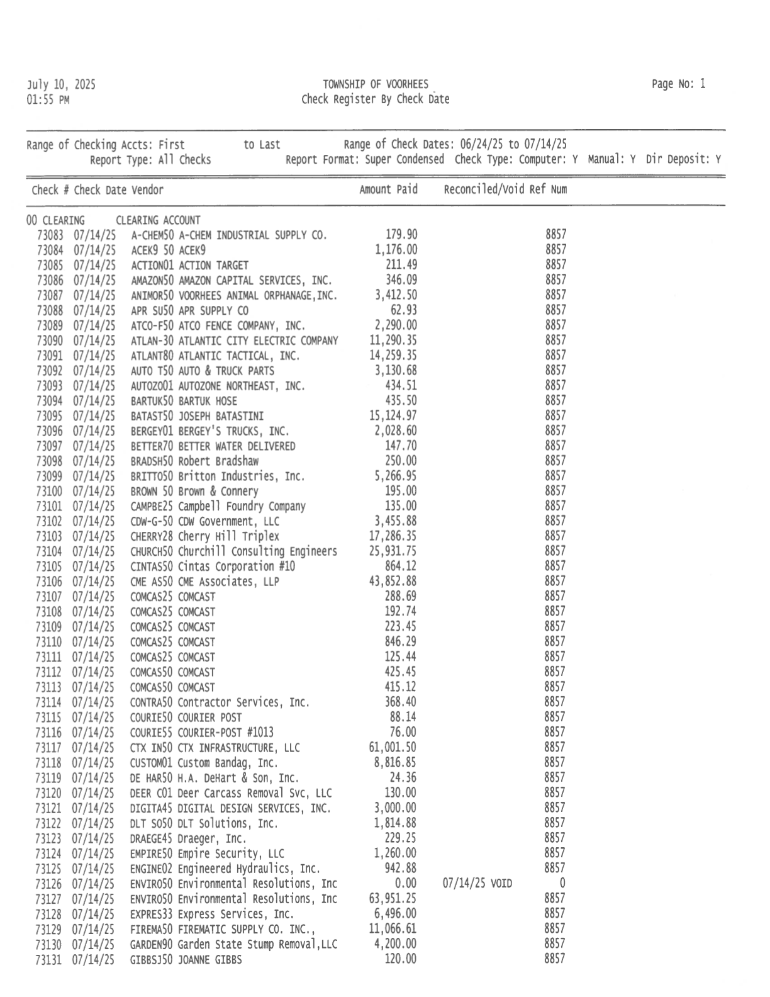
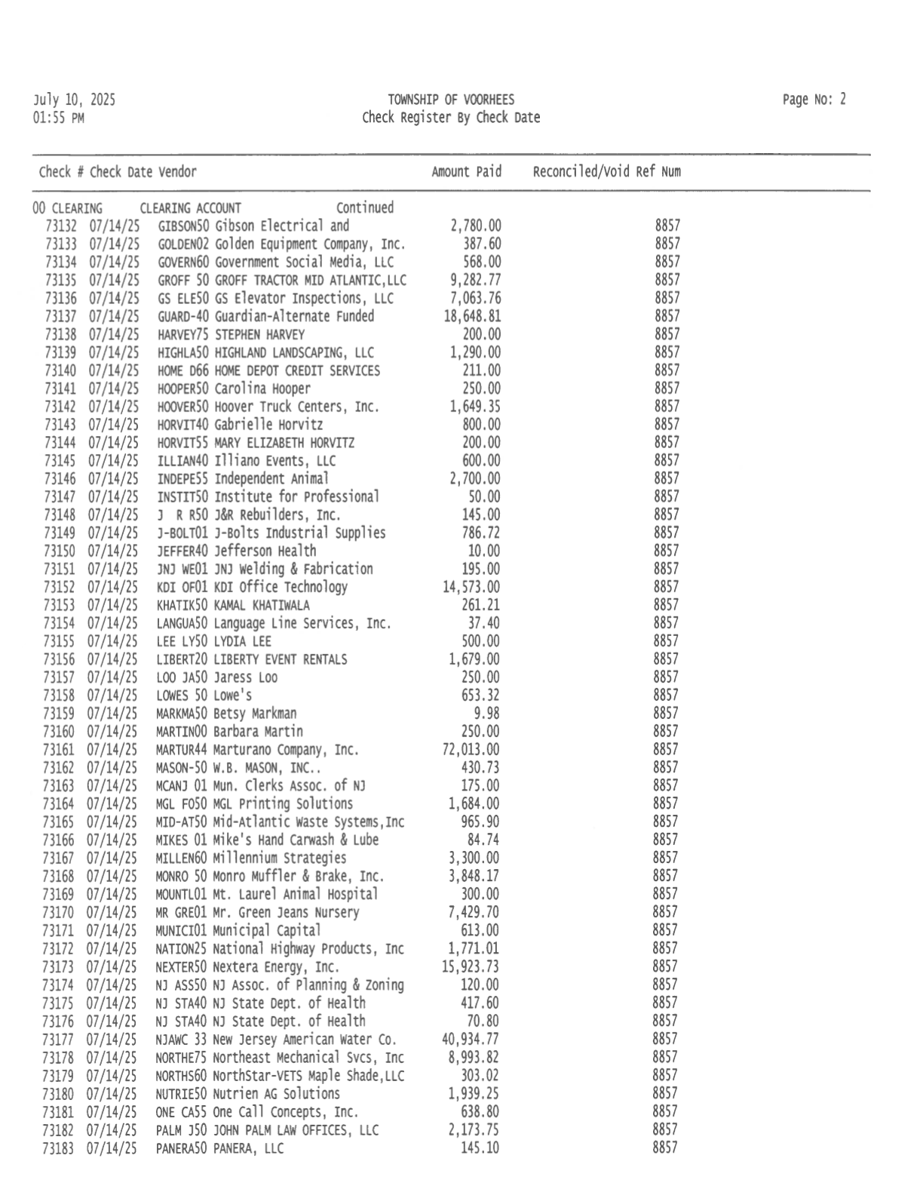
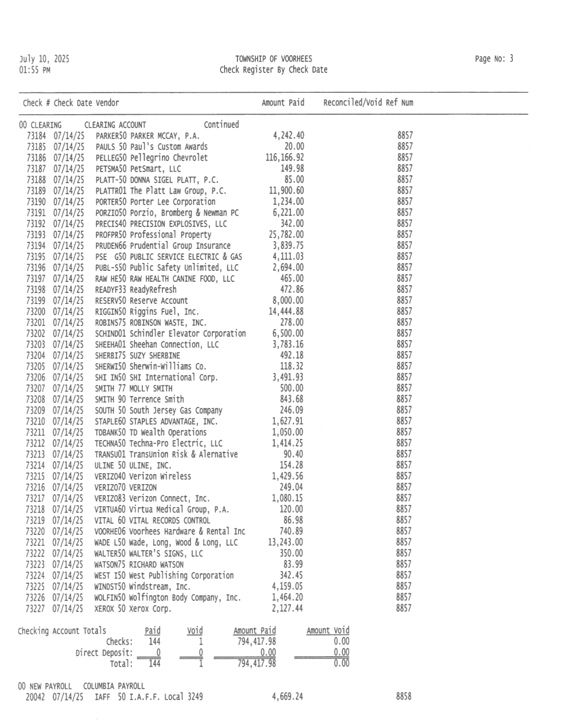
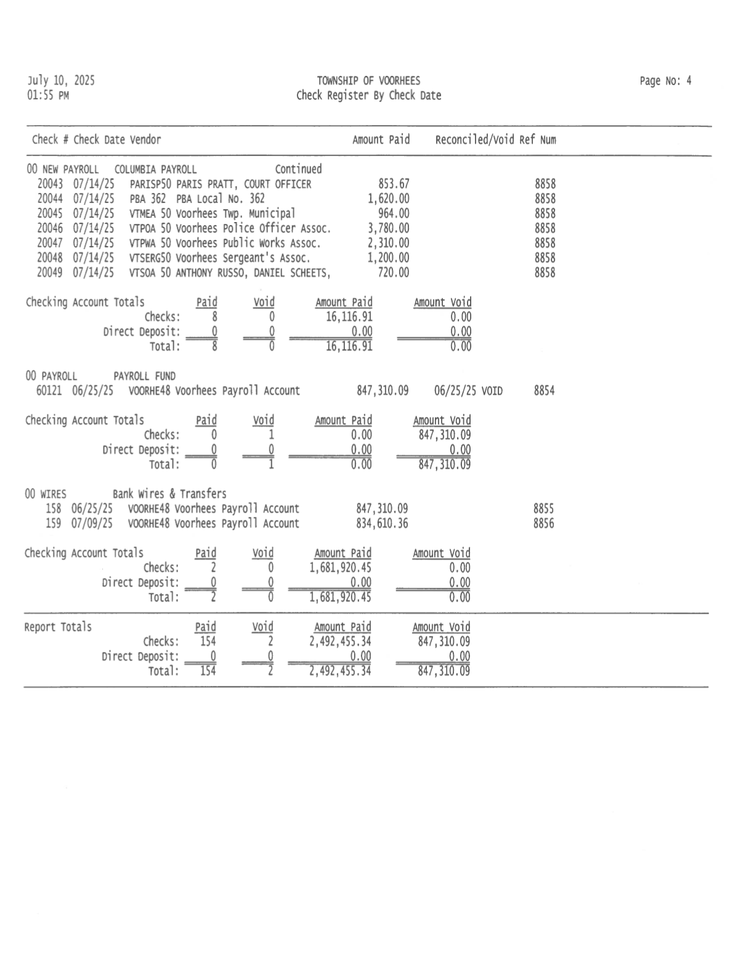
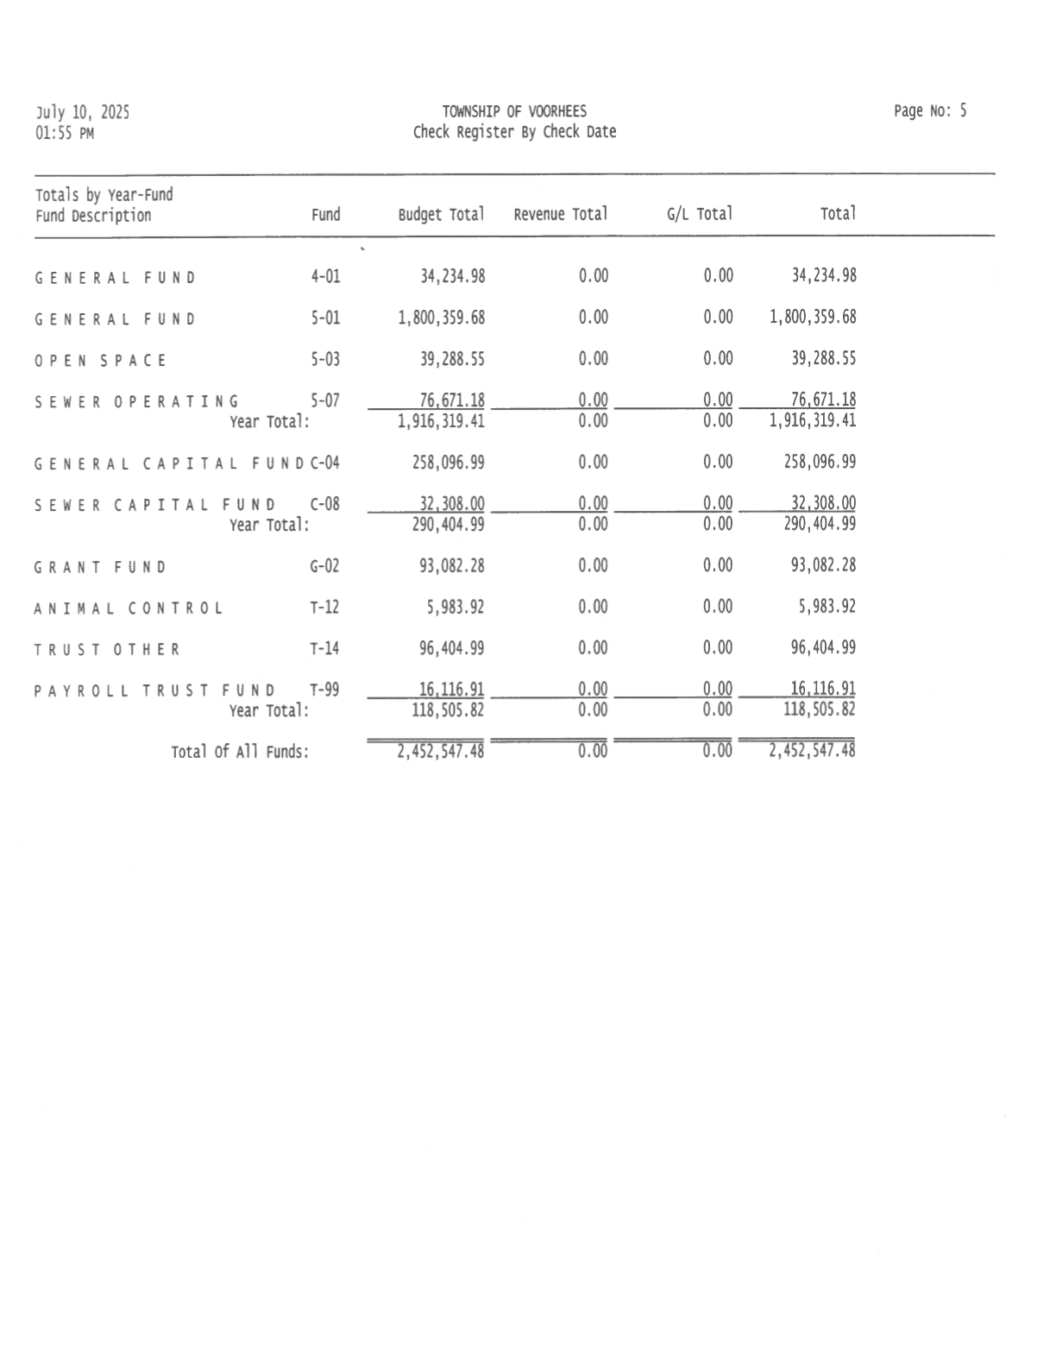
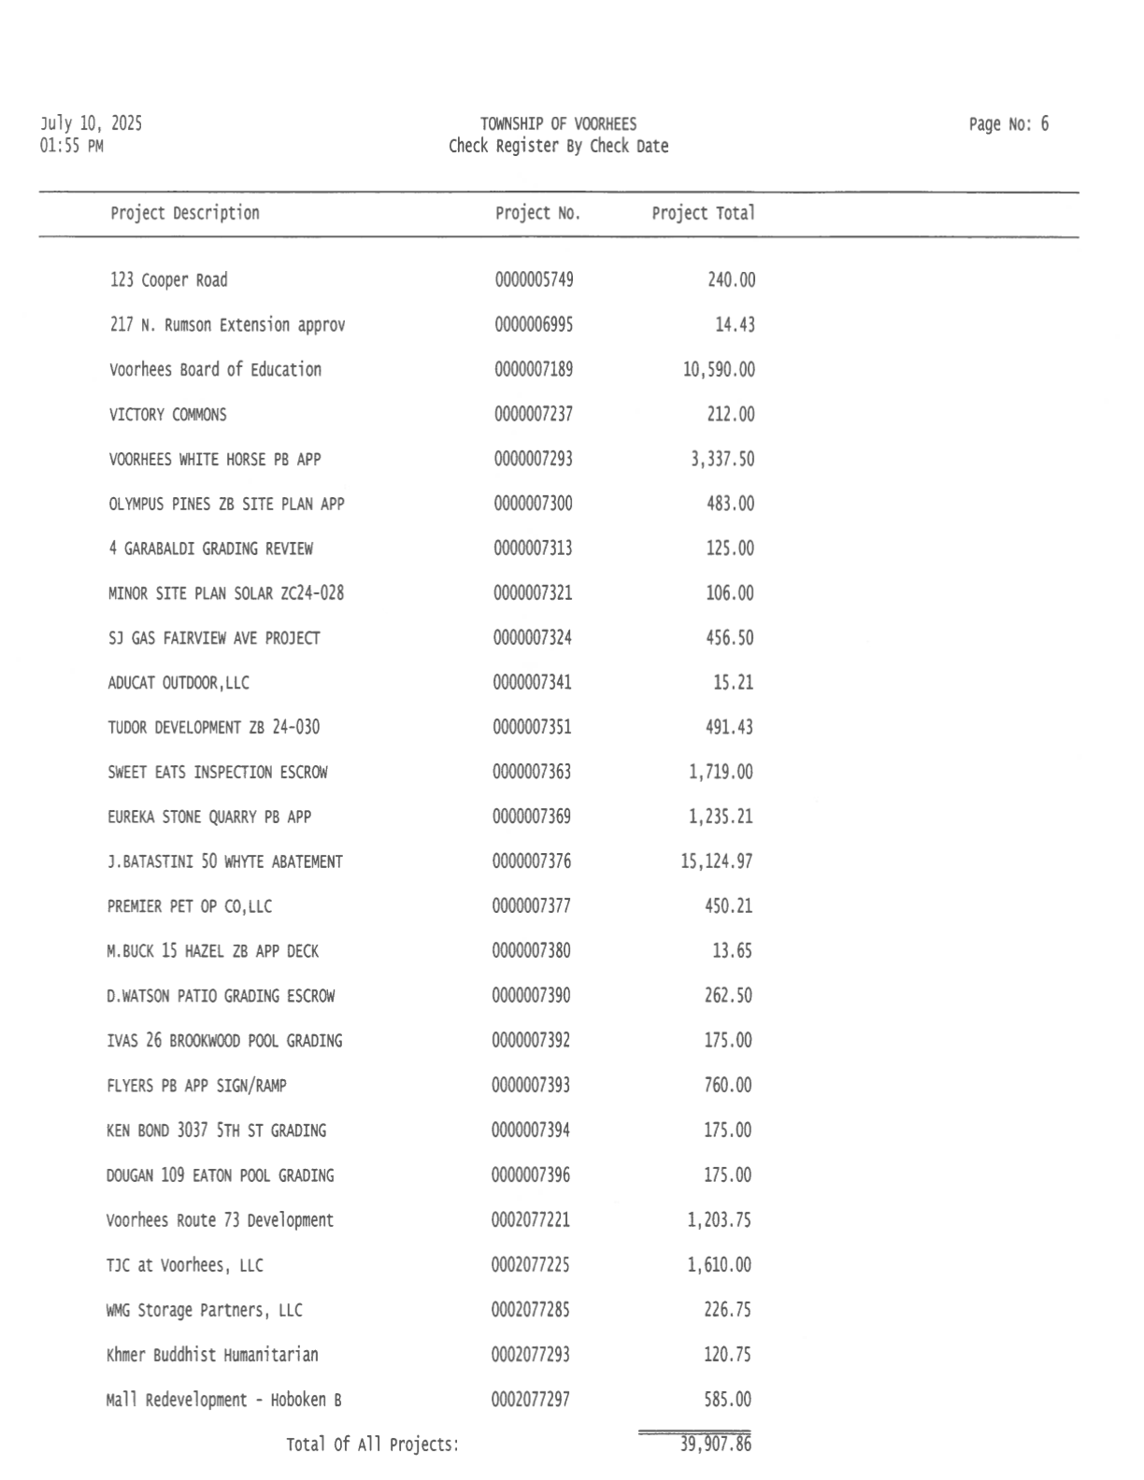

Proclamation
WHEREAS, the Voorhees Township Police Department proudly recognizes the loyal and dedicated service of K-9 Brutus, who has served with honor, courage, and unwavering commitment for seven and a half years; and
WHEREAS, K-9 Brutus faithfully served alongside his handler, Sergeant Tom Bordi, as a valued member of the Voorhees Township Police Department's K-9 Unit; and
WHEREAS, K-9 officers like Brutus are a vital part of modern law enforcement, providing capabilities unmatched by human officers alone — their keen senses, courage under pressure, and ability to de-escalate dangerous situations make them indispensable assets in protecting both the public and their fellow officers; and
WHEREAS, the partnership between K-9 Brutus and Sergeant Bordi exemplified the highest standards of law enforcement teamwork, dedication, and mutual trust; and
WHEREAS, K-9 Brutus's skill, bravery, and loyalty brought distinction not only to himself and Sergeant Bordi but to the entire department and the community they served; and
WHEREAS, as he concludes his years of active duty, K-9 Brutus now begins a well-earned and peaceful retirement.
NOW, THEREFORE, BE IT PROCLAIMED that the Voorhees Township Police Department, along with the Mayor, Township Committee, and the citizens of Voorhees, hereby extend their deepest gratitude to K-9 Brutus for his loyal service and wish him health, happiness, and relaxation in retirement.

_________________________________
Michael R. Mignogna, Mayor
July 14, 2025

