VOORHEES TOWNSHIP COMMITTEE
MINUTES FOR THE MEETING OF JUNE 9, 2025
REGULAR MEETING 7:00 PM

FLAG SALUTE

PRESENT
Committeewoman Fetbroyt - Present
Committeeman Platt - Absent
Deputy Mayor Ravitz – Present- By Phone
Deputy Mayor Nocito – Present- By Phone
Mayor Mignogna

ALSO PRESENT
Stephen Steglik, Township Administrator; Christopher Long, Township Solicitor

SUNSHINE STATEMENT
In compliance with the “Open Public Meetings Act”, notice of this meeting has been published as required in the Courier Post and the Inquirer Newspapers, and notice has been posted on the bulletin board outside of the Township Clerk’s office and on the Township website.

SECOND READING ON ORDINANCE NO. 9-25
BOND ORDINANCE AUTHORIZING THE COMPLETION OF VARIOUS IMPROVEMENTS TO TOWNSHIP BUILDINGS AND GROUNDS; APPROPRIATING THE SUM OF $250,000 THEREFOR; AUTHORIZING THE ISSUANCE OF GENERAL OBLIGATION BONDS OR BOND ANTICIPATION NOTES OF THE TOWNSHIP OF VOORHEES, COUNTY OF CAMDEN, NEW JERSEY, IN THE AGGREGATE PRINCIPAL AMOUNT OF UP TO $237,500 MAKING CERTAIN DETERMINATIONS AND COVENANTS; AND AUTHORIZING CERTAIN RELATED ACTIONS IN CONNECTION WITH THE FOREGOING

MOTION TO CLOSE
PUBLIC PORTION: MRS. FETBROYT AYES: 4
SECONDED: MR. RAVITZ NAYS: NONE

MOTION TO APPROVE: MRS. FETBROYT
SECONDED: MS. NOCITO

ROLL CALL: MRS. FETBROYT - YES MR. PLATT - ABSENT
MR. RAVITZ - YES MS. NOCITO - YES
MAYOR MIGNOGNA - YES

SECOND READING ON ORDINANCE NO. 10-25
BOND ORDINANCE AUTHORIZING THE COMPLETION OF VARIOUS ROAD AND RELATED IMPROVEMENTS IN AND FOR THE TOWNSHIP OF VOORHEES, COUNTY OF CAMDEN, NEW JERSEY; APPROPRIATING THE SUM OF $3,650,000 THEREFOR; AUTHORIZING THE ISSUANCE OF GENERAL OBLIGATION BONDS OR BOND ANTICIPATION NOTES OF THE TOWNSHIP OF VOORHEES, COUNTY OF CAMDEN, NEW JERSEY, IN THE AGGREGATE PRINCIPAL AMOUNT OF UP TO $3,467,500 MAKING CERTAIN DETERMINATIONS AND COVENANTS; AND AUTHORIZING CERTAIN RELATED ACTIONS IN CONNECTION WITH THE FOREGOING

MOTION TO CLOSE
PUBLIC PORTION: MRS. FETBROYT AYES: 4
SECONDED: MR. RAVITZ NAYS: NONE

MOTION TO APPROVE: MRS. FETBROYT
SECONDED: MR. RAVITZ

ROLL CALL: MRS. FETBROYT - YES MR. PLATT - ABSENT
MR. RAVITZ - YES MS. NOCITO - YES
MAYOR MIGNOGNA - YES

SECOND READING ON ORDINANCE NO. 11-25
BOND ORDINANCE AUTHORIZING VARIOUS IMPROVEMENTS AND ACQUISITION OF VARIOUS EQUIPMENT IN AND FOR THE SEWER UTILITY SYSTEM FOR THE TOWNSHIP OF VOORHEES, COUNTY OF CAMDEN, NEW JERSEY; APPROPRIATING THE SUM OF $1,515,000 THEREFOR; AUTHORIZING THE ISSUANCE OF GENERAL OBLIGATION BONDS OR BOND ANTICIPATION NOTES OF THE TOWNSHIP OF VOORHEES, COUNTY OF CAMDEN, NEW JERSEY, IN THE AGGREGATE PRINCIPAL AMOUNT OF UP TO $1,439,250 MAKING CERTAIN DETERMINATIONS AND COVENANTS; AND AUTHORIZING CERTAIN RELATED ACTIONS IN CONNECTION WITH THE FOREGOING
MOTION TO CLOSE
PUBLIC PORTION: MRS. FETBROYT
SECONDED: MR. RAVITZ

MOTION TO APPROVE: MRS. FETBROYT
SECONDED: MR. RAVITZ

ROLL CALL: MRS. FETBROYT - YES MR. PLATT - ABSENT
MR. RAVITZ -YES MS. NOCITO - YES
MAYOR MIGNOGNA: YES

SECOND READING ON ORDINANCE NO. 12-25
BOND ORDINANCE AUTHORIZING THE ACQUISITION OF VEHICLES AND EQUIPMENT FOR THE TOWNSHIP OF VOORHEES, COUNTY OF CAMDEN, NEW JERSEY; APPROPRIATING THE SUM OF $2,369,500 THEREFOR; AUTHORIZING THE ISSUANCE OF GENERAL OBLIGATION BONDS OR BOND ANTICIPATION NOTES OF THE TOWNSHIP OF VOORHEES, COUNTY OF CAMDEN, NEW JERSEY, IN THE AGGREGATE PRINCIPAL AMOUNT OF UP TO $2,118,823; MAKING CERTAIN DETERMINATIONS AND COVENANTS; AND AUTHORIZING CERTAIN RELATED ACTIONS IN CONNECTION WITH THE FOREGOING

MOTION TO CLOSE
PUBLIC PORTION: MRS. FETBROYT AYES: 4
SECONDED: MS. NOCITO NAYS: NONE

MOTION TO APPROVE: MRS. FETBROYT
SECONDED: MR. RAVITZ

ROLL CALL: MRS. FETBROYT - YES MR. PLATT - ABSENT
MR. RAVITZ - YES MS. NOCITO - YES
MAYOR MIGNOGNA - YES

PUBLIC COMMENT FOR RESOLUTIONS ONLY

MOTION TO CLOSE
PUBLIC PORTION: MRS. FETBROYT AYES: 4
SECONDED: MR. RAVITZ NAYS: NONE

RESOLUTION NO. 186-25 MEMORIALIZING AN EXECUTIVE SESSION FROM THE MEETING OF MAY 27, 2025
MOTION TO APPROVE: MRS. FETBROYT
SECONDED: MR. RAVITZ
AYES: 4
NAYS: NONE

RESOLUTION NO. 187-25 APPROVING THE INSERTION OF AN ITEM OF REVENUE ($81,441.50 CLEAN COMMUNITIES GRANT)
MOTION TO APPROVE: MRS. FETBROYT
SECONDED: MR. RAVITZ
AYES: 4
NAYS: NONE

RESOLUTION NO. 188-25 APPROVING THE INSERTION OF AN ITEM OF REVENUE ($1,100.00 VCDC LOCAL SCHOLARSHIP FUND)
MOTION TO APPROVE: MRS. FETBROYT
SECONDED: MR. RAVITZ
AYES: 4
NAYS: NONE

RESOLUTION NO. 189-25 APPROVING THE INSERTION OF AN ITEM OF REVENUE ($4,599.63 NATIONAL OPIOD SETTLEMENT PROGRAM)
MOTION TO APPROVE: MRS. FETBROYT
SECONDED: MR. RAVITZ
AYES: 4
NAYS: NONE

RESOLUTION NO. 190-25 AUTHORIZING THE SUBMISSION OF APPLICATIONS FOR STATE TRANSPORTATION TRUST FUNDS UNDER THE SAFE ROUTES TO TRANSIT FOR LAUREL OAK ROAD FROM WHITE HORSE ROAD (CR 673) TO HADDONFIELD-BERLIN ROAD (CR 561)
MOTION TO APPROVE: MRS. FETBROYT
SECONDED: MR. RAVITZ
AYES: 4
NAYS: NONE

RESOLUTION NO. 191-25 AUTHORIZING THE SUBMISSION OF A GRANT APPLICATION AND EXECUTE A GRANT AGREEMENT WITH THE NEW JERSEY DEPARTMENT OF TRANSPORTATION FOR THE LUCAS LANE ROADWAY IMPROVEMENTS
MOTION TO APPROVE: MRS. FETBROYT
SECONDED: MR. RAVITZ
AYES: 4
NAYS: NONE

RESOLUTION NO. 192-25 AUTHORIZING THE SUBMISSION OF APPLICATIONS FOR STATE TRANSPORTATION TRUST FUNDS UNDER THE LOCAL BIKEWAY PROGRAM FOR THE EXTENSION OF THE VOORHEES TOWNSHIP BICYCLE NETWORK ALONG NEW JERSEY STATE HIGHWAY ROUTE 73 SOUTHBOUND
MOTION TO APPROVE: MRS. FETBROYT
SECONDED: MR. RAVITZ
AYES: 4
NAYS: NONE

RESOLUTION NO. 193-25 AUTHORIZING THE AMENDMENT OF A SHARED SERVICES AGREEMENT BETWEEN VOORHEES TOWNSHIP AND VOORHEES TOWNSHIP PUBLIC SCHOOLS FOR SCHOOL SECURITY SERVICES
MOTION TO APPROVE: MRS. FETBROYT
SECONDED: MR. RAVITZ
AYES: 4
NAYS: NONE

RESOLUTION NO. 194-25 APPROVING THE RENEWAL OF LIQUOR LICENSES FOR THE 2025-2026 LICENSING YEAR
MOTION TO APPROVE: MRS. FETBROYT
SECONDED: MR. RAVITZ
AYES: 4
NAYS: NONE

RESOLUTION NO. 195-25 APPROVING THE HIRING OF JUSTYNA ZIEBA AS A POLICE OFFICER IN THE VOORHEES TOWNSHIP POLICE DEPARTMENT
MOTION TO APPROVE: MRS. FETBROYT
SECONDED: MR. RAVITZ
AYES: 4
NAYS: NONE

RESOLUTION NO. 196-25 APPROVING THE HIRING OF JACOB BRENNAN AS A POLICE OFFICER IN THE VOORHEES TOWNSHIP POLICE DEPARTMENT
MOTION TO APPROVE: MRS. FETBROYT
SECONDED: MR. RAVITZ
AYES: 4
NAYS: NONE

RESOLUTION NO. 197-25 APPROVING THE HIRING OF MATTHEW KACZOROWSKI AS A POLICE OFFICER IN THE VOORHEES TOWNSHIP POLICE DEPARTMENT
MOTION TO APPROVE: MRS. FETBROYT
SECONDED: MR. RAVITZ
AYES: 4
NAYS: NONE

RESOLUTION NO. 198-25 APPROVING THE HIRING OF GEORGE DUFFIELD, JR. AS A POLICE OFFICER IN THE VOORHEES TOWNSHIP POLICE DEPARTMENT
MOTION TO APPROVE: MRS. FETBROYT
SECONDED: MR. RAVITZ
AYES: 4
NAYS: NONE

RESOLUTION NO. 199-25 APPROVING THE HIRING OF ZURIEL POLANCO AS A PART-TIME EMERGENCY MEDICAL TECHNICIAN IN THE VOORHEES TOWNSHIP FIRE DEPARTMENT
MOTION TO APPROVE: MRS. FETBROYT
SECONDED: MR. RAVITZ
AYES: 4
NAYS: NONE

RESOLUTION NO. 200-25 CONFIRMING THE SEPARATION OF PAMELA COOPER FROM THE VOORHEES TOWNSHIP DEPARTMENT OF VITAL STATISTICS
MOTION TO APPROVE: MRS. FETBROYT
SECONDED: MR. RAVITZ
AYES: 4
NAYS: NONE

RESOLUTION NO. 201-25 AUTHORIZING THE REAPPOINTMENT OF SPECIAL OFFICERS IN THE VOORHEES POLICE DEPARTMENT
MOTION TO APPROVE: MRS. FETBROYT
SECONDED: MR. RAVITZ
AYES: 4
NAYS: NONE

RESOLUTION NO. 202-25 APPOINTING CONDITIONAL REDEVELOPER AND AUTHORIZING AND APPROVING A REDEVELOPMENT AGREEMENT BETWEEN THE TOWNSHIP OF VOORHEES (“TOWNSHIP”) AND NJ HOME BUILDERS AND DEVELOPERS, LLC (“CONDITIONAL REDEVELOPER”)
MOTION TO TABLE: MAYOR MIGNOGNA
SECONDED: MRS. FETBROYT
AYES: 4
NAYS: NONE

APPROVAL OF MINUTES OF MAY 27, 2025

MOTION TO APPROVE: MRS. FETBROYT AYES: 3
SECONDED: MR.RAVITZ NAYS: NONE
ABSTAIN: MS. NOCITO

TAX COLLECTOR’S REPORT FOR MAY 2025
TREASURER’S REPORT FOR MAY 2025
APPROVAL OF BILLS FOR JUNE 9, 2025

MOTION TO APPROVE: MRS. FETBROYT AYES: 4
SECONDED: MR. RAVITZ NAYS: NONE

COMMENTS FROM COMMITTEE
Mayor Mignogna reminded the public of the VCDC Freedom Day Celebration will be held on June 21st at Connolly Park from 1:00pm – 4:00pm. There will be music, performances, food trucks and arts and crafts. Mayor Mignogna stated that the first concern in the Summer Concert Series will be held on June 26th with a performance by the FM Band, featuring songs from various musical genres. The concert starts at 7:30pm. Mayor Mignogna wished Mr. Platt, Mr. Ravitz and all the dads in the community a Happy Father’s Day.

Mrs. Fetbroyt invited the community to attend the Voorhees Arts Commission’s Art in the Park event on June 28th from 10:00am – 1:00pm at Connoly Park.

COMMENTS FROM THE PUBLIC
Jeff Craighead – MS Society City to Shore
627 Cheswick Road
Philadelphia

Mr. Craighead once again thanked Voorhees Township for their continued support of the annual City to Shore Bike Ride through Voorhees Township. He thanked the police and fire departments for their assistance as well as all in the community who are affected by the ride.

He spoke about the effects MS has on the body and added that the continued efforts of the MS Society’s fundraising is helping to create breakthroughs in treatment.

He presented Township Committee with a plaque in appreciation of the continued support. He advised that the 2025 ride will take place on September 27th & 28th.

Mayor Mignogna thanked Mr. Craighead and added that it is always a great effect that we as a community look forward to supporting.

PROCLAMATION – RECOGNIZING JUNE AS PRIDE MONTH – read by Mayor Mignogna

MOTION TO CLOSE PUBLIC PORTION
AND ADJOURN: MRS. FETBROYT AYES: 4
SECONDED: MAYOR MIGNOGNA NAYS: NONE

ORDINANCE NO. 9-2025

BOND ORDINANCE AUTHORIZING THE COMPLETION OF VARIOUS IMPROVEMENTS TO TOWNSHIP BUILDINGS AND GROUNDS; APPROPRIATING THE SUM OF $250,000 THEREFOR; AUTHORIZING THE ISSUANCE OF GENERAL OBLIGATION BONDS OR BOND ANTICIPATION NOTES OF THE TOWNSHIP OF VOORHEES, COUNTY OF CAMDEN, NEW JERSEY, IN THE AGGREGATE PRINCIPAL AMOUNT OF UP TO $237,500 MAKING CERTAIN DETERMINATIONS AND COVENANTS; AND AUTHORIZING CERTAIN RELATED ACTIONS IN CONNECTION WITH THE FOREGOING

BE IT ORDAINED by the Township Committee of the Township of Voorhees, County of Camden, New Jersey (not less than two-thirds of all the members thereof affirmatively concurring), pursuant to the provisions of the Local Bond Law, Chapter 169 of the Laws of 1960 of the State of New Jersey, as amended and supplemented ("Local Bond Law"), as follows:

Section 1. The purposes described in Section 7 hereof are hereby authorized as general improvements to be made or acquired by the Township of Voorhees, County of Camden, New Jersey ("Township").

Section 2. It is hereby found, determined and declared as follows:

(a) the estimated amount to be raised by the Township from all sources for the purposes stated in Section 7 hereof is $250,000; and

(b) the estimated amount of bonds or bond anticipation notes to be issued for the purposes stated in Section 7 hereof is $237,500; and

(c) a down payment in the amount of $12,500 for the purposes stated in Section 7 hereof is currently available in accordance with the requirements of Section 11 of the Local Bond Law, N.J.S.A. 40A:2-11.

Section 3. The sum of $237,500, to be raised by the issuance of bonds or bond anticipation notes, together with the sum of $12,500, which amount represents the required down payment, is hereby appropriated for the purposes stated in this bond ordinance ("Bond Ordinance").

Section 4. The issuance of negotiable bonds of the Township in an amount not to exceed $237,500 to finance the costs of the purposes described in Section 7 hereof is hereby authorized. Said bonds shall be sold in accordance with the requirements of the Local Bond Law.

Section 5. In order to temporarily finance the purposes described in Section 7 hereof, the issuance of bond anticipation notes of the Township in an amount not to exceed $237,500 is hereby authorized. Pursuant to the Local Bond Law, the Chief Financial Officer is hereby authorized to sell part or all of the bond anticipation notes from time to time at public or private sale and to deliver the same to the purchasers thereof upon receipt of payment of the purchase price plus accrued interest from their date to delivery thereof. The Chief Financial Officer is hereby directed to report in writing to the governing body at the meeting next succeeding the date when any sale or delivery of the bond anticipation notes pursuant to this Bond Ordinance is made. Such report must include the amount, the description, the interest rate and the maturity schedule of the bond anticipation notes sold, the price obtained and the name of the purchaser.

Section 6. The amount of the proceeds of the obligations authorized by this Bond Ordinance which may be used for the payment of interest on such obligations, accounting, engineering, legal fees and other items as provided in Section 20 of the Local Bond Law, N.J.S.A. 40A:2-20, shall not exceed the sum of $50,000.

Section 7. The improvements hereby authorized and the purposes for which said obligations are to be issued; the estimated costs of each said purpose; the amount of down payment for each said purpose; the maximum amount obligations to be issued for each said purpose and the period of usefulness of each said purpose within the limitations of the Local Bond Law are as follows:

 | Purpose/Improvement | Estimated  Total Cost | Down  Payment | Amount of  Obligations | Period of  Usefulness
A. | Various Traffic Signal Repairs throughout the Township including, but not limited to, the Cooper Road and Centennial Boulevard Intersection, together with the acquisition of all materials and equipment and completion of all work necessary therefor or related thereto. | $250,000 | $12,500 | $237,500 | 15 years

Section 8. The average period of useful life of the several purposes for the financing of which this Bond Ordinance authorizes the issuance of bonds or bond anticipation notes, taking into consideration the respective amounts of bonds or bond anticipation notes authorized for said several purposes, is not less than 15.00 years.

Section 9. Grants or other monies received from any governmental entity, if any, will be applied to the payment of, or repayment of obligations issued to finance, the costs of the purposes described in Section 7 above.

Section 10. The supplemental debt statement provided for in Section 10 of the Local Bond Law, N.J.S.A. 40A:2-10, was duly filed in the office of the Clerk prior to the passage of this Bond Ordinance on first reading and a complete executed duplicate original thereof has been filed in the Office of the Director of the Division of Local Government Services in the Department of Community Affairs of the State of New Jersey. The supplemental debt statement shows that the gross debt of the Township, as defined in Section 43 of the Local Bond Law, N.J.S.A. 40A:2-43, is increased by this Bond Ordinance by $237,500 and that the obligations authorized by this Bond Ordinance will be within all debt limitations prescribed by said Local Bond Law.

Section 11. The full faith and credit of the Township are irrevocably pledged to the punctual payment of the principal of and interest on the bonds or bond anticipation notes authorized by this Bond Ordinance, and to the extent payment is not otherwise provided, the Township shall levy ad valorem taxes on all taxable real property without limitation as to rate or amount for the payment thereof.

Section 12. The applicable Capital Budget of the Township is hereby amended to conform with the provisions of this Bond Ordinance to the extent of any inconsistency therewith, and the resolution promulgated by the Local Finance Board showing full detail of the amended applicable Capital Budget and Capital Program as approved by the Director of the Division of Local Government Services, is on file with the Clerk and available for inspection.

Section 13. The Township hereby declares its intent to reimburse itself from the proceeds of the bonds or bond anticipation notes authorized by this Bond Ordinance pursuant to Income Tax Regulation Section 1.150-2(e), promulgated under the Internal Revenue Code of 1986, as amended ("Code"), for "original expenditures", as defined in Income Tax Regulation Section 1.150-2(c)(2), made by the Township prior to the issuance of such bonds or bond anticipation notes.

Section 14. The Township hereby covenants as follows:

(a) it shall take all actions necessary to ensure that the interest paid on the bonds or bond anticipation notes authorized by the Bond Ordinance is exempt from the gross income of the owners thereof for federal income taxation purposes, and will not become a specific item of tax preference pursuant to Section 57(a)(5) of the Code; and

(b) it will not make any use of the proceeds of the bonds or bond anticipation notes or do or suffer any other action that would cause the bonds or bond anticipation notes to be "arbitrage bonds" as such term is defined in Section 148(a) of the Code and the Regulations promulgated thereunder; and

(c) it shall calculate or cause to be calculated and pay, when due, the rebatable arbitrage with respect to the "gross proceeds" (as such term is used in Section 148(f) of the Code) of the bonds or bond anticipation notes; and

(d) it shall timely file with the Internal Revenue Service, such information report or reports as may be required by Sections 148(f) and 149(e) of the Code; and

(e) it shall take no action that would cause the bonds or bond anticipation notes to be "federally guaranteed" within the meaning of Section 149(b) of the Code.

Section 15. The improvements authorized hereby are not current expenses and are improvements that the Township may lawfully make. No part of the cost of the improvements authorized hereby has been or shall be specially assessed on any property specially benefited thereby.

Section 16. All ordinances, or parts of ordinances, inconsistent herewith are hereby repealed to the extent of such inconsistency.

Section 17. In accordance with the Local Bond Law, this Bond Ordinance shall take effect twenty (20) days after the first publication thereof after final passage.

ATTEST: TOWNSHIP OF VOORHEES:

_______________________ _________________________________
Dee Ober, RMC Michael Mignogna, Mayor

I, Dee Ober, Clerk of the Township of Voorhees, hereby certify the foregoing to be a true and correct copy of an Ordinance adopted by the Mayor and Township Committee at their meeting of June 9, 2025 held in the Voorhees Township Municipal Building, 2400 Voorhees Town Center, Voorhees, NJ 08043.

Introduced: May 12, 2025
Adopted: June 9, 2025

ORDINANCE NO. 10-2025

BOND ORDINANCE AUTHORIZING THE COMPLETION OF VARIOUS ROAD AND RELATED IMPROVEMENTS IN AND FOR THE TOWNSHIP OF VOORHEES, COUNTY OF CAMDEN, NEW JERSEY; APPROPRIATING THE SUM OF $3,650,000 THEREFOR; AUTHORIZING THE ISSUANCE OF GENERAL OBLIGATION BONDS OR BOND ANTICIPATION NOTES OF THE TOWNSHIP OF VOORHEES, COUNTY OF CAMDEN, NEW JERSEY, IN THE AGGREGATE PRINCIPAL AMOUNT OF UP TO $3,467,500 MAKING CERTAIN DETERMINATIONS AND COVENANTS; AND AUTHORIZING CERTAIN RELATED ACTIONS IN CONNECTION WITH THE FOREGOING

BE IT ORDAINED by the Township Committee of the Township of Voorhees, County of Camden, New Jersey (not less than two-thirds of all the members thereof affirmatively concurring), pursuant to the provisions of the Local Bond Law, Chapter 169 of the Laws of 1960 of the State of New Jersey, as amended and supplemented ("Local Bond Law"), as follows:

Section 1. The purposes described in Section 7 hereof are hereby authorized as general improvements to be made or acquired by the Township of Voorhees, County of Camden, New Jersey ("Township").

Section 2. It is hereby found, determined and declared as follows:

(a) the estimated amount to be raised by the Township from all sources for the purposes stated in Section 7 hereof is $3,650,000; and

(b) the estimated amount of bonds or bond anticipation notes to be issued for the purposes stated in Section 7 hereof is $3,467,500; and

(c) a down payment in the amount of $182,500 for the purposes stated in Section 7 hereof is currently available in accordance with the requirements of Section 11 of the Local Bond Law, N.J.S.A. 40A:2-11.

Section 3. The sum of $3,467,500, to be raised by the issuance of bonds or bond anticipation notes, together with the sum of $182,500, which amount represents the required down payment, is hereby appropriated for the purposes stated in this bond ordinance ("Bond Ordinance").

Section 4. The issuance of negotiable bonds of the Township in an amount not to exceed $3,467,500 to finance the costs of the purposes described in Section 7 hereof is hereby authorized. Said bonds shall be sold in accordance with the requirements of the Local Bond Law.

Section 5. In order to temporarily finance the purposes described in Section 7 hereof, the issuance of bond anticipation notes of the Township in an amount not to exceed $3,467,500 is hereby authorized. Pursuant to the Local Bond Law, the Chief Financial Officer is hereby authorized to sell part or all of the bond anticipation notes from time to time at public or private sale and to deliver the same to the purchasers thereof upon receipt of payment of the purchase price plus accrued interest from their date to delivery thereof. The Chief Financial Officer is hereby directed to report in writing to the governing body at the meeting next succeeding the date when any sale or delivery of the bond anticipation notes pursuant to this Bond Ordinance is made. Such report must include the amount, the description, the interest rate and the maturity schedule of the bond anticipation notes sold, the price obtained and the name of the purchaser.

Section 6. The amount of the proceeds of the obligations authorized by this Bond Ordinance which may be used for the payment of interest on such obligations, accounting, engineering, legal fees and other items as provided in Section 20 of the Local Bond Law, N.J.S.A. 40A:2-20, shall not exceed the sum of $50,000.

Section 7. The improvements hereby authorized and the purposes for which said obligations are to be issued; the estimated costs of each said purpose; the amount of down payment for each said purpose; the maximum amount obligations to be issued for each said purpose and the period of usefulness of each said purpose within the limitations of the Local Bond Law are as follows:

 | Purpose/Improvement | Estimated Total Cost | Down  Payment | Amount of  Obligations | Period of  Usefulness
A. | Milling and Resurfacing of Various Roads in the Township and Parking Lot Installation at Connolly Park with ADA Compliant Access, together with the acquisition of all materials and equipment and completion of all work necessary therefor or related thereto | $3,550,000 | $177,500 | $3,372,500 | 10 years
B. | Reconstruction and Restoration of Various Roads in the Township, together with the acquisition of all materials and equipment and completion of all work necessary therefor or related thereto | 100,000 | 5,000 | 95,000 | 10 years
 | Total | $3,650,000 | $182,500 | $3,467,500

Section 8. The average period of useful life of the several purposes for the financing of which this Bond Ordinance authorizes the issuance of bonds or bond anticipation notes, taking into consideration the respective amounts of bonds or bond anticipation notes authorized for said several purposes, is not less than 10.00 years.

Section 9. Grants or other monies received from any governmental entity, if any, will be applied to the payment of, or repayment of obligations issued to finance, the costs of the purposes described in Section 7 above.

Section 10. The supplemental debt statement provided for in Section 10 of the Local Bond Law, N.J.S.A. 40A:2-10, was duly filed in the office of the Clerk prior to the passage of this Bond Ordinance on first reading and a complete executed duplicate original thereof has been filed in the Office of the Director of the Division of Local Government Services in the Department of Community Affairs of the State of New Jersey. The supplemental debt statement shows that the gross debt of the Township, as defined in Section 43 of the Local Bond Law, N.J.S.A. 40A:2-43, is increased by this Bond Ordinance by $3,467,500 and that the obligations authorized by this Bond Ordinance will be within all debt limitations prescribed by said Local Bond Law.

Section 11. The full faith and credit of the Township are irrevocably pledged to the punctual payment of the principal of and interest on the bonds or bond anticipation notes authorized by this Bond Ordinance, and to the extent payment is not otherwise provided, the Township shall levy ad valorem taxes on all taxable real property without limitation as to rate or amount for the payment thereof.

Section 12. The applicable Capital Budget of the Township is hereby amended to conform with the provisions of this Bond Ordinance to the extent of any inconsistency therewith, and the resolution promulgated by the Local Finance Board showing full detail of the amended applicable Capital Budget and Capital Program as approved by the Director of the Division of Local Government Services, is on file with the Clerk and available for inspection.

Section 13. The Township hereby declares its intent to reimburse itself from the proceeds of the bonds or bond anticipation notes authorized by this Bond Ordinance pursuant to Income Tax Regulation Section 1.150-2(e), promulgated under the Internal Revenue Code of 1986, as amended ("Code"), for "original expenditures", as defined in Income Tax Regulation Section 1.150-2(c)(2), made by the Township prior to the issuance of such bonds or bond anticipation notes.

Section 14. The Township hereby covenants as follows:

(a) it shall take all actions necessary to ensure that the interest paid on the bonds or bond anticipation notes authorized by the Bond Ordinance is exempt from the gross income of the owners thereof for federal income taxation purposes, and will not become a specific item of tax preference pursuant to Section 57(a)(5) of the Code; and

(b) it will not make any use of the proceeds of the bonds or bond anticipation notes or do or suffer any other action that would cause the bonds or bond anticipation notes to be "arbitrage bonds" as such term is defined in Section 148(a) of the Code and the Regulations promulgated thereunder; and

(c) it shall calculate or cause to be calculated and pay, when due, the rebatable arbitrage with respect to the "gross proceeds" (as such term is used in Section 148(f) of the Code) of the bonds or bond anticipation notes; and

(d) it shall timely file with the Internal Revenue Service, such information report or reports as may be required by Sections 148(f) and 149(e) of the Code; and

(e) it shall take no action that would cause the bonds or bond anticipation notes to be "federally guaranteed" within the meaning of Section 149(b) of the Code.

Section 15. The improvements authorized hereby are not current expenses and are improvements that the Township may lawfully make. No part of the cost of the improvements authorized hereby has been or shall be specially assessed on any property specially benefited thereby.

Section 16. All ordinances, or parts of ordinances, inconsistent herewith are hereby repealed to the extent of such inconsistency.

Section 17. In accordance with the Local Bond Law, this Bond Ordinance shall take effect twenty (20) days after the first publication thereof after final passage.

ATTEST: TOWNSHIP OF VOORHEES:

_______________________ _________________________________
Dee Ober, RMC Michael Mignogna, Mayor

I, Dee Ober, Clerk of the Township of Voorhees, hereby certify the foregoing to be a true and correct copy of an Ordinance adopted by the Mayor and Township Committee at their meeting of June 9, 2025 held in the Voorhees Township Municipal Building, 2400 Voorhees Town Center, Voorhees, NJ 08043.

Introduced: May 12, 2025
Adopted: June 9, 2025

ORDINANCE NO. 11-2025

BOND ORDINANCE AUTHORIZING VARIOUS IMPROVEMENTS AND ACQUISITION OF VARIOUS EQUIPMENT IN AND FOR THE SEWER UTILITY SYSTEM FOR THE TOWNSHIP OF VOORHEES, COUNTY OF CAMDEN, NEW JERSEY; APPROPRIATING THE SUM OF $1,515,000 THEREFOR; AUTHORIZING THE ISSUANCE OF GENERAL OBLIGATION BONDS OR BOND ANTICIPATION NOTES OF THE TOWNSHIP OF VOORHEES, COUNTY OF CAMDEN, NEW JERSEY, IN THE AGGREGATE PRINCIPAL AMOUNT OF UP TO $1,439,250 MAKING CERTAIN DETERMINATIONS AND COVENANTS; AND AUTHORIZING CERTAIN RELATED ACTIONS IN CONNECTION WITH THE FOREGOING

BE IT ORDAINED by the Township Committee of the Township of Voorhees, County of Camden, New Jersey (not less than two-thirds of all the members thereof affirmatively concurring), pursuant to the provisions of the Local Bond Law, Chapter 169 of the Laws of 1960 of the State of New Jersey, as amended and supplemented ("Local Bond Law"), as follows:

Section 1. The purposes described in Section 7 hereof are hereby authorized as general improvements to be made or acquired by the Township of Voorhees, County of Camden, New Jersey ("Township").

Section 2. It is hereby found, determined and declared as follows:

(a) the estimated amount to be raised by the Township from all sources for the purposes stated in Section 7 hereof is $1,515,000; and

(b) the estimated amount of bonds or bond anticipation notes to be issued for the purposes stated in Section 7 hereof is $1,439,250; and

(c) a down payment in the amount of $75,750 for the purposes stated in Section 7 hereof is currently available in accordance with the requirements of Section 11 of the Local Bond Law, N.J.S.A. 40A:2-11.

Section 3. The sum of $1,439,250 to be raised by the issuance of bonds or bond anticipation notes, together with the sum of $75,750, which amount represents the required down payment, are hereby appropriated for the purposes stated in this bond ordinance ("Bond Ordinance").

Section 4. The issuance of negotiable bonds of the Township in an amount not to exceed $1,439,250 to finance the costs of the purposes described in Section 7 hereof is hereby authorized. Said bonds shall be sold in accordance with the requirements of the Local Bond Law.

Section 5. In order to temporarily finance the purposes described in Section 7 hereof, the issuance of bond anticipation notes of the Township in an amount not to exceed $1,439,250 is hereby authorized. Pursuant to the Local Bond Law, the Chief Financial Officer is hereby authorized to sell part or all of the bond anticipation notes from time to time at public or private sale and to deliver the same to the purchasers thereof upon receipt of payment of the purchase price plus accrued interest from their date to delivery thereof. The Chief Financial Officer is hereby directed to report in writing to the governing body at the meeting next succeeding the date when any sale or delivery of the bond anticipation notes pursuant to this Bond Ordinance is made. Such report must include the amount, the description, the interest rate and the maturity schedule of the bond anticipation notes sold, the price obtained and the name of the purchaser.

Section 6. The amount of the proceeds of the obligations authorized by this Bond Ordinance which may be used for the payment of interest on such obligations, accounting, engineering, legal fees and other items as provided in Section 20 of the Local Bond Law, N.J.S.A. 40A:2-20, shall not exceed the sum of $75,000.

Section 7. The improvements hereby authorized and the purposes for which said obligations are to be issued; the estimated costs of each said purpose; the amount of down payment for each said purpose; the maximum amount obligations to be issued for each said purpose and the period of usefulness of each said purpose within the limitations of the Local Bond Law are as follows:

 | Purpose/Improvement | Estimated  Total Cost | Down Payment | Amount of Obligations | Period of  Usefulness
A. | Various Improvements to the Sewer Utility System including, but not limited to, Sewer Force Main Replacements and Cured-In-Place Pipe Lining, together with the acquisition of all materials and equipment and completion of all work necessary therefor or related thereto. | $975,000 | $48,750 | $926,250 | 40 years
B. | Acquisition of Various Equipment including, but not limited to, Motors, Valves, Grinders, and Pumps, together with the acquisition of all materials and equipment and completion of all work necessary therefor or related thereto. | 300,000 | 15,000 | 285,000 | 15 years
C. | Acquisition of Various Vehicles and related equipment including, but not limited to, Mini-Jetter Truck and Sewer Bypass Pump Trailer, together with the acquisition of all materials and equipment and completion of all work necessary therefor or related thereto. | 240,000 | 12,000 | 228,000 | 10 years
 | Total | $1,515,000 | $75,750 | $1,439,250

Section 8. The average period of useful life of the several purposes for the financing of which this Bond Ordinance authorizes the issuance of bonds or bond anticipation notes, taking into consideration the respective amounts of bonds or bond anticipation notes authorized for said several purposes, is not less than 30.29 years.

Section 9. Grants or other monies received from any governmental entity, if any, will be applied to the payment of, or repayment of obligations issued to finance, the costs of the purposes described in Section 7 above.

Section 10. The supplemental debt statement provided for in Section 10 of the Local Bond Law, N.J.S.A. 40A:2-10, was duly filed in the office of the Clerk prior to the passage of this Bond Ordinance on first reading and a complete executed duplicate original thereof has been filed in the Office of the Director of the Division of Local Government Services in the Department of Community Affairs of the State of New Jersey. The supplemental debt statement shows that the gross debt of the Township, as defined in Section 43 of the Local Bond Law, N.J.S.A. 40A:2-43, is increased by this Bond Ordinance by $1,439,250 and that the obligations authorized by this Bond Ordinance will be within all debt limitations prescribed by said Local Bond Law.

Section 11. The full faith and credit of the Township are irrevocably pledged to the punctual payment of the principal of and interest on the bonds or bond anticipation notes authorized by this Bond Ordinance, and to the extent payment is not otherwise provided, the Township shall levy ad valorem taxes on all taxable real property without limitation as to rate or amount for the payment thereof.

Section 12. The applicable Capital Budget of the Township is hereby amended to conform with the provisions of this Bond Ordinance to the extent of any inconsistency therewith, and the resolution promulgated by the Local Finance Board showing full detail of the amended applicable Capital Budget and Capital Program as approved by the Director of the Division of Local Government Services, is on file with the Clerk and available for inspection.

Section 13. The Township hereby declares its intent to reimburse itself from the proceeds of the bonds or bond anticipation notes authorized by this Bond Ordinance pursuant to Income Tax Regulation Section 1.150-2(e), promulgated under the Internal Revenue Code of 1986, as amended ("Code"), for "original expenditures", as defined in Income Tax Regulation Section 1.150-2(c)(2), made by the Township prior to the issuance of such bonds or bond anticipation notes.

Section 14. The Township hereby covenants as follows:

(a) it shall take all actions necessary to ensure that the interest paid on the bonds or bond anticipation notes authorized by the Bond Ordinance is exempt from the gross income of the owners thereof for federal income taxation purposes, and will not become a specific item of tax preference pursuant to Section 57(a)(5) of the Code; and

(b) it will not make any use of the proceeds of the bonds or bond anticipation notes or do or suffer any other action that would cause the bonds or bond anticipation notes to be "arbitrage bonds" as such term is defined in Section 148(a) of the Code and the Regulations promulgated thereunder; and

(c) it shall calculate or cause to be calculated and pay, when due, the rebatable arbitrage with respect to the "gross proceeds" (as such term is used in Section 148(f) of the Code) of the bonds or bond anticipation notes; and

(d) it shall timely file with the Internal Revenue Service, such information report or reports as may be required by Sections 148(f) and 149(e) of the Code; and

(e) it shall take no action that would cause the bonds or bond anticipation notes to be "federally guaranteed" within the meaning of Section 149(b) of the Code.

Section 15. The improvements authorized hereby are not current expenses and are improvements that the Township may lawfully make. No part of the cost of the improvements authorized hereby has been or shall be specially assessed on any property specially benefited thereby.

Section 16. All ordinances, or parts of ordinances, inconsistent herewith are hereby repealed to the extent of such inconsistency.

Section 17. In accordance with the Local Bond Law, this Bond Ordinance shall take effect twenty (20) days after the first publication thereof after final passage.

ATTEST: TOWNSHIP OF VOORHEES:

_______________________ _______________________________
Dee Ober, RMC Michael Mignogna, Mayor

I, Dee Ober, Clerk of the Township of Voorhees, hereby certify the foregoing to be a true and correct copy of an Ordinance adopted by the Mayor and Township Committee at their meeting of June 9, 2025 held in the Voorhees Township Municipal Building, 2400 Voorhees Town Center, Voorhees, NJ 08043.

Introduced: May 12, 2025
Adopted: June 9, 2025

ORDINANCE NO. 12-2025

BOND ORDINANCE AUTHORIZING THE ACQUISITION OF VEHICLES AND EQUIPMENT FOR THE TOWNSHIP OF VOORHEES, COUNTY OF CAMDEN, NEW JERSEY; APPROPRIATING THE SUM OF $2,369,500 THEREFOR; AUTHORIZING THE ISSUANCE OF GENERAL OBLIGATION BONDS OR BOND ANTICIPATION NOTES OF THE TOWNSHIP OF VOORHEES, COUNTY OF CAMDEN, NEW JERSEY, IN THE AGGREGATE PRINCIPAL AMOUNT OF UP TO $2,118,823; MAKING CERTAIN DETERMINATIONS AND COVENANTS; AND AUTHORIZING CERTAIN RELATED ACTIONS IN CONNECTION WITH THE FOREGOING

BE IT ORDAINED by the Township Committee of the Township of Voorhees, County of Camden, New Jersey (not less than two-thirds of all the members thereof affirmatively concurring), pursuant to the provisions of the Local Bond Law, Chapter 169 of the Laws of 1960 of the State of New Jersey, as amended and supplemented ("Local Bond Law"), as follows:

Section 1. The purposes described in Section 7 hereof are hereby authorized as general improvements to be made or acquired by the Township of Voorhees, County of Camden, New Jersey ("Township").

Section 2. It is hereby found, determined and declared as follows:

(a) the estimated amount to be raised by the Township from all sources for the purposes stated in Section 7 hereof is $2,369,500; and

(b) the estimated amount of bonds or bond anticipation notes to be issued for the purposes stated in Section 7 hereof is $2,118,823; and

(c) a down payment in the amount of $111,528 for the purposes stated in Section 7 hereof is currently available in accordance with the requirements of Section 11 of the Local Bond Law, N.J.S.A. 40A:2-11.

Section 3. The sum of $2,118,823, to be raised by the issuance of bonds or bond anticipation notes, together with the sum of $111,528, which amount represents the required down payment, and the sum of $138,449, which amount represents available funds in the capital reserve, are hereby appropriated for the purposes stated in this bond ordinance ("Bond Ordinance").

Section 4. The issuance of negotiable bonds of the Township in an amount not to exceed $2,118,823 to finance the costs of the purposes described in Section 7 hereof is hereby authorized. Said bonds shall be sold in accordance with the requirements of the Local Bond Law.

Section 5. In order to temporarily finance the purposes described in Section 7 hereof, the issuance of bond anticipation notes of the Township in an amount not to exceed $2,118,823 is hereby authorized. Pursuant to the Local Bond Law, the Chief Financial Officer is hereby authorized to sell part or all of the bond anticipation notes from time to time at public or private sale and to deliver the same to the purchasers thereof upon receipt of payment of the purchase price plus accrued interest from their date to delivery thereof. The Chief Financial Officer is hereby directed to report in writing to the governing body at the meeting next succeeding the date when any sale or delivery of the bond anticipation notes pursuant to this Bond Ordinance is made. Such report must include the amount, the description, the interest rate and the maturity schedule of the bond anticipation notes sold, the price obtained and the name of the purchaser.

Section 6. The amount of the proceeds of the obligations authorized by this Bond Ordinance which may be used for the payment of interest on such obligations, accounting, engineering, legal fees and other items as provided in Section 20 of the Local Bond Law, N.J.S.A. 40A:2-20, shall not exceed the sum of $475,000.

Section 7. The improvements hereby authorized and the purposes for which said obligations are to be issued; the estimated costs of each said purpose; the amount of down payment for each said purpose; the maximum amount obligations to be issued for each said purpose and the period of usefulness of each said purpose within the limitations of the Local Bond Law are as follows:

 | Purpose/Improvement | Estimated Total Cost | Grants & Available Funds | Down  Payment | Amount of  Obligations | Period of  Usefulness
A. | Acquisition of Various Vehicles and related equipment for the Fire Department including, but not limited to, an Ambulance, Ambulance Remount, and Pick-Up Truck, together with the acquisition of all materials and equipment and the completion of all work necessary therefor or related thereto. | $239,000 | $0 | $11,950 | $227,050 | 5 years
B. | Acquisition of Various Pieces of Equipment for the Fire Department including, but not limited to, Personal Protection Equipment, Tools, and Portable Radios, together with the acquisition of all materials and equipment and the completion of all work necessary therefor or related thereto. | 334,000 | 0 | 16,700 | 317,300 | 5 years
C. | Acquisition of Various Vehicles and related equipment for the Police Department including, but not limited to, Sport Utility Vehicles and Vehicle Upfits, together with the acquisition of all materials and equipment and the completion of all work necessary therefor or related thereto. | $483,500 | $0 | $24,150 | $458,850 | 5 years
D. | Acquisition of Various Pieces of Equipment for the Police Department including, but not limited to, Radios and Tools, together with the acquisition of all materials and equipment and the completion of all work necessary therefor or related thereto. | 50,000 | 0 | 2,500 | 47,500 | 5 years
E. | Acquisition of Various Vehicles for the Department of Public Works including, but not limited to, Sidearm and Automated Trash Truck, Rear Load Trash Truck, Passenger Bus, and Pickup Truck, together with the acquisition of all materials and equipment and the completion of all work necessary therefor or related thereto. | 940,000 | 138,449 | 40,078 | 761,473 | 10 years
F. | Acquisition of Various Pieces Equipment for the Department of Public Works including, but not limited to, Leaf Vacuum Trailer, together with the acquisition of all materials and equipment and the completion of all work necessary therefor or related thereto. | 148,000 | 0 | 7,400 | 140,400 | 15 years
G. | Acquisition of a Portable Stage Trailer, together with the acquisition of all materials and equipment and the completion of all work necessary therefor or related thereto. | 175,000 | 0 | 8,750 | 166,250 | 10 years
 | Total | $2,369,500 | $138,449 | $111,528 | $2,118,823

Section 8. The average period of useful life of the several purposes for the financing of which this Bond Ordinance authorizes the issuance of bonds or bond anticipation notes, taking into consideration the respective amounts of bonds or bond anticipation notes authorized for said several purposes, is not less than 7.85 years.

Section 9. Grants or other monies received from any governmental entity, if any, will be applied to the payment of, or repayment of obligations issued to finance, the costs of the purposes described in Section 7 above.

Section 10. The supplemental debt statement provided for in Section 10 of the Local Bond Law, N.J.S.A. 40A:2-10, was duly filed in the office of the Clerk prior to the passage of this Bond Ordinance on first reading and a complete executed duplicate original thereof has been filed in the Office of the Director of the Division of Local Government Services in the Department of Community Affairs of the State of New Jersey. The supplemental debt statement shows that the gross debt of the Township, as defined in Section 43 of the Local Bond Law, N.J.S.A. 40A:2-43, is increased by this Bond Ordinance by $2,118,823 and that the obligations authorized by this Bond Ordinance will be within all debt limitations prescribed by said Local Bond Law.

Section 11. The full faith and credit of the Township are irrevocably pledged to the punctual payment of the principal of and interest on the bonds or bond anticipation notes authorized by this Bond Ordinance, and to the extent payment is not otherwise provided, the Township shall levy ad valorem taxes on all taxable real property without limitation as to rate or amount for the payment thereof.

Section 12. The applicable Capital Budget of the Township is hereby amended to conform with the provisions of this Bond Ordinance to the extent of any inconsistency therewith, and the resolution promulgated by the Local Finance Board showing full detail of the amended applicable Capital Budget and Capital Program as approved by the Director of the Division of Local Government Services, is on file with the Clerk and available for inspection.

Section 13. The Township hereby declares its intent to reimburse itself from the proceeds of the bonds or bond anticipation notes authorized by this Bond Ordinance pursuant to Income Tax Regulation Section 1.150-2(e), promulgated under the Internal Revenue Code of 1986, as amended ("Code"), for "original expenditures", as defined in Income Tax Regulation Section 1.150-2(c)(2), made by the Township prior to the issuance of such bonds or bond anticipation notes.

Section 14. The Township hereby covenants as follows:

(a) it shall take all actions necessary to ensure that the interest paid on the bonds or bond anticipation notes authorized by the Bond Ordinance is exempt from the gross income of the owners thereof for federal income taxation purposes, and will not become a specific item of tax preference pursuant to Section 57(a)(5) of the Code; and

(b) it will not make any use of the proceeds of the bonds or bond anticipation notes or do or suffer any other action that would cause the bonds or bond anticipation notes to be "arbitrage bonds" as such term is defined in Section 148(a) of the Code and the Regulations promulgated thereunder; and

(c) it shall calculate or cause to be calculated and pay, when due, the rebatable arbitrage with respect to the "gross proceeds" (as such term is used in Section 148(f) of the Code) of the bonds or bond anticipation notes; and

(d) it shall timely file with the Internal Revenue Service, such information report or reports as may be required by Sections 148(f) and 149(e) of the Code; and

(e) it shall take no action that would cause the bonds or bond anticipation notes to be "federally guaranteed" within the meaning of Section 149(b) of the Code.

Section 15. The improvements authorized hereby are not current expenses and are improvements that the Township may lawfully make. No part of the cost of the improvements authorized hereby has been or shall be specially assessed on any property specially benefited thereby.

Section 16. All ordinances, or parts of ordinances, inconsistent herewith are hereby repealed to the extent of such inconsistency.

Section 17. In accordance with the Local Bond Law, this Bond Ordinance shall take effect twenty (20) days after the first publication thereof after final passage.

ATTEST: TOWNSHIP OF VOORHEES:

_______________________ ________________________________
Dee Ober, RMC Michael Mignogna, Mayor

I, Dee Ober, Clerk of the Township of Voorhees, hereby certify the foregoing to be a true and correct copy of an Ordinance adopted by the Mayor and Township Committee at their meeting of June 9, 2025 held in the Voorhees Township Municipal Building, 2400 Voorhees Town Center, Voorhees, NJ 08043.

Introduced: May 12, 2025
Adopted: June 9, 2025

RESOLUTION NO. 186-25

RESOLUTION MEMORIALIZING THE EXECUTIVE SESSION FROM MAY 27, 2025

WHEREAS, the Open Public Meetings Act (N.J.S.A. 10:4-6 et seq.) requires all meetings of the Township of Voorhees to be held in public, except as set forth in N.J.S.A. 10:4-12(b) which provides for nine (9) types of matters that may lawfully be discussed in “Executive Session,” i.e. without the public being permitted to attend; and
WHEREAS, the Township of Voorhees has determined that certain issues set forth below are permitted by N.J.S.A. 10:4-12(b) to be discussed without the public in attendance were discussed during an Executive Session held on May 27, 2025, at approximately 6:30 p.m.; and
WHEREAS, the nine (9) exceptions to public meetings set forth in N.J.S.A. 10:4-12(b) are listed below, and the items to be privately discussed that fall within such exceptions shall be identified and written, and after each exception is a space where additional information that will disclose as much information about the discussion as possible without undermining the purpose of the exception as follows:

“(1) Any matter which, by express provision of Federal law, State statute or rule of court shall be rendered confidential or excluded from public discussion.” The legal citation to the provision(s) at issue is, and the nature of the matter, described as specifically as possible without undermining the need for confidentiality is:

“(2) Any matter in which the release of information would impair a right to receive funds from the federal government.” The nature of the matter, described as specifically as possible without undermining the need for confidentiality is:

“(3) Any material the disclosure of which constitutes an unwarranted invasion of individual privacy such as any records, data, reports, recommendations, or other personal material of any educational, training, social service, medical, health, custodial, child protection, rehabilitation, legal defense, welfare, housing, relocation, insurance and similar program or institution operated by a public body pertaining to any specific individual admitted to or served by such institution or program, including but not limited to information relative to the individual's personal and family circumstances, and any material pertaining to admission, discharge, treatment, progress or condition of any individual, unless the individual concerned (or, in the case of a minor or incompetent, his guardian) shall request in writing that the same be disclosed publicly.” The nature of the matter, described as specifically as possible without undermining the need for confidentiality is:

“(4) Any collective bargaining agreement, or the terms and conditions of which are proposed for inclusion in any collective bargaining agreement, including the negotiation of terms and conditions with employees or representatives of employees of the public body” The collective bargaining contract(s) discussed are between the public body and the:

“(5) Any matter involving the purchase, lease or acquisition of real property with public funds, the setting of bank rates or investment of public funds where it could adversely affect the public interest if discussion of such matters were disclosed.” The nature of the matter, described as specifically as possible without undermining the need for confidentiality is:

“(6) Any tactics and techniques utilized in protecting the safety and property of the public provided that their disclosure could impair such protection. Any investigations of violations or possible violations of the law.” The nature of the matter, described as specifically as possible without undermining the need for confidentiality is: Securing property at the DPW Storage Facilities

“(7) Any pending or anticipated litigation or contract negotiation in which the public body is or may become a party. Any matters falling within the attorney-client privilege, to the extent that confidentiality is required in order for the attorney to exercise his ethical duties as a lawyer.” The parties to and docket numbers of each item of litigation and/or the parties to each contract discussed: Voorhees Town Center update; COAH update
X

(8) Any matter involving the employment, appointment, termination of employment, terms and conditions of employment, evaluation of the performance, promotion or discipline of any specific prospective public officer or employee or current public officer or employee employed or appointed by the public body, unless all individual employees or appointees whose rights could be adversely affected request in writing that such matter or matters be discussed at a public meeting.” The employee(s) and/or title(s) and nature of the discussion, described as specifically as possible without undermining the need for confidentiality are:

“(9) Any deliberation of a public body occurring after a public hearing that may result in the imposition of a specific civil penalty upon the responding party or the suspension or loss of a license or permit belonging to the responding party as a result of an act of omission for which the responding party bears responsibility.” The nature of the matter, described as specifically as possible without undermining the need for confidentiality is:

NOW, THEREFORE, BE IT RESOLVED that the Township of Voorhees entered into Executive Session for only the above stated reasons at their regular meeting caucus of May 27, 2025.
BE IT FURTHER RESOLVED that the Township hereby declares that its discussion of the aforementioned subject(s) will be made public at a time when the need for confidentiality no longer exists, or the public’s interest in disclosure is greater than any privacy or governmental interest being protected from disclosure.
BE IT FURTHER RESOLVED that the Township Clerk/Township Solicitor shall read aloud enough of this resolution so that members of the public in attendance can understand, as precisely as possible, the nature of the matters that were privately discussed.
BE IT FURTHER RESOLVED that the Township Clerk, on the next business day following this meeting, shall furnish a copy of this resolution to any member of the public who requests one at the fees allowed by N.J.S.A. 47:1A-1 et seq.

DATED: JUNE 9, 2025 MOTION: MRS. FETBROYT
AYES: 4 SECONDED: MR. RAVITZ
NAYS: NONE APPROVED BY: __________________________________
Michael Mignogna, Mayor

I, Dee Ober, Municipal Clerk of the Township of Voorhees, hereby certify the foregoing to be a true and correct copy of a resolution adopted by the Mayor and Township Committee of the Township of Voorhees at their meeting of June 9, 2025, held in the Municipal Building, 2400 Voorhees Town Center, Voorhees, NJ 08043.

____________________________
Dee Ober, RMC
Township Clerk

RESOLUTION NO. 187-25

APPROVING THE INSERTION OF AN ITEM OF REVENUE

WHEREAS, N.J.S.A. 40A: 4-87 provides that the Director of the Division of Local Government Services may approve the insertion of any special item of revenue in the budget of any county or municipality, when such item shall have been made available by law, and the amount thereof was not determined at the time of the adoption of the budget; and
WHEREAS, said Director may also approve the insertion of any item of appropriation for an equal amount.
NOW, THEREFORE, BE IT RESOLVED, that the Mayor and Township Committee of the Township of Voorhees, do hereby request the Director of the Division of Local Government Services to approve the insertion of an item of revenue in the budget of the year 2025 in the sum of $81,441.50, which is now available as a revenue from the Clean Communities Grant program.
BE IT FURTHER RESOLVED that a like sum of $81,441.50 is hereby appropriated under the title “Clean Communities Grant” pursuant to the provisions of the statute.

DATED: JUNE 9, 2025 MOTION: MRS. FETBROYT
AYES: 4 SECONDED: MR. RAVITZ
NAYS: NONE APPROVED BY: __________________________________
Michael Mignogna, Mayor

I, Dee Ober, Municipal Clerk of the Township of Voorhees, hereby certify the foregoing to be a true and correct copy of a resolution adopted by the Mayor and Township Committee of the Township of Voorhees at their meeting of June 9, 2025, held in the Municipal Building, 2400 Voorhees Town Center, Voorhees, NJ 08043.

____________________________
Dee Ober, RMC
Township Clerk

RESOLUTION NO. 188-25

APPROVING THE INSERTION OF AN ITEM OF REVENUE

WHEREAS, N.J.S.A. 40A: 4-87 provides that the Director of the Division of Local Government Services may approve the insertion of any special item of revenue in the budget of any county or municipality, when such item shall have been made available by law, and the amount thereof was not determined at the time of the adoption of the budget; and
WHEREAS, said Director may also approve the insertion of any item of appropriation for an equal amount.
NOW, THEREFORE, BE IT RESOLVED, that the Mayor and Township Committee of the Township of Voorhees, do hereby request the Director of the Division of Local Government Services to approve the insertion of an item of revenue in the budget of the year 2025 in the sum of $1,100.00, which is now available as a revenue from the VCDC Local Scholarship Fund.
BE IT FURTHER RESOLVED that a like sum of $1,100.00 is hereby appropriated under the title “Recycling Tonnage Grant” pursuant to the provisions of the statute.

DATED: JUNE 9, 2025 MOTION: MRS. FETBROYT
AYES: 4 SECONDED: MR. RAVITZ
NAYS: NONE APPROVED BY: __________________________________
Michael Mignogna, Mayor

I, Dee Ober, Municipal Clerk of the Township of Voorhees, hereby certify the foregoing to be a true and correct copy of a resolution adopted by the Mayor and Township Committee of the Township of Voorhees at their meeting of June 9, 2025, held in the Municipal Building, 2400 Voorhees Town Center, Voorhees, NJ 08043.

____________________________
Dee Ober, RMC
Township Clerk

RESOLUTION NO. 189-25

APPROVING THE INSERTION OF AN ITEM OF REVENUE

WHEREAS, N.J.S.A. 40A: 4-87 provides that the Director of the Division of Local Government Services may approve the insertion of any special item of revenue in the budget of any county or municipality, when such item shall have been made available by law, and the amount thereof was not determined at the time of the adoption of the budget; and
WHEREAS, said Director may also approve the insertion of any item of appropriation for an equal amount.
NOW, THEREFORE, BE IT RESOLVED, that the Mayor and Township Committee of the Township of Voorhees, do hereby request the Director of the Division of Local Government Services to approve the insertion of an item of revenue in the budget of the year 2025 in the sum of $4,599.63, which is now available as a revenue from the National Opioid Settlement Program.
BE IT FURTHER RESOLVED that a like sum of $4,599.63 is hereby appropriated under the title “National Opioid Settlement Program” pursuant to the provisions of the statute.

DATED: JUNE 9, 2025 MOTION: MRS. FETBROYT
AYES: 4 SECONDED: MR. RAVITZ
NAYS: NONE APPROVED BY: __________________________________
Michael Mignogna, Mayor

I, Dee Ober, Municipal Clerk of the Township of Voorhees, hereby certify the foregoing to be a true and correct copy of a resolution adopted by the Mayor and Township Committee of the Township of Voorhees at their meeting of June 9, 2025, held in the Municipal Building, 2400 Voorhees Town Center, Voorhees, NJ 08043.

____________________________
Dee Ober, RMC
Township Clerk

RESOLUTION NO. 190-25

authorizing submission of APPLICATIONS for state TRANSPORTATION trust funds UNDER THE SAFE ROUTES TO Transit for laurel oak road from white horse road (cr 673) to haddonfield-berlin road (cr 561)

whereas, the New Jersey Transportation Trust Fund Authority Act provides federal-aid highway funds for a wide variety of projects and activities that support and encourage residents to walk and bicycle to public transit stations; and
whereas, improvements to Laurel Oak Road’s pedestrian route have been identified as a potentially eligible project.
Now, therefore, be it resolved by the Voorhees Township Committee that the Mayor and Township Clerk are hereby authorized to submit an electronic grant application identified as Laurel Oak Road Pedestrian Improvements Application SST-2026-Laurel Oak Road Pedestrian Improvem-00013, to the New Jersey Department of Transportation on behalf of the Township of Voorhees.
be iT further resolved that the Mayor and Township Clerk are hereby authorized to sign the grant agreement on behalf of the Township of Voorhees and that their signature constitutes acceptance of the terms and conditions of the grant agreement and approves the execution of the grant agreement.
be iT further resolved by the Voorhees Township Committee, that Environmental Resolutions, Inc. be authorized to complete the electronic grant application and associated documentation for submission to the New Jersey Department of Transportation for the Laurel Oak Road Pedestrian Improvements, Application SST-2026-Laurel Oak Road Pedestrian Improvem-00013.

DATED: JUNE 9, 2025 MOTION: MRS. FETBROYT
AYES: 4 SECONDED: MR. RAVITZ
NAYS: NONE APPROVED BY: __________________________________
Michael Mignogna, Mayor

I, Dee Ober, Municipal Clerk of the Township of Voorhees, hereby certify the foregoing to be a true and correct copy of a resolution adopted by the Mayor and Township Committee of the Township of Voorhees at their meeting of June 9, 2025, held in the Municipal Building, 2400 Voorhees Town Center, Voorhees, NJ 08043.

____________________________
Dee Ober, RMC
Township Clerk

RESOLUTION NO. 191-25

aPPROVAL TO SUBMIT A GRANT APPLICATION AND EXECUTE A GRANT AGREEMENT WITH THE NEW JERSEY DEPARTMENT OF TRANSPORTATION FOR the LUCAS LANE ROADWAY IMPROVEMENTS

Now, therefore, be it resolved that the Committee of the Township of Voorhees, Camden County does formally approve the submission of the grant application for the above-mentioned project.
be iT further resolved that the Mayor and Municipal Clerk are hereby authorized to submit an electronic grant application identified as MA-2026-Lucas Lane Roadway Improvements-00137 to the New Jersey Department of Transportation on behalf of Voorhees Township, and
be iT further resolved that the Mayor and Municipal Clerk are hereby authorized to sign the grant agreement on behalf of Voorhees Township and that their signature constitutes acceptance of the terms and conditions of the grant agreement and approves the execution of the grant agreement.

DATED: JUNE 9, 2025 MOTION: MRS. FETBROYT
AYES: 4 SECONDED: MR. RAVITZ
NAYS: NONE APPROVED BY: __________________________________
Michael Mignogna, Mayor

I, Dee Ober, Municipal Clerk of the Township of Voorhees, hereby certify the foregoing to be a true and correct copy of a resolution adopted by the Mayor and Township Committee of the Township of Voorhees at their meeting of June 9, 2025, held in the Municipal Building, 2400 Voorhees Town Center, Voorhees, NJ 08043.

____________________________
Dee Ober, RMC
Township Clerk

RESOLUTION NO. 192-25

authorizing submission of APPLICATIONS for state TRANSPORTATION trust funds UNDER THE LOCAL BIKEWAY PROGRAM for THE EXTENSION OF THE VOORHEES TOWNSHIP BICYCLE NETWORK ALONG NEW JERSEY STATE HIGHWAY ROUTE 73 SOUTHBOUND

whereas, the New Jersey Transportation Trust Fund Authority Act provides that each county receive an annual state aid allotment for roads and bridge projects; and
whereas, improvements to Voorhees Township Bicycle Network been identified as a potentially eligible project.
Now, therefore, be it resolved by the Voorhees Township Committee that the Mayor and Township Clerk are hereby authorized to submit an electronic grant application identified as Voorhees Township Bicycle Network Extension, Application BIKE-2026-NJSH Route 73 Bikeway-00015 to the New Jersey Department of Transportation on behalf of the Township of Voorhees.
be iT further resolved that the Mayor and Township Clerk are hereby authorized to sign the grant agreement on behalf of the Township of Voorhees and that their signature constitutes acceptance of the terms and conditions of the grant agreement and approves the execution of the grant agreement.
be iT further resolved by the Voorhees Township Committee, that Environmental Resolutions, Inc. be authorized to complete the electronic grant application and associated documentation for submission to the New Jersey Department of Transportation for the Voorhees Township Bicycle Network Extension, Application BIKE-2026-NJSH Route 73 Bikeway-00015.

DATED: JUNE 9, 2025 MOTION: MRS. FETBROYT
AYES: 4 SECONDED: MR. RAVITZ
NAYS: NONE APPROVED BY: __________________________________
Michael Mignogna, Mayor

I, Dee Ober, Municipal Clerk of the Township of Voorhees, hereby certify the foregoing to be a true and correct copy of a resolution adopted by the Mayor and Township Committee of the Township of Voorhees at their meeting of June 9, 2025, held in the Municipal Building, 2400 Voorhees Town Center, Voorhees, NJ 08043.

____________________________
Dee Ober, RMC
Township Clerk

RESOLUTION NO. 193-25

AUTHORIZING AN AMENDMENT OF A SHARED SERVICES AGREEMENT WITH THE VOORHEES TOWNSHIP PUBLIC SCHOOLS FOR THE PROVISION OF SCHOOL SAFETY AND SECURITY SERVICES

WHEREAS, pursuant to N.J.S.A. 40A:65-1 et seq., the Township of Voorhees (“Voorhees”) is authorized to enter into an agreement for shared services; and
WHEREAS, on January 13, 2025, Voorhees Township Public Schools (“VTPS”) and Voorhees entered into a Shared Services Agreement (“Agreement”) pursuant to the Uniform Shared Services and Consolidation Act (N.J.S.A. 40A:65-1 et seq.) (“Shared Services Act”), regarding the provision of school safety and security services; and
WHEREAS, an amendment to the agreement is necessary to include The Early Childhood Learning Center (Gibbsboro, NJ); and
WHEREAS, an amended Shared Services Agreement between the Parties has been prepared setting forth the terms and conditions of the Agreement; and
WHEREAS, the Shared Services Agreement incorporates all of the terms of the agreement between the parties; and
WHEREAS, the Mayor and Township Committee finds that it is in the best interests of the residents of the Township of Voorhees to amend the previously approved the Shared Services Agreement.
NOW, THEREFORE, BE IT RESOLVED by the Mayor and Township Committee of the Township of Voorhees as follows:

- The provisions of the WHEREAS clauses set forth above are incorporated herein by reference and made a part hereof.

- The Mayor and/or his designee is hereby authorized to execute a Shared Services Agreement with the Voorhees Township Public Schools for school safety and security services.

- The Shared Services Agreement shall be placed on file in the office of the Clerk of the Township of Voorhees.

- The Clerk of the Township of Voorhees is hereby authorized and directed to provide a certified copy of this Resolution and a copy of the fully executed Agreement to the Division of Local Government Services in the Department of Community Affairs and to the Department of Environmental Protection for informational purposes.

DATED: JUNE 9, 2025 MOTION: MRS. FETBROYT
AYES: 4 SECONDED: MR. RAVITZ
NAYS: NONE APPROVED BY: __________________________________
Michael Mignogna, Mayor

I, Dee Ober, Municipal Clerk of the Township of Voorhees, hereby certify the foregoing to be a true and correct copy of a resolution adopted by the Mayor and Township Committee of the Township of Voorhees at their meeting of June 9, 2025, held in the Municipal Building, 2400 Voorhees Town Center, Voorhees, NJ 08043.

____________________________
Dee Ober, RMC
Township Clerk
RESOLUTION NO. 194-25

RENEWAL OF 2025-2026 LIQUOR LICENSES

WHEREAS, the following licensees have applied for a renewal of their Alcoholic Beverage Licenses; and

WHEREAS, the Township Clerk has not received any written objections to the renewal of the licenses; and
WHEREAS, the licensees have complied with the law, paid the necessary fees, and all tax clearance certificates have been received.
NOW, THEREFORE, BE IT RESOLVED, by the Mayor and Township Committee of the Township of Voorhees, County of Camden and State of New Jersey, that the following license renewals be granted:

2025-2026 LIQUOR LICENSE HOLDERS

C & D BREWING COMPANY OF VOORHEES, LLC
T/A IRON HILL BREWERY
13107 Town Center Boulevard
Voorhees, New Jersey 08043

License #0434-33-002-010 – Plenary Retail Consumption
Fee Paid: $2,500.00

DABNAG CORP.
T/A THE LIBRARY II
306 Route 73
Voorhees, New Jersey 08043

License #0434-33-003-004 – Plenary Retail Consumption
Fee Paid: $2,500.00
Special Conditions: Adjacent building is now covered under this license

D PUB VOORHEES
T/A DOONEY’S PUB
154 Route 73, Store 207
Suites BF1 BG BH at Unit 2A
Voorhees, New Jersey 08043

License #0434-33-004-005 – Plenary Retail Consumption
Fee Paid: $2,500.00

GMRI, INC.
T/A OLIVE GARDEN
202 Laurel Oak Road
Voorhees, New Jersey 08043

License #0434-33-005-007 – Plenary Retail Consumption
Fee Paid: $2,500.00

VOORHEES WINE & SPIRIT, INC.
T/A WINE WORLD OUTLET
10 Haddonfield-Berlin Road
Voorhees, New Jersey 08043

License #0434-44-006-007 – Plenary Retail Distribution
Fee Paid: $2,500.00

THE MANSION VOORHEES, LLC
T/A THE MANSION
3000 Main Street
Voorhees, New Jersey 08043

License #0434-33-011-012
Fee Paid: $2,500.00

100 W & T ENTERPRISES
T/A TRAINO’S WINE AND SPIRITS
2999 E. Evesham Road, Ste 2 & 3
Voorhees, New Jersey 08043

License #0434-44-012-006 – Plenary Retail Distribution
Fee Paid: $2,500.00

WINE WAREHOUSE & DISCOUNT LIQUOR OUTLET, INC.
T/A ROGER WILCO’S WINE WAREHOUSE
700 Haddonfield Berlin Road, #38B
Voorhees, New Jersey 08043

License #0434-44-014-009 – Plenary Retail Distribution
Fee Paid: $2,500.00

APPLE NEW JERSEY, LLC
T/A APPLEBEE’S NEIGHBORHOOD GRILL AND BAR
880 Berlin Road
Voorhees, New Jersey 08043

License #0434-33-015-006 – Plenary Retail Consumption
Fee Paid: $2,500.00

HADLEY HOUSE, LLC
T/A OTT’S TAVERN
910 Berlin Road
Voorhees, New Jersey 08043

License #0434-33-017-004 – Plenary Retail Consumption
Fee Paid: $2,500.00

J & S INVESTMENTS OF NJ, LLC
T/A CHEERS WINE & SPIRITS
91 Route 73 & Cooper Road
Voorhees, New Jersey 08043

License #0434-44-018-004 – Plenary Retail Distribution
Fee Paid: $2,500.00

SSN VOORHEES 1031, LLC
1031 Voorhees Drive
Voorhees, NJ 08043

License # 0434-36-019-007
Fee Paid: $2,500.00

MORI HOSPITALITY, LLC
320 NJ State Hwy 73
Voorhees, New Jersey

License #0434-36-020-001 – Hotel/Motel only
Fee Paid: $2,500.00

DATED: JUNE 9, 2025 MOTION: MRS. FETBROYT
AYES: 4 SECONDED: MR. RAVITZ
NAYS: NONE APPROVED BY: __________________________________
Michael Mignogna, Mayor

I, Dee Ober, Municipal Clerk of the Township of Voorhees, hereby certify the foregoing to be a true and correct copy of a resolution adopted by the Mayor and Township Committee of the Township of Voorhees at their meeting of June 9, 2025, held in the Municipal Building, 2400 Voorhees Town Center, Voorhees, NJ 08043.

____________________________
Dee Ober, RMC
Township Clerk

RESOLUTION NO. 195-25

APPOINTING JUSTYNA ZIEBA TO THE POSITION
OF POLICE OFFICER IN THE VOORHEES TOWNSHIP POLICE DEPARTMENT

WHEREAS, due to a retirement a vacancy exists for Police Officer in the Township of Voorhees Police Department; and
WHEREAS, Justyna Zieba is being hired under the Civil Service Alternate Route Program for the position of Police Officer; and
WHEREAS, Justyna Zieba has passed the background investigations, and
WHEREAS, Police Chief Louis Bordi has recommended the appointment of Justyna Zieba to the position of Police Officer.
NOW, THEREFORE, BE IT RESOLVED by the Mayor and Township Committee of the Township of Voorhees, County of Camden, State of New Jersey that JUSTYNA ZIEBA be appointed to the position of POLICE OFFICER in the Township of Voorhees Police Department effective June 23, 2025.

DATED: JUNE 9, 2025 MOTION: MRS. FETBROYT
AYES: 4 SECONDED: MR. RAVITZ
NAYS: NONE APPROVED BY: __________________________________
Michael Mignogna, Mayor

I, Dee Ober, Municipal Clerk of the Township of Voorhees, hereby certify the foregoing to be a true and correct copy of a resolution adopted by the Mayor and Township Committee of the Township of Voorhees at their meeting of June 9, 2025, held in the Municipal Building, 2400 Voorhees Town Center, Voorhees, NJ 08043.

____________________________
Dee Ober, RMC
Township Clerk

RESOLUTION NO. 196-25

APPOINTING JACOB BRENNAN TO THE POSITION
OF POLICE OFFICER IN THE VOORHEES TOWNSHIP POLICE DEPARTMENT

WHEREAS, due to a retirement a vacancy exists for Police Officer in the Township of Voorhees Police Department; and
WHEREAS, Jacob Brennan is being hired under the Civil Service Alternate Route Program for the position of Police Officer; and
WHEREAS, Jacob Brennan has passed the background investigations, and WHEREAS, Police Chief Louis Bordi has recommended the appointment of Jacob Brennan to the position of Police Officer.
NOW, THEREFORE, BE IT RESOLVED by the Mayor and Township Committee of the Township of Voorhees, County of Camden, State of New Jersey that JACOB BRENNAN be appointed to the position of POLICE OFFICER in the Township of Voorhees Police Department effective June 23, 2025.

DATED: JUNE 9, 2025 MOTION: MRS. FETBROYT
AYES: 4 SECONDED: MR. RAVITZ
NAYS: NONE APPROVED BY: __________________________________
Michael Mignogna, Mayor

I, Dee Ober, Municipal Clerk of the Township of Voorhees, hereby certify the foregoing to be a true and correct copy of a resolution adopted by the Mayor and Township Committee of the Township of Voorhees at their meeting of June 9, 2025, held in the Municipal Building, 2400 Voorhees Town Center, Voorhees, NJ 08043.

____________________________
Dee Ober, RMC
Township Clerk

RESOLUTION NO. 197-25

APPOINTING MATTHEW KACZOROWSKI TO THE POSITION
OF POLICE OFFICER IN THE VOORHEES TOWNSHIP POLICE DEPARTMENT

WHEREAS, due to a retirement a vacancy exists for Police Officer in the Township of Voorhees Police Department; and
WHEREAS, Matthew Kaczorowski is being hired under the Civil Service Alternate Route Program for the position of Police Officer; and
WHEREAS, Matthew Kaczorowski has passed the background investigations, and
WHEREAS, Police Chief Louis Bordi has recommended the appointment of Matthew Kaczorowski to the position of Police Officer.
NOW, THEREFORE, BE IT RESOLVED by the Mayor and Township Committee of the Township of Voorhees, County of Camden, State of New Jersey that MATTHEW KACZOROWSKI be appointed to the position of POLICE OFFICER in the Township of Voorhees Police Department effective June 23, 2025.

DATED: JUNE 9, 2025 MOTION: MRS. FETBROYT
AYES: 4 SECONDED: MR. RAVITZ
NAYS: NONE APPROVED BY: __________________________________
Michael Mignogna, Mayor

I, Dee Ober, Municipal Clerk of the Township of Voorhees, hereby certify the foregoing to be a true and correct copy of a resolution adopted by the Mayor and Township Committee of the Township of Voorhees at their meeting of June 9, 2025, held in the Municipal Building, 2400 Voorhees Town Center, Voorhees, NJ 08043.

____________________________
Dee Ober, RMC
Township Clerk

RESOLUTION NO. 198-25

APPOINTING GEORGE DUFFIELD, JR. TO THE POSITION
OF POLICE OFFICER IN THE VOORHEES TOWNSHIP POLICE DEPARTMENT

WHEREAS, due to a retirement a vacancy exists for Police Officer in the Township of Voorhees Police Department; and
WHEREAS, George Duffield, Jr. is being hired under the Civil Service Alternate Route Program for the position of Police Officer; and
WHEREAS, George Duffield, Jr. has passed the background investigations, and
WHEREAS, Police Chief Louis Bordi has recommended the appointment of George Duffield, Jr. to the position of Police Officer; and
NOW, THEREFORE, BE IT RESOLVED by the Mayor and Township Committee of the Township of Voorhees, County of Camden, State of New Jersey that GEORGE DUFFIELD, JR. be appointed to the position of POLICE OFFICER in the Township of Voorhees Police Department effective June 23, 2025.

DATED: JUNE 9, 2025 MOTION: MRS. FETBROYT
AYES: 4 SECONDED: MR. RAVITZ
NAYS: NONE APPROVED BY: __________________________________
Michael Mignogna, Mayor

I, Dee Ober, Municipal Clerk of the Township of Voorhees, hereby certify the foregoing to be a true and correct copy of a resolution adopted by the Mayor and Township Committee of the Township of Voorhees at their meeting of June 9, 2025, held in the Municipal Building, 2400 Voorhees Town Center, Voorhees, NJ 08043.

____________________________
Dee Ober, RMC
Township Clerk

RESOLUTION NO. 199-25

APPOINTING ZURIEL POLANCO TO THE POSITION OF PART-TIME EMERGENCY MEDICAL TECHNICIAN IN THE VOORHEES TOWNSHIP
FIRE DEPARTMENT

WHEREAS, there is a need to hire additional part-time Emergency Medical Technicians in the Township of Voorhees; and
WHEREAS, Zuriel Polanco possesses the necessary qualifications and abilities to perform the duties of Emergency Medical Technician; and
WHEREAS, Fire Chief James Poland has requested an appointment of the candidate set forth herein be provisional and subject to certain terms and conditions pending the passing of the employment physicals and drug test.
NOW, THEREFORE, BE IT RESOLVED by the Mayor and Township Committee of the Township of Voorhees, County of Camden, State of New Jersey that Zuriel Polanco be appointed as a part-time Emergency Medical Technician in the Township of Voorhees effective June 10, 2025.

DATED: JUNE 9, 2025 MOTION: MRS. FETBROYT
AYES: 4 SECONDED: MR. RAVITZ
NAYS: NONE APPROVED BY: __________________________________
Michael Mignogna, Mayor

I, Dee Ober, Municipal Clerk of the Township of Voorhees, hereby certify the foregoing to be a true and correct copy of a resolution adopted by the Mayor and Township Committee of the Township of Voorhees at their meeting of June 9, 2025, held in the Municipal Building, 2400 Voorhees Town Center, Voorhees, NJ 08043.

____________________________
Dee Ober, RMC
Township Clerk

RESOLUTION NO. 200-25

CONFIRMING THE SEPARATION OF PAMELA COOPER FROM THE
VOORHEES TOWNSHIP DEPARTMENT OF VITAL STATISTICS

WHEREAS, Pamela Cooper was hired as a Clerk 1 by Voorhees Township on November 30, 2015; and
WHEREAS, Pamela Cooper has separated service effective May 12, 2025.
SEPARATION:
PAMELA COOPER Effective May 12, 2025.
NOW, THEREFORE, BE IT RESOLVED by the Mayor and Township Committee of the Township of Voorhees, County of Camden, State of New Jersey that the aforementioned separation be confirmed

DATED: JUNE 9, 2025 MOTION: MRS. FETBROYT
AYES: 4 SECONDED: MR. RAVITZ
NAYS: NONE APPROVED BY: __________________________________
Michael Mignogna, Mayor

I, Dee Ober, Municipal Clerk of the Township of Voorhees, hereby certify the foregoing to be a true and correct copy of a resolution adopted by the Mayor and Township Committee of the Township of Voorhees at their meeting of June 9, 2025, held in the Municipal Building, 2400 Voorhees Town Center, Voorhees, NJ 08043.

____________________________
Dee Ober, RMC
Township Clerk

RESOLUTION NO. 201-25

AUTHORIZING THE REAPPOINTMENT OF SPECIAL OFFICERS IN THE VOORHEES TOWNSHIP POLICE DEPARTMENT

NOW, THEREFORE, BE IT RESOLVED by the Mayor and Township Committee of the Township of Voorhees, County of Camden and State of New Jersey, that the following persons are hereby appointed as SPECIAL OFFICERS for the year 2025 (3RD quarter) specifically as listed below:

CROSSING GUARDS
- KATHLEEN PEASE
- THERESA LIEG
- MICHELE HILEMAN
- VIOLET CORBAN
5. MARGARET LITTLE
6. MARIA MENDEZ
7. WALT DUZENSKI
8. MEGAN LIEG
9. SELINA KANOWITZ
10. DEBORAH ENNIS

SUBSTITUTE CROSSING GUARDS
1. CAROL DWIER
2. OPEN
3. OPEN

CLASS I OFFICERS
1. OPEN
2. OPEN
3. OPEN

CLASS II OFFICERS
- MICHAEL SCARDINO
- ORLANDO PEREZ
- JOHN BULLOCK
- ANTHONY BRICKLEY
- CHARLES FOWLER
- ROBERT SCAPICCHIO
- CHRISTOPHER TOMASCO
8. CARLOS DEPODER

CLASS III OFFICERS
- RICHARD WATSON
- CLEM FUSCELLARO
- JAMES JURSKI
- DENNIS OBER
- RANDY FREILING
- ROBERT BRUNGES
- KENNETH BALMER

DATED: JUNE 9, 2025 MOTION: MRS. FETBROYT
AYES: 4 SECONDED: MR. RAVITZ
NAYS: NONE APPROVED BY: __________________________________
Michael Mignogna, Mayor

I, Dee Ober, Municipal Clerk of the Township of Voorhees, hereby certify the foregoing to be a true and correct copy of a resolution adopted by the Mayor and Township Committee of the Township of Voorhees at their meeting of June 9, 2025, held in the Municipal Building, 2400 Voorhees Town Center, Voorhees, NJ 08043.

____________________________
Dee Ober, RMC
Township Clerk
RESOLUTION NO. 202-25

APPOINTING CONDITIONAL REDEVELOPER AND AUTHORIZING AND APPROVING A REDEVELOPMENT AGREEMENT BETWEEN THE TOWNSHIP OF VOORHEES (“TOWNSHIP”) AND NJ HOME BUILDERS AND DEVELOPERS, LLC (“CONDITIONAL REDEVELOPER”)

WHEREAS, pursuant to the provisions of the Local Redevelopment and Housing Law, N.J.S.A. 40A:12A-1 et seq. as amended and supplemented, (the “Act”) the Township has undertaken a program for the redevelopment of certain property identified as Block 197, Lots 4, 4.01, 4.02, 5 and 11 in Voorhees Township (the “Project Site” or “Property”). The Conditional Redeveloper is the owner of the Project Site. The Conditional Redeveloper intends to construct 77 senior independent living apartment units at the Property; and
WHEREAS, the Governing Body of the Township has determined that the redevelopment of the Project Site will promote job creation and economic redevelopment within the municipality and the County of Camden, as well as an attractive project; and
WHEREAS, the Township Committee has been authorized to act as a Redevelopment Entity to oversee the implementation of such Redevelopment Plan; and
WHEREAS, Conditional Redeveloper maintains that it is in the business of owning, maintaining, and enhancing real property for commercial, residential and other purposes and that it has the financial ability, experience and expertise to redevelop the Property within a reasonable time through its team, in accordance with the provisions of this Agreement. The Township and Conditional Redeveloper both desire and anticipate that the Project will consist of the construction of 77 senior independent living apartment units at 1219 Kirkwood Gibbsboro Road also known as Block 197, Lots 4, 4.01, 4.02, 5 and 11 on the Township of Voorhees Tax Map; and
WHEREAS, as a material inducement to the Township, the Conditional Redeveloper has agreed, among other things, to: (i) create a project at the Property that is both aesthetically pleasing and will spark revitalization and substantial investment in this area of the Township; (ii) redevelop the Property in accordance with the Concept Plan attached to the Redevelopment Agreement (as may be modified by the Parties, in writing, from time to time, pursuant to the Project Milestones/Timeline set forth herein); (iii) reimburse the Township for costs and fees incurred as set forth in the Redevelopment Agreement; (iv) make certain representations and warranties as set forth therein; and (v) tender payment of such escrow, deposits and payments as set forth therein; and
WHEREAS, to effectuate the purposes of the Act, the Township and Conditional Redeveloper agree to enter into a Redevelopment Agreement attached hereto as Exhibit “A” in order to further the Project; and
WHEREAS, the Township Committee finds it beneficial and in the best interest of the Township and its residents to appoint NJ Home Builders and Developers, LLC as Conditional Redeveloper for the Subject Property, subject to an approved Redevelopment Plan.
NOW, THEREFORE, BE IT RESOLVED, that the Mayor and Township Committee of the Township of Voorhees that NJ Home Builders and Developers, LLC is hereby appointed Conditional Redeveloper for the Subject Property, subject to an approved Redevelopment Plan; and
BE IT FURTHER RESOLVED by the Mayor and Township Committee of the Township of Voorhees that it hereby authorizes and approves the Redevelopment Agreement between NJ Home Builders and Developers, LLC, the Conditional Redeveloper and the Township, attached hereto as Exhibit “A”; and
BE IT FURTHER RESOLVED that the Mayor of the Township of Voorhees is hereby authorized to execute the Redevelopment Agreement on behalf of the Township and the appropriate Township Officials are hereby authorized to take the necessary action in furtherance of the Redevelopment Agreement.

DATED: JUNE 9, 2025 MOTION TO TABLE: MAYOR MIGNOGNA
AYES: 4 SECONDED: MRS. FETBROYT
NAYS: NONE APPROVED BY: ______________________________
Michael Mignogna, Mayor

I, Dee Ober, Municipal Clerk of the Township of Voorhees, hereby certify the foregoing to be a true and correct copy of a resolution adopted by the Mayor and Township Committee of the Township of Voorhees at their meeting of June 9, 2025, held in the Municipal Building, 2400 Voorhees Town Center, Voorhees, NJ 08043.

____________________________
Dee Ober, RMC
Township Clerk

VOORHEES TOWNSHIP COMMITTEE
MINUTES FOR THE MEETING OF MAY 27, 2025
REGULAR MEETING 7:00 PM

FLAG SALUTE

PRESENT
Committeewoman Fetbroyt - Absent
Committeeman Platt - Present
Deputy Mayor Ravitz - Present
Deputy Mayor Nocito - Absent
Mayor Mignogna - Present

ALSO PRESENT
Stephen Steglik, Township Administrator; Christopher Long, Township Solicitor

SUNSHINE STATEMENT
In compliance with the “Open Public Meetings Act”, notice of this meeting has been published as required in the Courier Post and the Inquirer Newspapers, and notice has been posted on the bulletin board outside of the Township Clerk’s office and on the Township website.

SECOND READING ON ORDINANCE NO. 9-25
BOND ORDINANCE AUTHORIZING THE COMPLETION OF VARIOUS IMPROVEMENTS TO TOWNSHIP BUILDINGS AND GROUNDS; APPROPRIATING THE SUM OF $250,000 THEREFOR; AUTHORIZING THE ISSUANCE OF GENERAL OBLIGATION BONDS OR BOND ANTICIPATION NOTES OF THE TOWNSHIP OF VOORHEES, COUNTY OF CAMDEN, NEW JERSEY, IN THE AGGREGATE PRINCIPAL AMOUNT OF UP TO $237,500 MAKING CERTAIN DETERMINATIONS AND COVENANTS; AND AUTHORIZING CERTAIN RELATED ACTIONS IN CONNECTION WITH THE FOREGOING

MOTION TO TABLE
PUBLIC PORTION: MAYOR MIGNOGNA AYES: 3
SECONDED: MR. PLATT NAYS: NONE

SECOND READING ON ORDINANCE NO. 10-25
BOND ORDINANCE AUTHORIZING THE COMPLETION OF VARIOUS ROAD AND RELATED IMPROVEMENTS IN AND FOR THE TOWNSHIP OF VOORHEES, COUNTY OF CAMDEN, NEW JERSEY; APPROPRIATING THE SUM OF $3,650,000 THEREFOR; AUTHORIZING THE ISSUANCE OF GENERAL OBLIGATION BONDS OR BOND ANTICIPATION NOTES OF THE TOWNSHIP OF VOORHEES, COUNTY OF CAMDEN, NEW JERSEY, IN THE AGGREGATE PRINCIPAL AMOUNT OF UP TO $3,467,500 MAKING CERTAIN DETERMINATIONS AND COVENANTS; AND AUTHORIZING CERTAIN RELATED ACTIONS IN CONNECTION WITH THE FOREGOING

MOTION TO TABLE
PUBLIC PORTION: MAYOR MIGNOGNA AYES: 3
SECONDED: MR. PLATT NAYS: NONE

SECOND READING ON ORDINANCE NO. 11-25
BOND ORDINANCE AUTHORIZING VARIOUS IMPROVEMENTS AND ACQUISITION OF VARIOUS EQUIPMENT IN AND FOR THE SEWER UTILITY SYSTEM FOR THE TOWNSHIP OF VOORHEES, COUNTY OF CAMDEN, NEW JERSEY; APPROPRIATING THE SUM OF $1,515,000 THEREFOR; AUTHORIZING THE ISSUANCE OF GENERAL OBLIGATION BONDS OR BOND ANTICIPATION NOTES OF THE TOWNSHIP OF VOORHEES, COUNTY OF CAMDEN, NEW JERSEY, IN THE AGGREGATE PRINCIPAL AMOUNT OF UP TO $1,439,250 MAKING CERTAIN DETERMINATIONS AND COVENANTS; AND AUTHORIZING CERTAIN RELATED ACTIONS IN CONNECTION WITH THE FOREGOING

MOTION TO TABLE
PUBLIC PORTION: MAYOR MIGNOGNA AYES: 3
SECONDED: MR. PLATT NAYS: NONE

SECOND READING ON ORDINANCE NO. 12-25
BOND ORDINANCE AUTHORIZING THE ACQUISITION OF VEHICLES AND EQUIPMENT FOR THE TOWNSHIP OF VOORHEES, COUNTY OF CAMDEN, NEW JERSEY; APPROPRIATING THE SUM OF $2,369,500 THEREFOR; AUTHORIZING THE ISSUANCE OF GENERAL OBLIGATION BONDS OR BOND ANTICIPATION NOTES OF THE TOWNSHIP OF VOORHEES, COUNTY OF CAMDEN, NEW JERSEY, IN THE AGGREGATE PRINCIPAL AMOUNT OF UP TO $2,118,823; MAKING CERTAIN DETERMINATIONS AND COVENANTS; AND AUTHORIZING CERTAIN RELATED ACTIONS IN CONNECTION WITH THE FOREGOING

MOTION TO TABLE
PUBLIC PORTION: MAYOR MIGNOGNA AYES: 3
SECONDED: MR. PLATT NAYS: NONE

PUBLIC COMMENT FOR RESOLUTIONS ONLY

MOTION TO CLOSE
PUBLIC PORTION: MR. PLATT AYES: 3
SECONDED: MR. RAVITZ NAYS: NONE

RESOLUTION NO. 178-25 MEMORIALIZING AN EXECUTIVE SESSION FROM THE MEETING OF MAY 12, 2025
MOTION TO APPROVE: MR. RAVITZ
SECONDED: MR. PLATT
AYES: 3
NAYS: NONE

RESOLUTION NO. 179-25 AMENDING CERTAIN RECORDS OF THE TAX COLLECTOR
MOTION TO APPROVE: MR. RAVITZ
SECONDED: MR. PLATT
AYES: 3
NAYS: NONE

RESOLUTION NO. 180-25 AMENDING CERTAIN RECORDS OF THE TAX ASSESSOR
MOTION TO APPROVE: MR. RAVITZ
SECONDED: MR. PLATT
AYES: 3
NAYS: NONE

RESOLUTION NO. 181-25 AUTHORIZING THE ACCEPTANCE OF A PERFORMANCE GUARANTEE FOR PREMIER PET OP CO, LLC, BLOCK 207; LOT 4.23
MOTION TO APPROVE: MR. RAVITZ
SECONDED: MR. PLATT
AYES: 3
NAYS: NONE

RESOLUTION NO. 182-25 ACCEPTING A CONTRACT AND PERFORMANCE BOND FOR MAC-ROSE CONTRACTORS, INC. FOR THE LAWNSIDE FORCE MAIN PROJECT
MOTION TO APPROVE: MR. RAVITZ
SECONDED: MR. PLATT
AYES: 3
NAYS: NONE

RESOLUTION NO. 183-25 AUTHORIZING THE EXTENSION OF A SHARED SERVICES AGREEMENT WITH THE VOORHEES TOWNSHIP BOARD OF EDUCATION TO ALLOW THE USE OF THEIR BID PRICE FOR GROUNDSKEEPING SERVICES
MOTION TO APPROVE: MR. RAVITZ
SECONDED: MR. PLATT
AYES: 3
NAYS: NONE

RESOLUTION NO. 184-25 AUTHORIZING THE SUBMISSION OF A LEAP IMPLEMENTATION GRANT APPLICATION
MOTION TO APPROVE: MR. RAVITZ
SECONDED: MR. PLATT
AYES: 3
NAYS: NONE

RESOLUTION NO. 185-25 ACCEPTING THE RETIREMENT OF DEREK HAWKINS FROM THE VOORHEES TOWNSHIP POLICE DEPARTMENT

MOTION TO APPROVE: MR. RAVITZ
SECONDED: MR. PLATT
AYES: 3
NAYS: NONE

APPROVAL OF MINUTES OF MAY 12, 2025

MOTION TO TABLE: MAYOR MIGNOGNA AYES: 3
SECONDED: MR PLATT NAYS: NONE

REGISTRAR’S REPORT FOR MARCH 2025
TREASURER’S REPORT FOR APRIL 2025
APPROVAL OF BILLS FOR MAY 27, 2025

MOTION TO APPROVE: MR. RAVITZ AYES: 3
SECONDED: MR. PLATT NAYS: NONE

COMMENTS FROM COMMITTEE
Mayor Mignogna reminded the public of the VCDC Freedom Day Celebration will be held on June 21st at Connolly Park from 1:00pm – 4:00pm. There will be music, performances, food trucks and arts and crafts. Mayor Mignogna stated that the first concern in the Summer Concert Series will be held on June 26th with a performance by the FM Band, featuring songs from various musical genres. The concert starts at 7:30pm.

COMMENTS FROM THE PUBLIC - NONE
PROCLAMATION – RECOGNIZING MAY AS JEWISH AMERICAN HERITAGE MONTH

Read by Deputy Mayor Ravitz.

Mr. Platt thanked Jen Weiss, who was present to receive the proclamation, for the many things she does for the community.

Ms. Weiss replied that she is a very proud resident of Voorhees Township and stated that the community feels all of the support given by Township Committee.

MOTION TO CLOSE PUBLIC PORTION
AND ADJOURN: MR. RAVITZ AYES: 3
SECONDED: MR. PLATT NAYS: NONE

Respectfully submitted:
Dee Ober, RMC

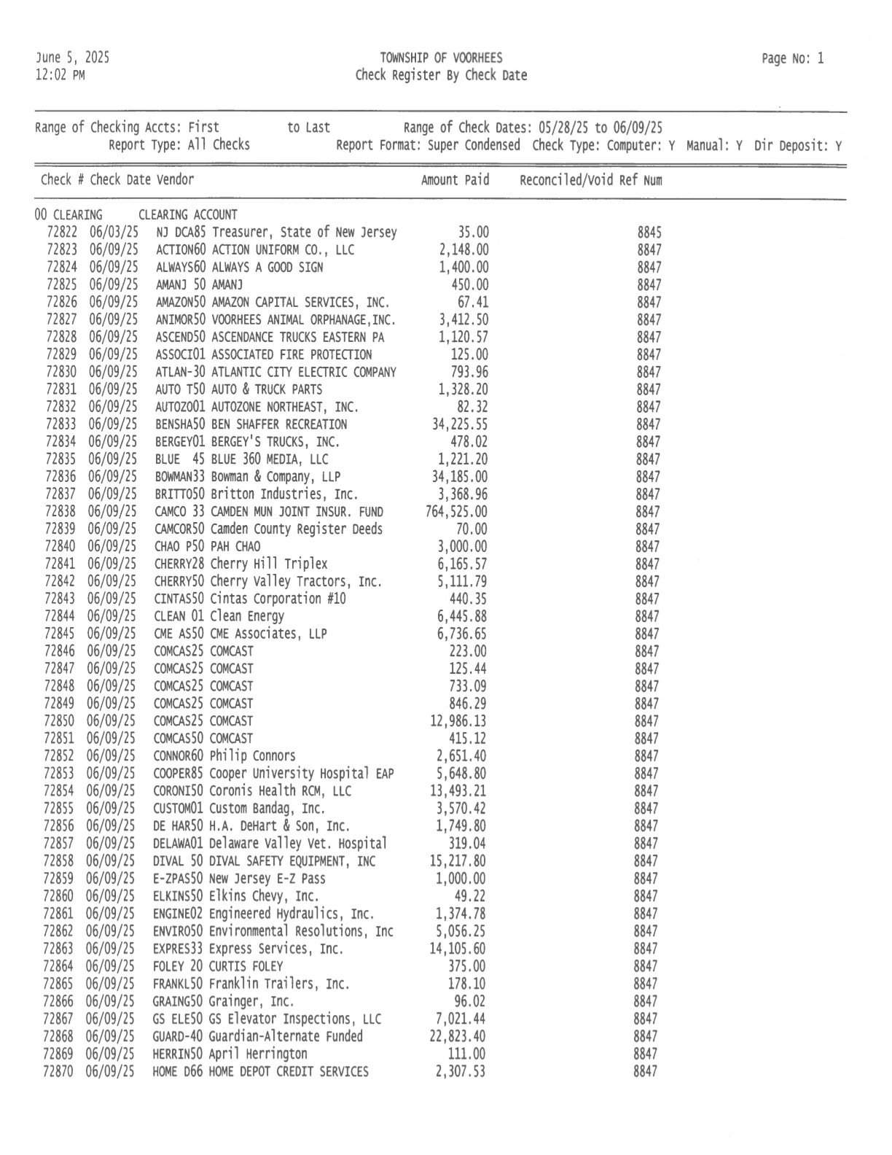

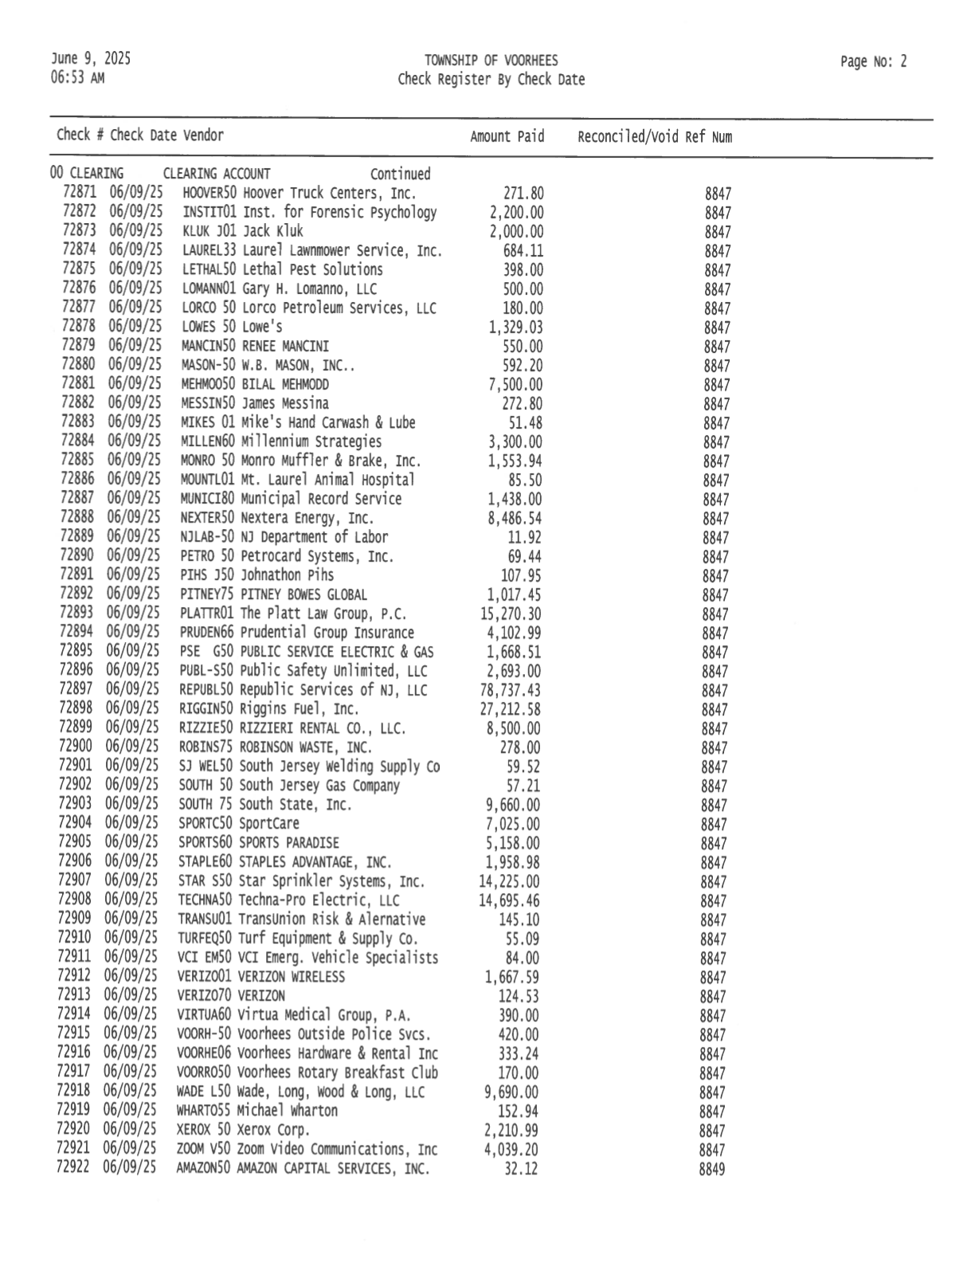
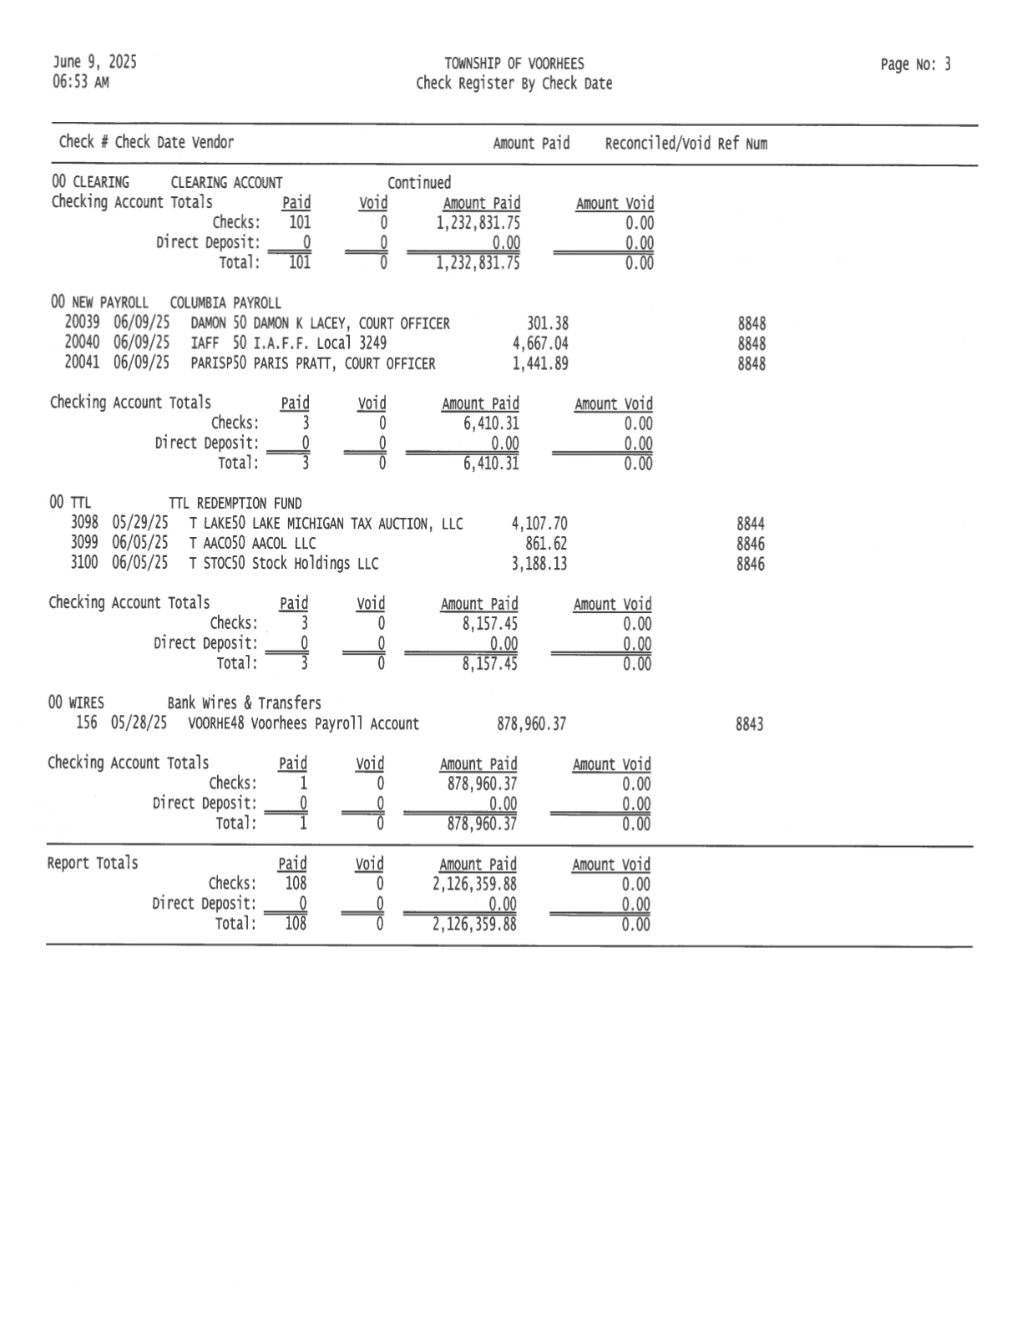
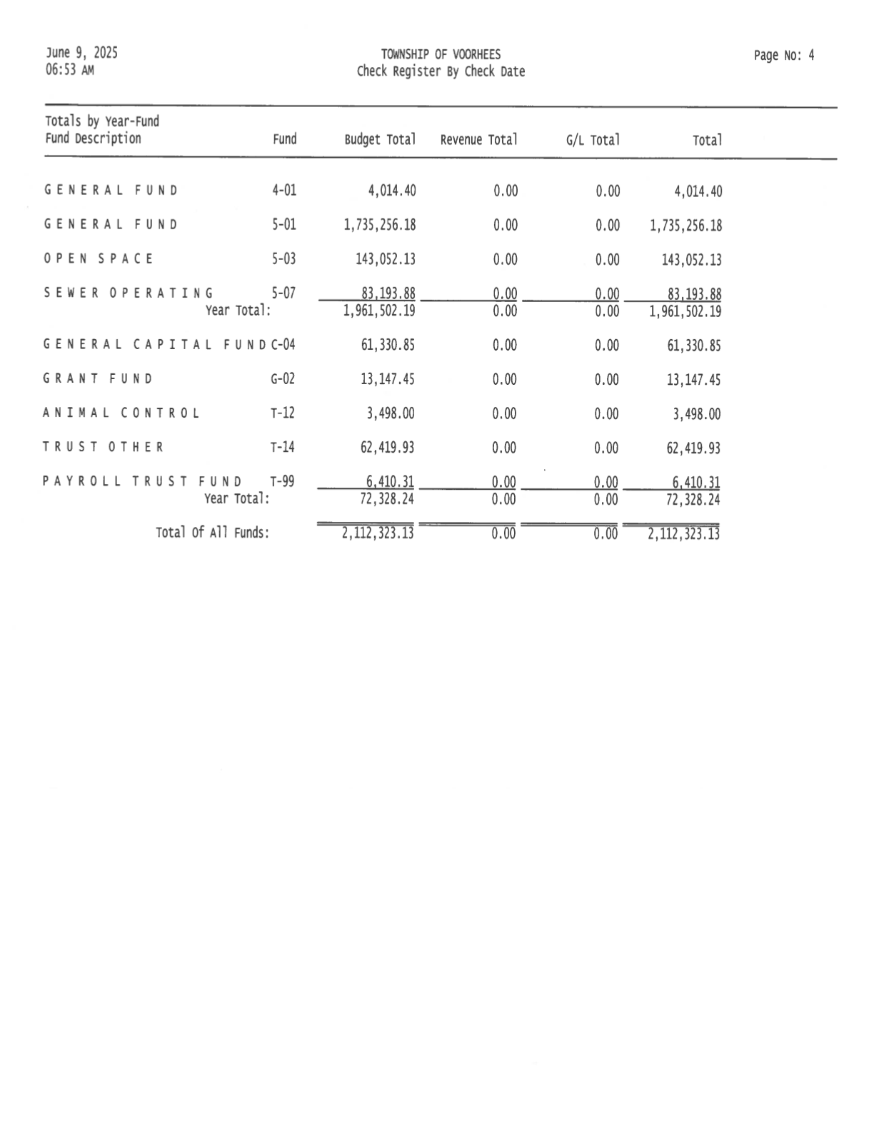
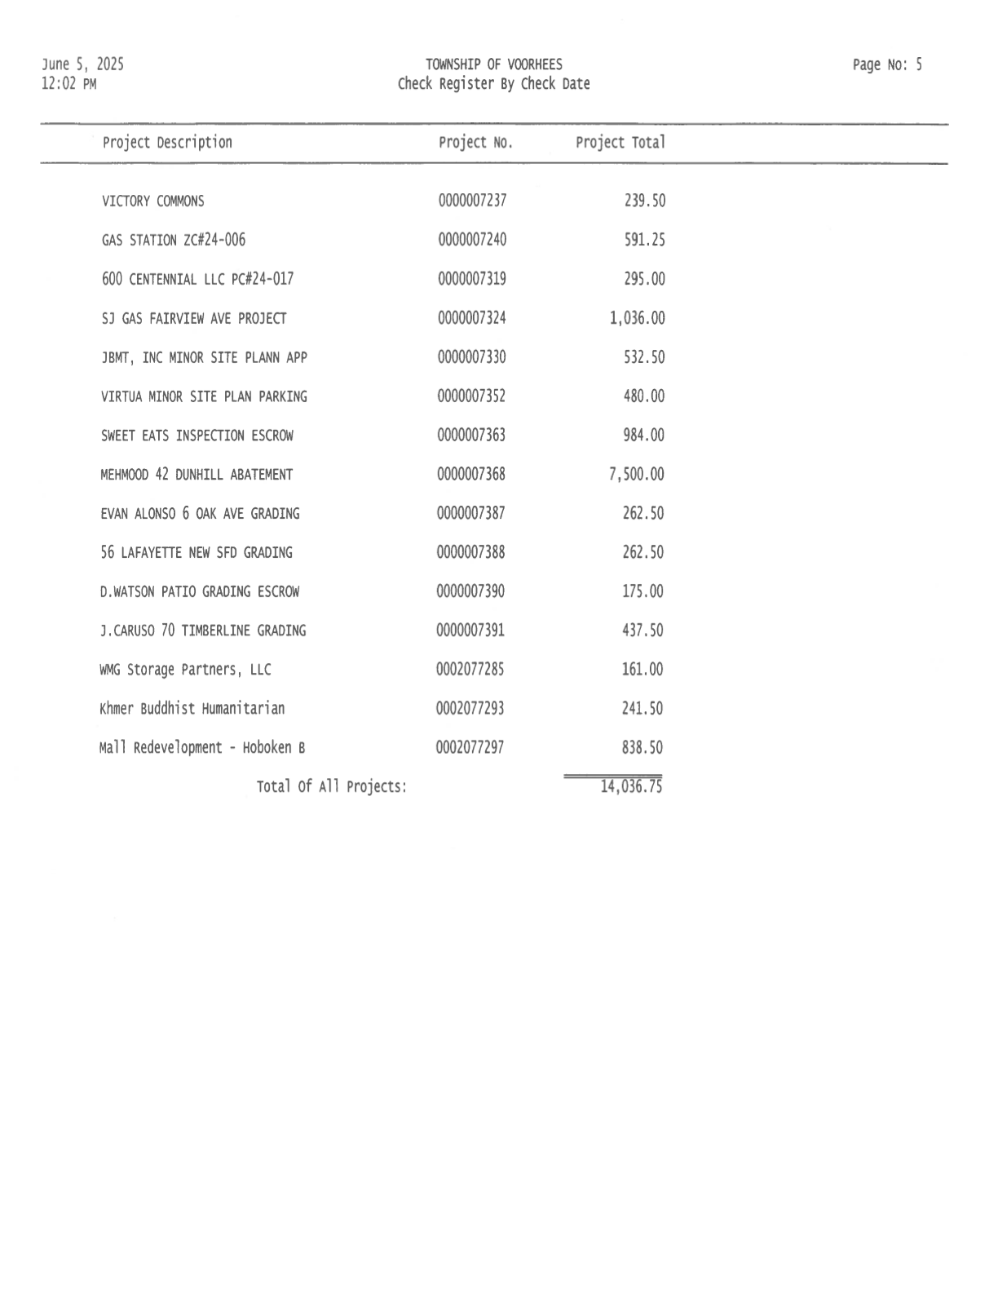

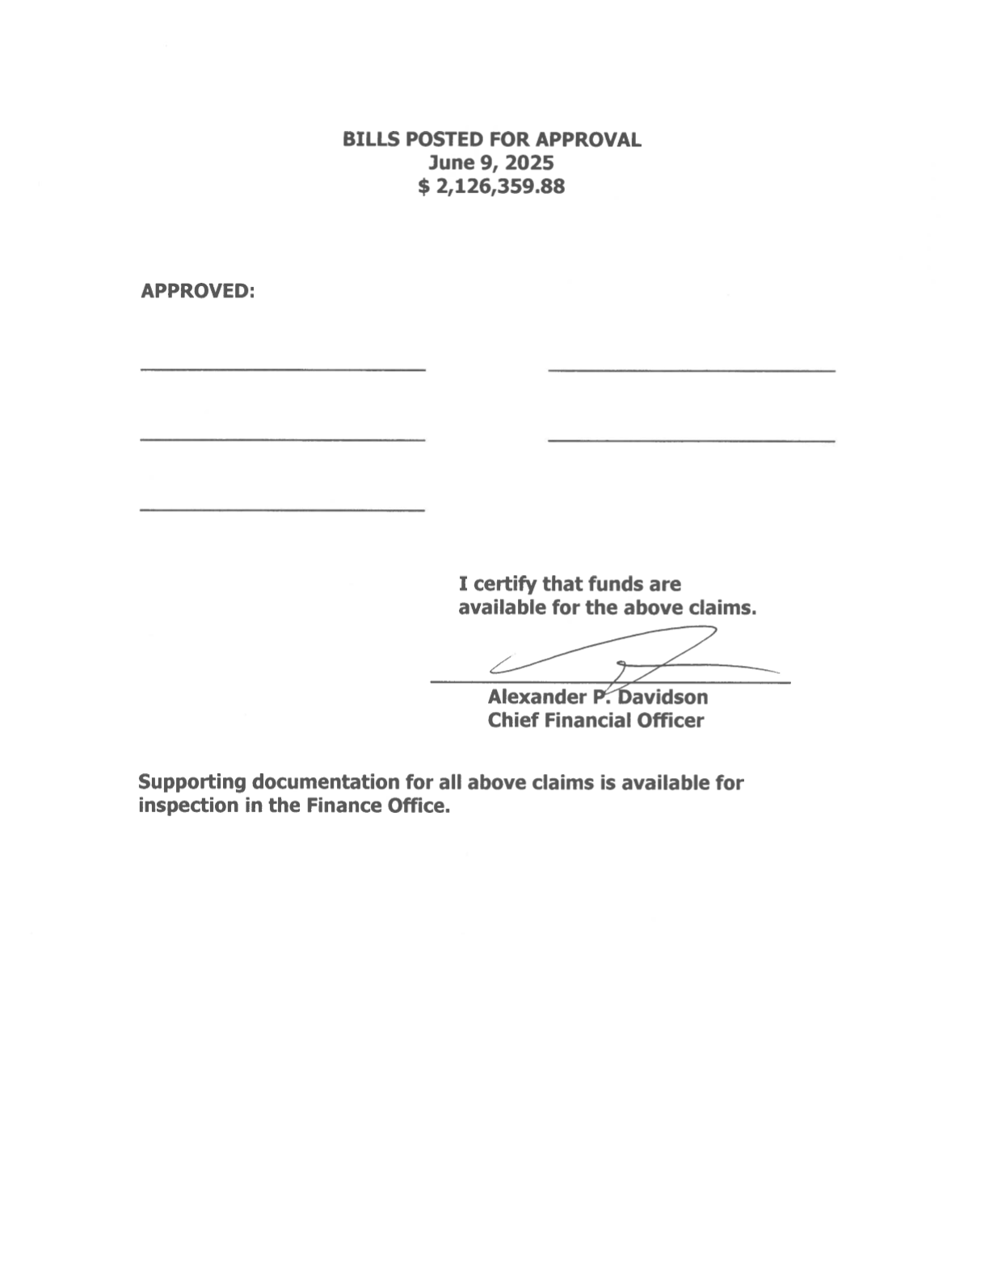

Proclamation
WHEREAS, the month of June is recognized as Lesbian, Gay, Bisexual, Transgender, and Queer (LGBTQ+) PRIDE Month across the United States, commemorating the Stonewall Uprising of 1969 and celebrating the progress made toward achieving equal justice and opportunity for LGBTQ+ individuals; and
WHEREAS, PRIDE Month is a time to reflect on the challenges the LGBTQ+ community has faced, honor the courage of those who have fought and continue to fight for equality, and celebrate the diversity and resilience that enriches our society; and
WHEREAS, Voorhees Township recognizes and respects the rights of all individuals to live without fear of discrimination or prejudice because of who they are or who they love; and
WHEREAS, we acknowledge the valuable contributions of our LGBTQ+ residents, neighbors, and allies who strengthen our community through their talent, service, leadership, and advocacy; and
WHEREAS, the Mayor and Township Committee are committed to fostering a welcoming, inclusive, and equitable community for all residents, regardless of sexual orientation, gender identity, or gender expression.
NOW, THEREFORE, BE IT PROCLAIMED, that Mayor Mignogna, and the Township Committee of the Township of Voorhees, do hereby recognize June 2025 as PRIDE Month in Voorhees Township.
BE IT FURTHER PROCLAIMED, that we encourage all residents to reflect on the ongoing struggle for LGBTQ+ rights, to stand in solidarity with the LGBTQ+ community, and to work together to promote equity, dignity, and respect for all.

______________________________
Michael R. Mignogna, Mayor
June 9, 2025

